THE GOOD, THE BAD AND THE FUNGI

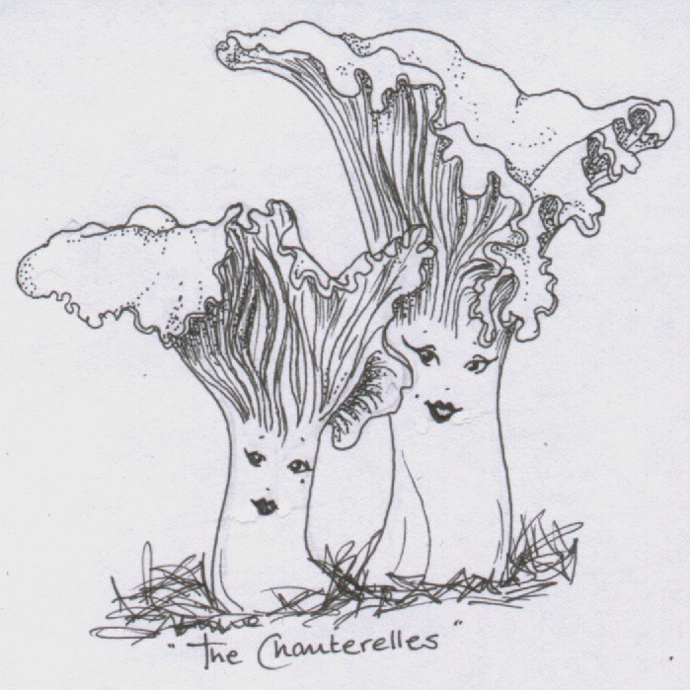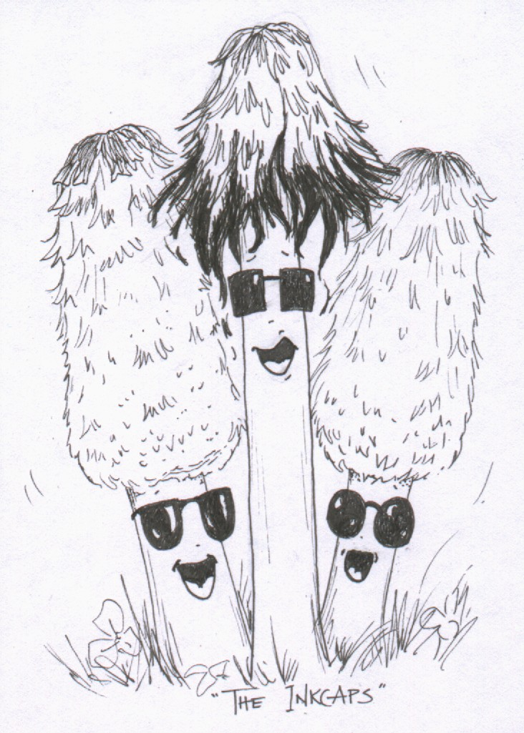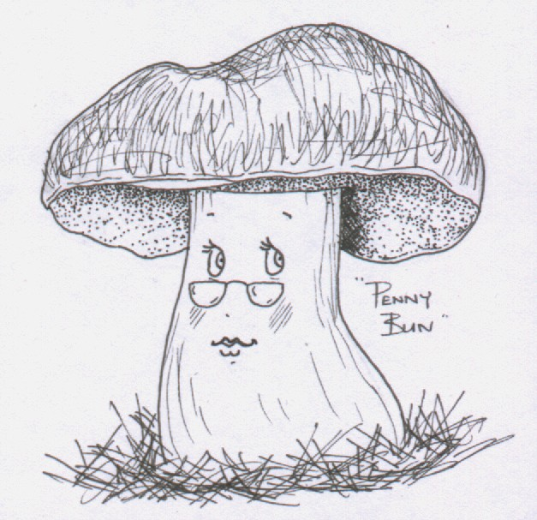

TEACHER’S NOTES

Compiled by Liz Holden (Grampian Fungus Group) in association with Aberdeen Environmental Education Centre, Aberdeenshire Council Health and Safety Unit, Aberdeenshire Council Ranger Service, British Mycological Society and Buchan Countryside Group. With support from Scottish Natural Heritage.



These documents may be copied freely for educational purposes only
Contents

Introduction 3
Background Information
Some useful terms for the children to know 4
Fungi – the essentials 5
Fungal history and folklore 6
Fascinating fungal facts 7
Fungi in the school curriculum 8
Mycological education on the Web 9
General references on fungi 10
Health and Safety - General Recommendations 12
Fungi in the classroom – some ideas to try before the activity day

Activity 1 Looking at fungi 14
Activity 2 Making a spore print 15

Fungi in the classroom – some ideas for follow up work
Activity 3 Understanding fungi 17
Activity 4 Why study fungi? 18
Activity 5 Where do fungi grow? Making a habitat collage 19
Activity 6 Growing mushrooms 20
Activity 7 Experimenting with fungi 21
Activity 8 Making paper with fungi 22
Activity 9 Dyeing wool with fungi 23
Activity 10 Drama ‘The Circle of Life’ 26
Appendices (in a separate document)
Risk Assessment Work Sheets
Appendix 1 Activity 1 Looking at fungi
Appendix 2 Activity 2 Making a spore print
Appendix 3 Activity 5 Where do fungi grow? Making a habitat collage
Appendix 4 Activity 6 Growing mushrooms
Appendix 5 Activity 7 Experimenting with fungi (including COSHH)
Appendix 6 Activity 8 Making paper with fungi

Appendix 7 Activity 9 Dyeing wool with fungi

Additional guidance notes

Appendix 8 Guidelines for collecting wild fungi
Appendix 9 Scottish wild mushroom code
Appendix 10 Outings
Appendix 11 Scottish Office guidance notes ‘E.coli 0157 and open farms’

Classroom worksheets
Appendix 12 ‘Identifying Fungi – What To Look For’
Appendix 13 ‘Parts of a Fungus’
Appendix 14 ‘Understanding fungi/Understanding fungi in the forest’
Appendix 15 ‘Fungi and food chains’
Teacher’s Notes
‘The Good, The Bad and The Fungi’ is a day of interactive learning and fun finding out about the kingdom of the fungi.

Introduction

Why should we bother to teach children about fungi?
Something is seriously lacking in our educational system when 150 out of 170 Year 10 children at a recent Summer School in England think that fungi are bacteria. By restricting the curriculum to a comparison of plants and animals, our children can leave school knowing next to nothing about the largest kingdom of higher organisms which are neither plant nor animal. With their own unique lifestyles the fungi are crucial to the functioning of every food web on the planet and a vital component of many human commercial activities. Without fungi the supermarket shelves would be bare and many of our medicines would disappear. Most higher plants would not survive and the carbon cycle would be severely compromised. Fungi are far more than just mushrooms, yeasts and moulds and it is time that we challenged our cultural inhibitions by giving fungi the attention that they deserve. What better place to start that in our primary schools?

The Good, The Bad and The Fungi
Feedback from schools that participated in the first activity day during 2001 suggested that the children’s learning experience would be greatly enhanced if a small amount of preparation had been done in advance of the visit. These notes should make this possible and also enable teachers to undertake a range of follow up activities if they wish.

The following notes include sections on ‘Background information’, ‘Health and Safety recommendations’ and ‘Fungi in the classroom’ – ideas to try before and after the activity day. The appendices contain ‘Risk Assessment Work Sheets’ for every relevant activity; additional guidance notes that include information on the collection of wild fungi and a series of classroom worksheets for use in follow up activities.

These notes have been produced with the help of Aberdeenshire Council Health and Safety Unit and in consultation with Aberdeen City and Moray Councils, to ensure that all the necessary Risk Assessments and Health and Safety recommendations are in place. Many of the activities and background notes have been adapted from How the Mushroom got its Spots – an explainers guide to fungi by Sue Assinder and Gordon Rutter. There are other ideas and activities in this publication which you can read online on the fungi4schools website (see the entry under ‘General References about Fungi’ below on page 11).

Background Information

Some useful terms for the children to know

EXCHANGER Exchanger fungi live with many of our trees and plants and the tree and the fungus exchange foodstuffs.
FUNGUS (singular) FUNGI (plural) is what the whole organism is called.
HABITAT Different kinds of fungi live in different places. The place where we find a fungus is called its habitat.
HYPHAE Fungi are composed of minute threads called hyphae (singular is hypha).
KINGDOM A fungus isn’t a plant or an animal. Fungi have their own kingdom.
MUSHROOM/TOADSTOOL These two words are used interchangeably to refer to the part of the ‘umbrella shaped’ fungi that you see above ground. This is sometimes referred to as the ‘fruit body’. Many people think that mushrooms are edible and toadstools are poisonous. There is no scientific division of the two names on this basis.
MYCELIUM The main part of the fungus is a dense network of hyphae called the mycelium. This is often hidden from sight.
PARASITE A parasitic fungus gets its food by attacking a living organism (e.g. a tree) and can sometimes kill it.
PHOTOSYNTHESIS Plants get their energy from the sun by the process of photosynthesis. Fungi do not contain chlorophyll and so cannot photosynthesise.
RECYCLE Recycler fungi break down dead plant material and recycle the nutrients back into the woodland ecosystem.
SPORES Fungi reproduce by producing millions of tiny (microscopic) spores. These have the same function as tiny plant seeds but they do not have the food reserves that a seed contains.

Fungi - the essentials
Fungi used to be regarded as plants but they are now placed in their own kingdom. They range in size from single celled organisms that can only be seen with a microscope through to the largest living organism. They can be found everywhere, from the deserts to the Arctic Circle, and even proved a hazard on the Russian Space Station Mir. The fungal kingdom is vast, with nearly 100,000 different species known to date and estimates of over a million left to be discovered.

To exploit new habitats, fungi produce countless millions of spores, which are equivalent to the seeds of plants but without the massive food reserves. Most fungi grow in the form of microscopic filaments called hyphae that extend and branch at their tips to form a vast network or mycelium. The cell walls of fungi are made of chitin – the same material found in an insect’s exoskeleton. What we normally think of as fungi – mushrooms and toadstools – are the fruiting bodies that arise from the mycelial network. The mushroom is just a device to spread the spores of particular types of fungi at certain times of the year. The mycelium, in some species, is present year in, year out and it produces a fruiting body only when the conditions are suitable. The reproductive structures of many fungi do not have the characteristic mushroom shape at all (e.g. puffballs, earthstars and fairy clubs).

Fungi do not possess the green pigment chlorophyll found in plants, so they have to gain their food from other sources in much the same way that an animal does. Many are saprotrophs, living on dead organic matter such as leaf litter, whilst others are parasitic and may in extreme cases kill the host. Fungi play a vital role in recycling by breaking down lignin. Without this action, all the nutrients locked in plants would remain there, nutrient cycles would stop and plants would no longer have enough raw materials to survive. Many fungi form symbiotic associations with trees and other plants (mycorrhizal fungi), which extend the plant root system assisting in the uptake of water and nutrients. Over 90% of plants have a fungus associated with their roots and many would not survive without their fungal partner. Fungi may also form symbiotic relationships with algae, known as lichens.

Fungi are used by humans for a variety of processes – from alcohol and bread production (with yeast) to genetic engineering. Some of the most important organisms used in biotechnology are fungi. Fungal fermentation has been harnessed to manufacture important therapeutic compounds, such as antibiotics, and enzymes for use in the food, textile and other manufacturing industries.
Fungal history and folklore
Here are some interesting anecdotes about fungi:

- It was not always so easy to go on fungal forays. In ancient Egypt, the consumption of mushrooms was a privilege restricted to the pharaoh and his family – a commoner was forbidden even to touch one!
- Mushroom poisoning was a problem even in ancient Rome. Emperor Claudius died at the hand of his third wife Agrippina, who fed him a poison mushroom in order to ensure that her son Nero would become the next emperor.
- People have also been using fungi for purposes other than food for thousands of years. Tinder material prepared from the bracket fungus, Fomes fomentarius, was found with the frozen remains of a Neolithic man in an alpine glacier in 1991, and have been dated to 3350 – 3100BC
- Fairy rings in Germany are allegedly caused by dragons flying in circles and scorching the earth beneath them with their tails.
- To discover the fungal story behind Santa and his reindeer see http://www.uio.no/conferences/imc7/NFotm99/December99.htm
- It is said that the ancient highlanders used to pack their circular shields (targes) with dried material from the Birch Bolete (Piptoporus betulinus). The fungus is light and tough and is a good shock absorber. It was also used for honing blades (the Victorians called it the ‘razor strop’ fungus and cleaned and sharpened their old fashioned razor blades on it. Good job that this fungus also has some antiseptic qualities!

Fascinating fungal facts
- A piece of a ‘death cap’ sufficient to cover the tip of a knife has enough poison to kill 100,000 mice.
- An individual honey fungus is claimed to be the world’s largest and oldest living organism – estimated to be some 1,500 years old and more than 10,000 kg in weight, its underground network of hyphae occupies 15 hectares. The rings that it makes are visible from space!
- The first discovered antibiotic – penicillin – is from a mould. The discovery was probably one of the greatest medical advances of the 20th century and it came about entirely by accident. Some of the wonder drugs of today are also derived from fungi (e.g. statins that control cholesterol levels, and cyclosporin to control rejection in transplant patients).
- When fungi are collected from tropical rainforests approximately one in every eight types collected is a species completely new to science.
- The stinkhorn has been recorded as elongating to a length of 20 cm in only 2-3 hours.
- One bracket, the Dryad’s Saddle, is recorded as reaching a weight of 14 kg in only 3 weeks
- Field mushrooms have been found with a cap circumference of 115 cm.
- Mushrooms are quite capable of forcing their way up through asphalt and lifting paving stones. Two mushrooms growing beneath a 35 kg paving stone that had been cemented into place were able to push the slab up by nearly 4 cm.

Fungi in the school curriculum
The guidelines for the Science component (Scotland) of Environmental Studies (5 – 14), include an attainment outcome ‘Living Things and the Processes of Life’. At the earliest stages of primary (P1 –P3), studies of the local environment are encouraged to allow children to appreciate how living things depend upon each other, whilst later stages of primary (P4 – P7) should introduce the importance of conservation and recycling. Older pupils (S1/S2) should be able to give the main distinguishing features of micro-organisms and describe their harmful and beneficial effects, and also create and use keys to identify living things.

Fungi can be used in many other areas of the curriculum, or in cross curricular activities and these activities should lend themselves well to the new 3 – 18 curriculum proposed in Scotland. For example, practical work can provide useful quantitative data for analysis in maths lessons. There is scope for creative writing, artwork and drama.

Although fungi do not currently feature strongly in the National Curriculum for Science (England, Wales and Northern Ireland), because many of the units are limited to comparisons of plants and animals, aspects of fungal biology can be introduced in relevant areas to provide a properly balanced view of biology in the real world. In Science at Key Stages 1 and 2, Units 4B (Habitats), 5-6H (Enquiry in environmental and technological contexts), 6A (Interdependence and adaptation) and 6B (Micro-organisms) lend themselves particularly well. Simple recording of fungal form and habitat presents an opportunity to begin working on investigative skills at primary level. Interesting scientific studies can be undertaken using fungi to enable children to evaluate and present evidence (see Activity 7, page 21 below and refer to the fungi4schools website [www.fungi4schools.org/] for ideas and resources from primary through to post-16 level). Further information on the National Curriculum for Science can be found on the National Curriculum online website at www.nc.uk.net

Mycological education on the Web
- British Mycological Society teaching resource website at www.fungi4schools.org/. Lots of excellent material here, including background information and work sheets for secondary schools.
- The WWW Virtual Library: Mycology. Probably the most comprehensive listing of mycological resources on the internet, including an invaluable section on teaching and learning about fungi (URL = http://mycology.cornell.edu/).
- Fungi images on the Net (www.in2.dk/fungi/) A metadirectory from which you can locate and view nearly 1600 beautiful and informative images of fungi.
- North American Mycological Association (www.namyco.org/) Includes an excellent teaching section with downloadable lesson plans and handouts and a comprehensive bibliography
- Tom Volk’s Fungi (http://botit.botany.wisc.edu/toms_fungi/) A ‘one stop shop’ for mycology, featuring a ‘fungus of the month’ column, with entertaining text and good photos, plus a plethora of other information, including tips for teachers on ways to use the internet for teaching about fungi
- Northern Ireland Fungus Group website offers lots of good links and ‘fascinating facts’ at http://www.nifg.org.uk/home.htm
- Royal Botanic Gardens Edinburgh, Flora Celtica site (http://www.rbge.org.uk/research/celtica/fc.htm) has information on fungal uses in the section on Scottish Plant Uses.

General references on fungi

Fungi
An excellent and easy to read book (96 pages) on the biology of fungi and their relationships with people written by Roy Watling. Published by the Natural History Museum in their Life Series, ISBN 0565091824).

Fungi for Schools
The BMS fungi4schools website is the ultimate source of resources for the school classroom. Visit http://www.fungi4schools.org/ to find material for all Key Stages, and post-16, to compensate for the lack of fungal biology in the National Curriculum. Here you can access resources teachers can use within the current National Curriculum because they address National Curriculum topics and also give proper representation to fungi. For FREE download you will find ready-to-use lessons and classroom activities, teacher’s guides, pupil class sheets, and much more. All classroom tested and well received by pupils.

Fungi Name Trail
This new key by Liz Holden and Kath Hamper is in the form of a fold-out chart. It is designed to be used by teachers and students as an introduction to some of the more easily recognised fungi present in our woods and fields. It will also be of interest to any non-expert wanting to find out more about fungi. For this key, fungi have been grouped according to their shape. The Fungi Name Trail takes you through a series of yes or no questions to help you identify your fungi. The chart also contains lots of fascinating information such as ‘What are fungi’, ‘How do fungi feed?’ as well as some ‘Fun things to do with fungi’. Published by the Field Studies Council (FSC) in their Name Trail series, The Fungi Name Trail was produced in partnership with the BMS. Order on-line through the FSC (http://www.field-studies-council.org/publications) or by mail-order using an order form you can download from the British Mycological Society (http://www.fungi4schools.org/Reprints/BMS_Publ_orderform.pdf).

Fungus Fred goes Foraying
How do you tell young people about fungi? Why should you want to tell them about fungi anyway? Fungus Fred has the answers! Fungus Fred goes Foraying is a book for children by Maggie Hadley. You can buy by mail-order from the BMS using an order form from the website at this URL (http://www.fungi4schools.org/Reprints/BMS_Publ_orderform.pdf) or read the whole book online on the fungi4schools website at this URL http://www.fungi4schools.org/fred_pages/fred_contents.htm.

How the Mushroom got it Spots
How the Mushroom got its Spots: an explainers' guide to fungi, written by Sue Assinder and Gordon Rutter, is published for free and distributed by the BMS. It is aimed at anyone who wants to tell children, or non-experts of any age, more about the fascinating world of mushrooms, toadstools, moulds and other fungi. It will be useful for teachers, leaders of wildlife groups and science clubs, and others interested in nature. You can read the book online at this URL on the fungi4schools website: http://www.fungi4schools.org/mushroom_pages/SPOTS_page01.htm and/or download the COMPLETE text as a PDF file from the same site at http://www.fungi4schools.org/Reprints/MUSHROOM_SPOTS-website.pdf. The printed version can be ordered by mail-order from the BMS using the order form you can download from the website at http://www.fungi4schools.org/Reprints/BMS_Publ_orderform.pdf).

Recommended English Names for Fungi
The Recommended English Names for Fungi provides an agreed list of English names for fungi will help to give fungi the popular, accessible identity that they deserve. It includes many names already in popular use and creates a further 400 or so memorable new names for those with only a scientific name. This list was compiled by E. M. Holden and funded by the British Mycological Society, together with English Nature, Scottish Natural Heritage and Plantlife International. It also has the support of The Countryside Council for Wales and the Environment and Heritage Service Northern Ireland. It can be downloaded free from the British Mycological Society’s fungi4schools website at this URL: http://www.fungi4schools.org/Reprints/ENGLISH_NAMES.pdf

Useful books for identifying fungi
The most comprehensive photographic field guide for collecting mushrooms and other fungi is Roger Phillips’ Mushrooms (2006; Macmillan, ISBN: 0330442376).

R. Gillmor, N. Hammond, P. Harding, T. Lyon, and G. Tomblin, Collins How to Identify Edible Mushrooms, (1999; Harper Collins, ISBN 000219984X).

Health and Safety

The Health and Safety Units of Aberdeenshire Council, Aberdeen City and Moray have checked through the following activities and produced generic risk assessments where appropriate (Appendices 1 –7). These risk assessments are offered as examples that can be consulted and amended as necessary to suit your own purposes prior to undertaking any activities.

General recommendations
- Complete a risk assessment before undertaking any activity.
- Fungi are a diverse and important group and many are considered to be excellent to eat. Children should be made aware, however, that some fungi contain toxins dangerous enough to cause death if eaten.
- Read and make use of the guidelines on collecting and identifying wild fungi.
- Never eat wild fungi in the classroom situation.
- Always wash your hands after touching fungi and do not allow children to suck their fingers or chew their fingernails before doing so.
- All demonstrations using wild fungi should be teacher lead.
- General class work should be undertaken using fungi from a reputable source e.g. supermarket.
- Supervision Levels (Scotland) (see also Appendix 10): P1-3, 1 : 1 to 1: 10; P4-7, 1 : 8 to 1 : 15; S1, 1 : 30.

Disposal of used fungi and other materials from any of the activities involving real fungi, i.e. looking at fungi in the classroom, making a spore print, grow your own mushrooms, experimenting with fungi, dying wool and making paper must follow appropriate guidelines. Guidelines include double wrapping non-cultured waste and disposing in an outside bin. Cultures should be sterilised prior to disposal. The most effective method involves heating for 15 minutes in a pressure cooker. Where this facility is not available, use freshly prepared disinfectant. Microsol or Virkon is suitable and available in 50 g sachets from laboratory suppliers – instructions included. Good quality domestic bleach, diluted with no more than nine times its volume of water thus creating a 10% solution or stronger, is another option. Gloves should be worn when handling all solutions of disinfectant or bleach (see Appendix 5 COSHH guidelines). Procedure: open the culture of microorganisms under the surface of the disinfectant so as not to release live spores into the air. Soak the culture for at least one hour or overnight. Pour away the disinfectant, place the culture in an opaque polythene bag, seal it and place it within a second opaque polythene bag, seal this and place in an outside dustbin. Glass or other reusable containers can be washed and recycled after soaking. Disinfectant powders or solutions should be kept locked away until required (COSHH guidelines).

If you are worried about doing practical work with fungi, helpful information can be obtained from the Microbiology in Schools Advisory Committee (MISAC). MISAC helps teachers recognise the potential of micro-organisms as educational resources and provides authoritative advice on the safe use of micro-organisms in schools. It can also provide information on where to find resources and offer many suggestions for suitable and safe investigations. Information about MISAC can be found on the Microbiology Online web site, hosted by SGM at this URL: http://www.microbiologyonline.org.uk/misac.html.



Fungi in the classroom – some ideas to try before the activity day

ACTIVITY 1

Looking at fungi
This activity can be undertaken with mushrooms bought from a reputable supplier such as a supermarket. Oyster mushrooms, Shiitake mushrooms, Lion’s Mane mushrooms and more familiar flat cap Agaricus species would all be suitable. A selection of wild fungi would give a more varied and interesting range of shapes, colours, textures and smells but attention should be given to the guidelines on collecting and identification (Appendix 8).
Reference to the ‘General Recommendations’ in the section on ‘Health and Safety’ (page 12) must be made and a risk assessment undertaken (Appendix 1).

Supervision Levels (Scotland) (see also Appendix 10): P1-3, 1 : 1 to 1: 10; P4-7, 1 : 8 to 1 : 15; S1, 1 : 30.

Methodology
Investigate the colours, smell, size and texture. Simple tests can be carried out - are the gills brittle and crumbly? (see notes under ‘Russula’ in Appendix 8) Does the damaged flesh produce a milky fluid? (see notes under ‘Lactarius’ in Appendix 8) Does the flesh change colour when exposed to the air or bruised? (see notes on ‘Boletes’ in Appendix 8) Drawing, painting and labelling the different parts are all good ways of focusing attention on these organisms. The worksheet ‘Identifying Fungi – What To Look For’ (Appendix 12) will help.
N.B. Don’t leave wild fungi for more than a day in a warm environment as they often contain the larvae of fungus gnats that have a habit of abandoning their home when stressed!
- Disposal of used fungi and other materials from any of the activities involving real fungi i.e. looking at fungi in the classroom must follow appropriate guidelines (details on page 12). Guidelines include double wrapping non-cultured waste and disposing in an outside bin.
- Guidelines on collecting wild fungi (Appendix 8). Collection is envisaged as a teacher only activity and reference should be made to Appendix 8. Russula, Lactarius, Bolete species and the Fly Agaric (Amanita muscaria) are all suitable for this activity. Obtaining the permission of the landowner and following the countryside and access codes are recommended (see also Appendix 11). Other general guidelines are given in the ‘Scottish Wild Mushroom Code’ (Appendix 9).

ACTIVITY 2

Making a spore print
This activity can be undertaken with mushrooms bought from a reputable supplier such as a supermarket. Oyster mushrooms (spore print white), Shiitake mushrooms (spore print white) and more familiar open cap Agaricus species (spore print dark brown) would all be suitable. A selection of wild fungi would give a more varied and interesting range of spore colours but attention should be given to the guidelines on collecting and identification (Appendix 8).
Reference to the ‘General Recommendations’ in the section on ‘Health and Safety’ (page 12) must be made and a risk assessment undertaken (Appendix 2)

Supervision Levels (Scotland) (see also Appendix 10): P1-3, 1 : 1 to 1: 10; P4-7, 1 : 8 to 1 : 15; S1, 1 : 30.

Methodology
You will need a mushroom, sheet of white paper, sheet of black paper, sticky tape, empty yoghurt container or similar, hairspray (optional).

N.B. Don’t leave wild fungi for more than a day in a warm environment as they often contain the larvae of fungus gnats that have a habit of abandoning their home when stressed!

What to do
- Overlap the two sheets of paper and join them at the back with the sticky tape
- Gently remove the cap from the mushroom and place it face down on the joined paper so that half is on each colour.
- Cover the mushroom cap with the pot or jar to stop it drying out (a couple of drops of water dripped onto the top of the cap can help maintain humidity).
- Leave everything where it is for at least two hours.
- Carefully remove the pot or jar and the mushroom cap. The spore pattern should be visible on one side of the paper (depending on the colour). With practise arrangements of different coloured prints can be created.
- To prevent smudging, the teacher can spray the spore print with hair spray.
- Disposal of used fungi and other materials from any of the activities involving real fungi i.e. making a spore print, must follow appropriate guidelines (details on page 12). Guidelines include double wrapping non-cultured waste and disposing in an outside bin.

Guidelines on collecting wild fungi (Appendix 8). Collection is envisaged as a teacher only activity and reference should be made to Appendix 8. Russula, Lactarius, Bolete species and the Fly Agaric (Amanita muscaria) are all suitable for this activity. Obtaining the permission of the landowner and following the countryside and access codes are recommended (see also Appendix 11). Other general guidelines are given in the ‘Scottish Wild Mushroom Code’ (Appendix 9).

If you are having problems it might be that the fungus is too old or too dry or maybe it has not been left long enough. Commercially grown shop-bought mushrooms can be difficult to work with as they are often stored upside down or tipped away from the vertical and the gills move to try and get back to the vertical (now there’s an interesting discussion point about growth and development!). Note that button mushrooms have not usually developed enough to produce spores and will often still have a protective membrane covering the gills completely.

Fungi in the classroom - some ideas for follow up work

ACTIVITY 3
‘Understanding fungi’
This is a normal classroom activity with no specific health and safety requirements.

Complete the assessment worksheets ‘Understanding Fungi’/‘Understanding Fungi in the Forest’ (Appendix 14) and also ‘Fungi and Food Chains’ (Appendix 15).

ACTIVITY 4

Why study fungi?
This is a normal classroom activity with no specific health and safety requirements.

Fungi are important because –
- They are used to make medicines
- They help to recycle nutrients in the soil
- They help plants and trees to grow
- They cause diseases of plants and animals
- They are used to make food and drink
- They provide food and shelter for many insects

How many other reasons can you think of?
(If you need help with ideas, look through the pages of the fungi4schools website at http://www.fungi4schools.org/).

ACTIVITY 5

Where do fungi grow? Making a habitat collage
Reference to the ‘General Recommendations’ in the section on ‘Health and Safety’ (page 12) must be made and a risk assessment undertaken (Appendix 3).

Supervision Levels (Scotland) (see also Appendix 10): P1-3, 1 : 1 to 1: 10; P4-7, 1 : 8 to 1 : 15; S1, 1 : 30.

Background
Fungi live in a variety of habitats and exhibit many different life styles. ‘Exchanger’ fungi can link up to the root systems and exchange nutrients with the tree, ‘recycler’ fungi can break down stumps, twigs, leaves and other dead plant material. Parasitic fungi can attack damaged or weakened tree and even kill them. Don’t forget that the death of a tree can be good for the insects and birds that need dead wood to live in. When a dead tree falls over, it opens up a glade, allowing sunlight to reach the woodland floor and encourage re-growth.

Methodology
A good way of reinforcing these ideas with a younger group is to make a ‘habitat collage’. Participants can draw a picture of their favourite fungus (or colour in a prepared outline drawing). From their experiences in the field, they can stick the pictures onto the appropriate part of a background (the background should have a good range of habitats – maybe conifers and broadleaved trees, dead wood and leaf litter) N.B. P1- 3 should draw only, P4 upwards can use natural materials as long as they wash their hands afterwards). For a 3D effect, plasticine or clay models could be made and placed in the foreground.

ACTIVITY 6

Growing mushrooms
Reference to the ‘General Recommendations’ in the section on ‘Health and Safety’ (page 12) must be made and a risk assessment undertaken (Appendix 4).

Supervision Levels (Scotland) (see also Appendix 10): P1-3, 1 : 1 to 1: 10; P4-7, 1 : 8 to 1 : 15; S1, 1 : 30.

Methodology
It is possible to buy kits with full instructions and grow mushrooms indoors on full toilet rolls or out of doors on pre-inoculated logs. One such supplier is Ann Miller (ann@annforfungi.co.uk) Greenbank, Meiklewartle, Inverurie, AB51 5AA.
N.B. Mushrooms grown in this manner should not be consumed in the school situation.

- Disposal of used fungi and other materials from any of the activities involving real fungi i.e. grow your own mushrooms must follow appropriate guidelines (details on page 12). Guidelines include double wrapping non-cultured waste and disposing in an outside bin.

ACTIVITY 7

Experimenting with fungi
Reference to the ‘General Recommendations’ in the section on ‘Health and Safety’ must be made (page 12) and a risk assessment undertaken (Appendix 5)
Supervision Levels (Scotland) (see also Appendix 10): P1-3, 1 : 1 to 1: 10; P4-7, 1 : 8 to 1 : 15; S1, 1 : 30.

Methodology
Fungi offer many opportunities for experimental science and project work at all levels. A simple idea is to examine the conditions necessary for the growth of fungi. This is an excellent way of introducing the ideas of a fair test and controlling variables. Place identically sized pieces of bread, or soft fruit such a plum or peach, in clear jars or sealed plastic bags. Vary the conditions within the containers (e.g. adding water) and place them in a variety of locations (e.g. on a sunny windowsill, in the dark etc). Examine the contents periodically (do NOT open the containers) and record their appearance.
N.B. The disposal of any materials that you use in this experiment must follow recommended guidelines:
- Disposal of used fungi and other materials from any of the activities involving real fungi i.e. looking at fungi in the classroom, making a spore print, grow your own mushrooms, experimenting with fungi, dying wool and making paper must follow appropriate guidelines. Guidelines include double wrapping non-cultured waste and disposing in an outside bin. Cultures should be sterilised prior to disposal. The most effective method involves heating for 15 minutes in a pressure cooker. Where this facility is not available, use freshly prepared disinfectant. Microsol or Virkon is suitable and available in 50g sachets from laboratory suppliers – instructions included. Good quality domestic bleach, diluted with no more than nine times its volume of water thus creating a 10% solution or stronger, is another option. Gloves should be worn when handling all solutions of disinfectant or bleach and COSHH procedures followed. Procedure: open the culture of micro-organisms under the surface of the disinfectant so as not to release live spores into the air. Soak the culture for at least one hour or overnight. Pour away the disinfectant, place the culture in an opaque polythene bag, seal it and place it within a second opaque polythene bag, seal this and place in an outside dustbin. Glass or other reusable containers can be washed and recycled after soaking. Disinfectant powders or solutions should be kept locked away until required (see COSHH procedures).
ACTIVITY 8

Making paper with fungi
Reference to the ‘General Recommendations’ in the section on ‘Health and Safety’ (page 12) must be made and a risk assessment undertaken (Appendix 6). Suitable for P6 upward.

Note: when collecting wild fungi for this activity, consideration should be given to the quantity collected. It is unlikely to be practical or ecologically sound to collect enough material for each individual in the class to undertake their own preparations.
The fibrous nature of many bracket fungi (i.e. shelf like fungi that grow on trees) makes them particularly suitable for this activity but difficult to chop up. It is recommended that only the teacher cubes the fungus.

Supervision Levels (Scotland) (see also Appendix 10): P1-3, 1 : 1 to 1: 10; P4-7, 1 : 8 to 1 : 15; S1, 1 : 30.

Guidelines on collecting wild fungi (Appendix 8)
Collection is envisaged as a teacher only activity and reference should be made to Appendix 8. Although many fungi would give good results for this activity the following are two common fungi growing on old birch trees on Deeside: Hoof Fungus, Fomes fomentarius or the Birch Polypore, Piptoporus betulinus. Obtaining the permission of the landowner and following the countryside and access codes are recommended (see also Appendix 11). Other general guidelines are given in the ‘Scottish Wild Mushroom Code’ (Appendix 9).

Methodology
You will need: Bracket fungi, a tray (e.g. cat litter tray), heavy weight, blotting paper, blender, pieces of cloth (larger that the paper being made, the thicker and more absorbent the better), a mesh frame (specialised paper-making frames can be bought from most art suppliers, but any mesh will do provided it will keep back the fungus whilst allowing water to pass through).

What to do
- Chop up clean bracket fungi into 2 cm cubes (N.B. teacher only) and blend them with a small quantity of water in a blender. The amount of fungus required is enough to make a fluffy marshmallow –like consistency when blended with the water. The consistency is important – too watery and the paper will end up too thin, too concentrated and the paper will be lumpy.
- Pour the mixture into the tray, along with some more water.
- Place the mesh frame into the tray until the mashed bracket covers all of the mesh. Gently remove the mesh and hold it above the tray until most of the water has drained away.
- Gently tip the mashed bracket on the mesh onto a piece of cloth. Place another piece of cloth on top.
- Repeat until you have a pile of 10 –12 sheets of fungal paper. Place the weight on top of the pile to squeeze out the remaining water.
- Hang the cloth sheets with the bracket paper up to dry.
- For final drying, press the sheets of fungal paper onto blotting paper until dry.
- Disposal of used fungi and other materials from any of the activities involving real fungi i.e. making paper must follow appropriate guidelines (details on page 21). Guidelines include double wrapping non-cultured waste and disposing in an outside bin.

ACTIVITY 9

Dyeing wool with fungi
Reference to the ‘General Recommendations’ in the section on ‘Health and Safety’ (page 12) must be made and a risk assessment undertaken (Appendix 7). N.B. Suitable for S1 upwards

Many fungi contain substances that enable wool to be coloured and these include boletes and the root parasite of conifers Phaeolus schweinitzii. The fibrous nature of the latter fungus makes it difficult to chop up. It is recommended that only the teacher cubes the fungus.
Some fungi do not contain dye substances and will give a negative result. It is possible to obtain results using dried fungi bought from a reputable source such as a supermarket however the following notes will help in the collection and identification of wild fungi that are known to contain dyes.

Supervision Levels (Scotland) (see also Appendix 10): P1-3, 1 : 1 to 1: 10; P4-7, 1 : 8 to 1 : 15; S1, 1 : 30.

Guidelines on collecting wild fungi (Appendix 8)
Collection is envisaged as a teacher only activity and reference should be made to Appendix 8. Phaeolus schweinitzii and Boletes are suitable for this activity. N.B. when collecting wild fungi for this activity, consideration should be given to the quantity collected. It is unlikely to be practical or ecologically sound to collect enough material for each individual in the class to undertake their own preparations.

Obtaining the permission of the landowner and following the countryside and access codes are recommended (see also Appendix 11). Other general guidelines are given in the ‘Scottish Wild Mushroom Code’ (Appendix 9).

Methodology
You will need:
Mushrooms – different species give different colours (see above). The amount of fungus used will affect the shade of colour.
Wool
An aluminium, tin or copper pot
A mixing spoon
A means of heating water

N.B. boiling water constitutes a serious potential hazard

What to do:
- Boil 3 litres of water in the pot and then add 100g of clean, sliced mushrooms (reduce the water to 2 litres if dried mushrooms are used). Simmer for 30 minutes and then remove the mushrooms.
- Add 100g of wool to the water and simmer for 30 – 60 minutes. Add more water if the volume is getting low.
- Allow the wool to cool in the pot, wash in warm water and then dry (e.g. outside on a sunny day or in an airing cupboard).
- Disposal of used fungi and other materials from any of the activities involving real fungi i.e. dying wool must follow appropriate guidelines (details on page 21). Guidelines include double wrapping non-cultured waste and disposing in an outside bin.

ACTIVITY 10

Drama ‘The Circle of Life’
This is a dance activity with no specific health and safety requirements.

Try taking the ‘Build a Tree’ (notes given below) activity a bit further. Allow a scaled down version (depending on numbers of children available) of the tree to become old, or a limb to be blown off causing a hole in the bark. The parasitic spore finds a way in and gradually the tree will die and fall to the ground. Wood decomposing fungi and insects (keep some children free to take on these roles) can start to break down the parts of the tree and gently remove (literally) the various parts of the now dead tree. Eventually the dead tree has completely rotted away and there is now a clearing in the wood. During the process of decay, carbon and other important ingredients which the seedling trees will need to grow, will have been released from the old tree back into the system by the decomposer fungi. This recycling of nutrients combined with the sunlight that can now shine onto the forest floor will allow the seeds left behind by the tree to germinate. The children could all come into the ‘clearing’ and complete the cycle by becoming a new generation of tree seedlings.
This would probably need a narrator and could be embellished with ‘home-made’ fungus ‘coolie’ style hats and any amount of imagination!

Build a Tree
N.B. this activity is a development of Joseph Cornell’s activity ‘Build a Tree’. Permission has been gained from J. Cornell to use his activity in this format.
props:
spotty umbrella/s (optional but effective).
This can work for quite a large group but attention must be paid to how many people need to be allocated for each part of the tree and fungus. Introduce the activity by recapping how trees and fungi work together exchanging food stuffs (sugars and mineral salts) for the advantage of both, then set about building the tree:
Heartwood 1/2 people - The heartwood player/s need to stand in the middle of the activity space. The heartwood holds the trunk and branches upright so that the leaves can get their share of the sunlight. It is very strong but has been around a long time, is completely dead…but well preserved.
Taproot 1/2 people - The taproot player/s need to sit at the base of the heartwood facing outwards, drawing their knees up to their tummies. The taproots can go down as much as 10 metres and act as an anchor for the tree and also bring up water from deep in the earth (N.B. not all trees have tap roots).
Lateral roots 2+ people - The lateral root players should lie down on the ground with their feet towards the heartwood and spread out their arms and fingers. A real tree has hundreds of lateral roots that spread out through the soil. Each lateral root tip has tiny root hairs that grow into every centimetre of soil around the tree. When they sense water the cells at the tips grow towards it and draw water up for the tree to use. The tap and lateral roots should practice slurping (noisily!!) to the instruction from the leader ‘Let’s slurp’. Use fingers for root hairs – mind that they don’t get trodden on!
Sapwood 3+ - the sapwood players need to form a circle around the heartwood, facing inwards and holding hands - don’t tread on any of the roots! The sapwood (or xylem) draws the water up from the roots into the highest parts of the tree. On the leader’s instruction ‘Bring the water up’ the sapwood throw their arms up and shout ‘Wheeee!’
Cambium/phloem enough people to form a circle facing inwards outside the sapwood. The phloem has to distribute the food that is manufactured by the leaves to the rest of the tree. The phloem’s hands become leaves, so leader says ‘Let’s make food’, phloem holds hands up and flutters ‘leaves’; leader says ‘Bring the food down’, phloem goes ‘Whooo’- a long descending sound and drops down towards the ground.
Run through the activities - ‘Let’s slurp’; ‘Bring the water up’; ‘Let’s make food’; ‘Bring the food down’
Bark enough people to make as complete a circle as possible outside the phloem, facing outwards and working together to protect the tree from….fires, insects or maybe the dreaded ‘Wood Cauliflower’ which will infect and kill trees that are old or weak.
Fungus 1+ people, lying on the ground, stretch out their arms and use their fingers as the tubes that will grow around the trees root hairs (the fingers of the lateral roots) and enable the exchange of nutrients to take place. The tree is complete now the mineral salts that it receives from its fungal partner will enable it to grow in the poorest soils. The fungus is also now receiving sugars from the tree - I think that it might hum and/or put up an umbrella (fruit body) so that it can produce spores.

At this point the entire tree can run through its actions - probably without instructions - the leader could remind the bark to watch out for the ghastly, root gobbling, fungal spore and indeed become the spore if so inclined! The whole group should be involved at this point and when finished give itself a round of applause!

