Fungal Food Chains: templates

- Explanatory text
- The Sun
- The Beetle larva
- The Frog
- The Fox
- The Hawk
- The Slug
- The Blue tit
- The dead Birch tree
- The live Birch tree
- The Fly Agaric
- The Birch Polypore

There are two complete but mixed up food chains here. Each card represents one step in the food chain. Can you sort them out to show how the sun’s energy is passed along the chain right to the top predator?

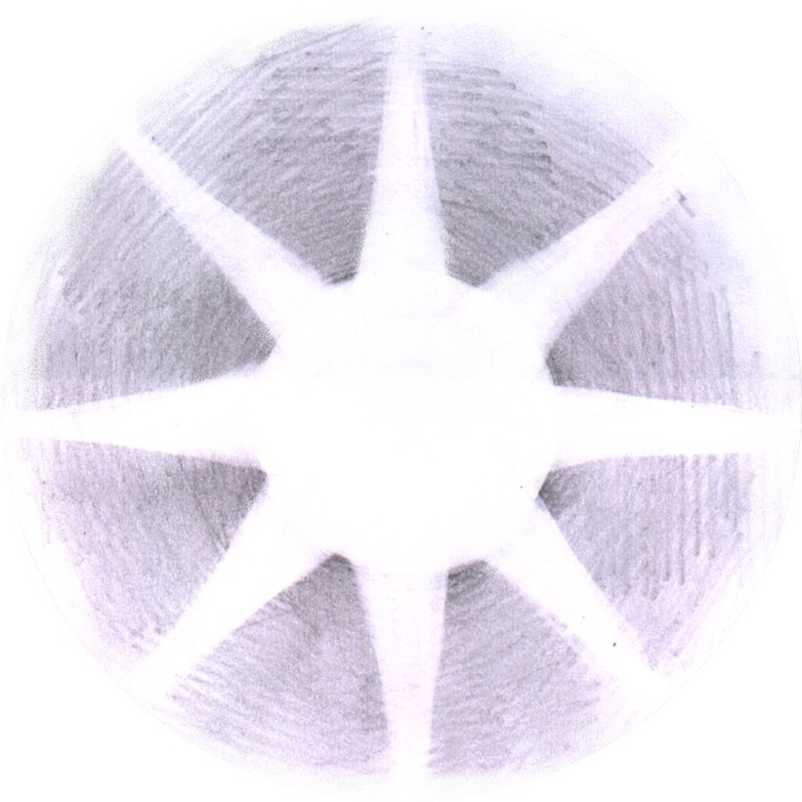

beetle larva

frog

fox

hawk

slug

blue tit

dead birch tree

live birch tree
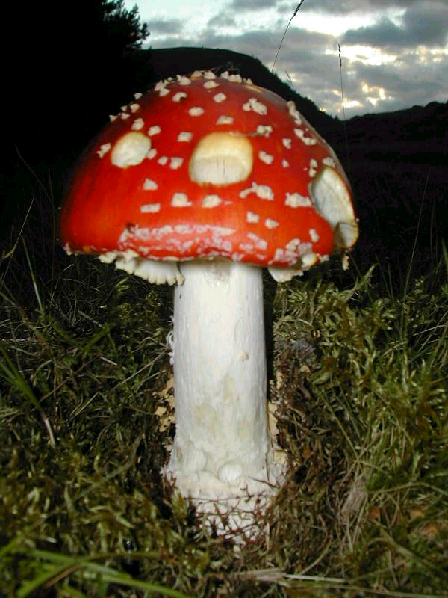
Fly Agaric

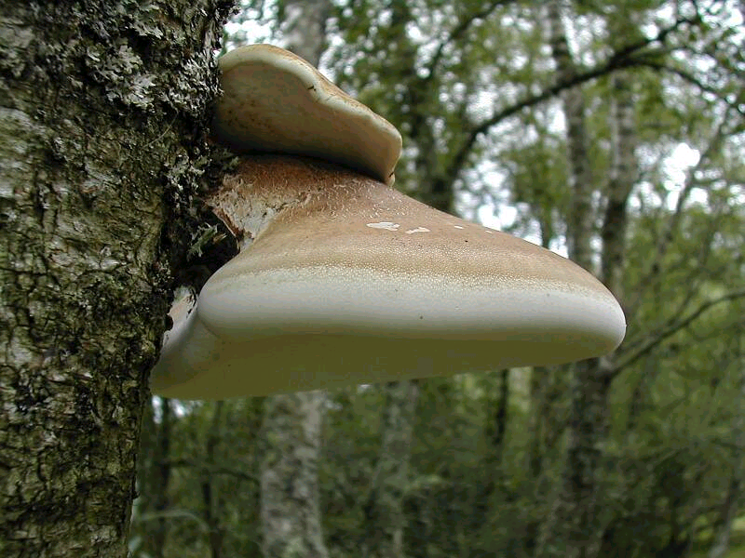
Birch Polypore

