Appendix 2: The Good, The Bad and The Fungi Activity Photos
Photos © John Latham and reproduced with the permission of King Edward School, Aberdeenshire.

Fig 1. Make a Mycelium – creating the web
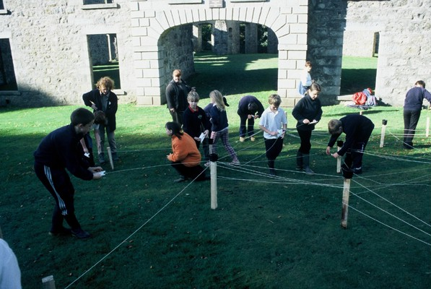

Fig.2 Working in a small group with the key
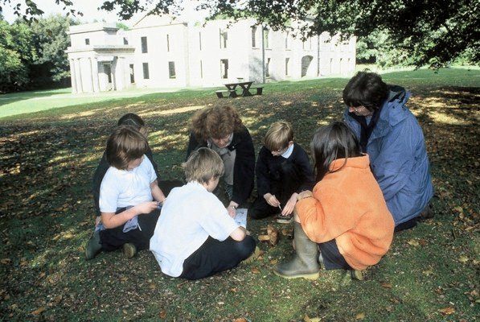

Fig. 3 Build a Tree – getting ready to fend off the parasitic spore!
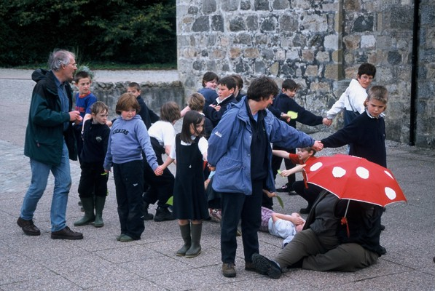

Fig 4: Mushroom Murder Mystery – discussing the death of the larch.
