THE GOOD, THE BAD AND THE FUNGI

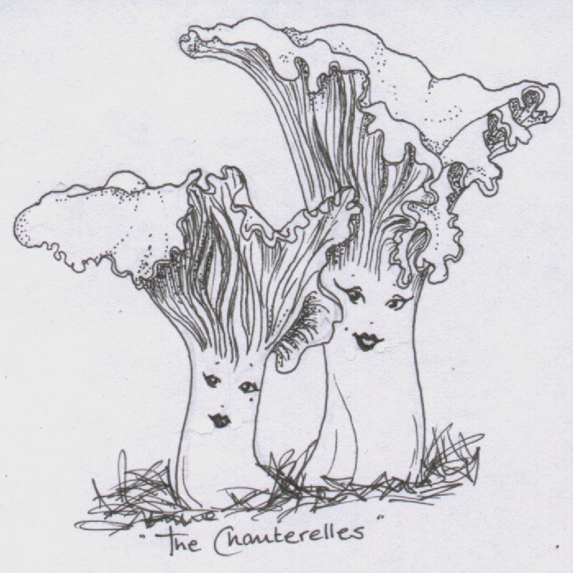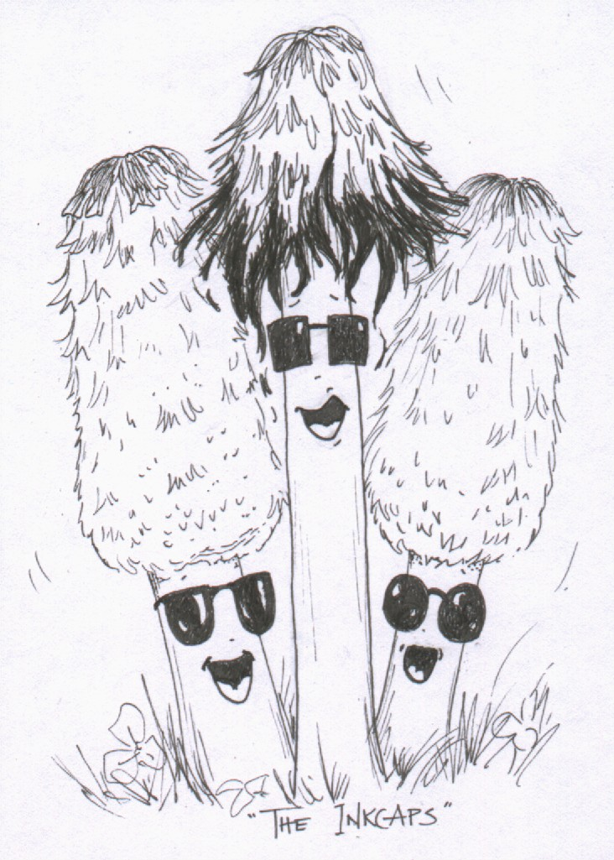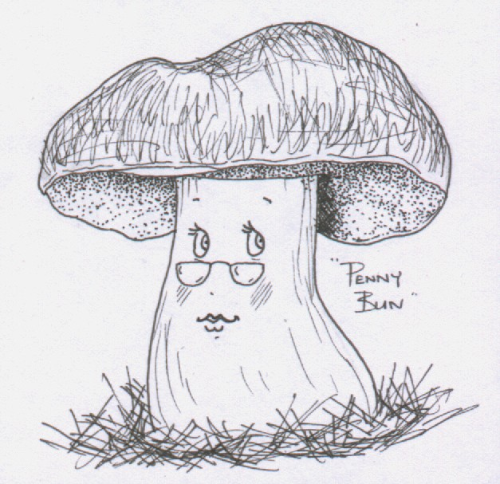

ACTIVITY NOTES FOR LEADERS

Compiled by Liz Holden (Grampian Fungus Group) in association with Aberdeen Environmental Education Centre, Aberdeenshire Council Health and Safety Unit, Aberdeenshire Council Ranger Service, British Mycological Society and Buchan Countryside Group. With support from Scottish Natural Heritage.


These documents may be copied freely for educational purposes only

Contents

Aims and Objectives 2

Props list for each activity 3

Why should we bother to teach children about fungi? 4

School curricula 4

Mycological education on the web 5

General references on fungi 5

Useful books for identifying fungi 7

The Activities

Introductory parachute games 8

What is a toadstool? 11

Spore prints and spots 12

How the toadstool got its spots 13

Make a mycelium 14

Fungi in the field 15

Build a tree 16

Mushroom murder mystery 18

Indoor activities 21

Toadstools and trees 22

Appendices

1 Suggested timetable

2 Activity pictures

‘The Good, the Bad and the Fungi’

Activity notes for leaders

This is intended to be a full day of linked activities mostly undertaken outside and suitable for 7 – 11 year olds. The activity notes are for guidance only and do not need to be followed verbatim.

Aim
Explore the kingdom of the fungi and discover their vital importance in the natural world through a series of fun and interactive activities.

Objectives
- To have an enjoyable and informative day out
- To demonstrate how all parts of the natural world are inter related
- To find out how flowering plants and fungi differ
- To find out why fungi are important in the forest habitat
- To find out where fungi fit into food chains
- To find out how people use fungi today
- To practise using a simple key

List of Activities
- Introductory parachute games
- What is a toadstool?
- Spore prints and spots
- Make a mycelium
- Fungi in the Field
- Build a tree
- Mushroom murder mystery
- Indoor activities
- Toadstools and trees

The children will need
- Sensible outdoor footwear
- Warm, old clothing and waterproof jackets

Packed lunch

‘The Good, The Bad and The Fungi’ activity day has been running annually in Aberdeenshire since 2001 and has received positive feedback from both teachers and children.

Props List: The Good, The Bad and The Fungi

ACTIVITY | PROPS
Introductory parachute games | Parachute  Whistle  Crib list of questions See Props and Images  Small foam balls (10 – 20 each of 2 colours) plus one large lightweight ball – preferably a different colour again
What is a toadstool? | A complete mushroom or toadstool
Spore prints | Wild mushrooms (see activity text below)  Pots to cover  Paper & Pencils  Card ‘How big are fungal spores’? See Props and Images
How the toadstool got its spots | Balloon  Tissue  Water + containers (water labels in Props and Images)  Strings
Make a mycelium | Lengths of thin nylon string (c. 20m on each) on card winder See Props and Images  Wooden posts  Tiddlywinks or Fimo pieces  Containers for tiddlywinks  Optional – means of making toadstools for fairy ring
Fungi in the field | Dentist mirrors optional see Props and Images  Simple keys available as a pdf See Props and Images  or use the ‘Fungus Name Trail’ key see ‘References’
Build a tree | Spotty balloons/spotty umbrella optional. Crib notes -make your own according to the number of children
Mushroom murder mystery | Material (approx 2.5 m) for bags  Material of contrasting colour (approx 0.5m) for tree/toadstool motif  Glue, thread, drawstring  17 empty film canisters  Flour, rice, dried chickpeas  16 laminated leaf outline drawings See Props and Images  7 laminated fungi pictures + text See Props and Images  Spotty umbrellas or balloons?  Model beetle and or old bark with beetle galleries
Indoor displays | Laminated food chain cards See Props and Images  Fresh fungi  Magnifiers  Display of uses/odd one out See Props and Images  Fascinating facts See Props and Images  Worksheets or badges See Props and Images  Pencils/crayons
Toadstools and trees | Crib list of questions See Props and Images  Plastic storage containers

Fungi in the school curriculum

Why should we bother to teach children about fungi?
Something is seriously lacking in our educational system when 150 out of 170 Year 10 children at a recent Summer School in England think that fungi are bacteria. By restricting the curriculum to a comparison of plants and animals, our children can leave school knowing next to nothing about the largest kingdom of higher organisms which are neither plant nor animal. With their own unique lifestyles the fungi are crucial to the functioning of every food web on the planet and a vital component of many human commercial activities. Without fungi the supermarket shelves would be bare and many of our medicines would disappear. Most higher plants would not survive and the carbon cycle would be severely compromised. Fungi are far more than just mushrooms, yeasts and moulds and it is time that we challenged our cultural inhibitions by giving fungi the attention that they deserve. What better place to start that in our primary schools?

School curricula
The guidelines for the Science component (Scotland) of Environmental Studies (5 – 14) include an attainment outcome ‘Living Things and the Processes of Life’. At the earliest stages of primary (P1 –P3), studies of the local environment are encouraged to allow children to appreciate how living things depend upon each other, whilst later stages of primary (P4 – P7) should introduce the importance of conservation and recycling. Older pupils (S1/S2) should be able to give the main distinguishing features of micro-organisms and describe their harmful and beneficial effects, and also create and use keys to identify living things.

Fungi can be used in many other areas of the curriculum, or in cross curricular activities and these activities should lend themselves well to the new 3 – 18 curriculum proposed in Scotland. For example, practical work can provide useful quantitative data for analysis in maths lessons. There is scope for creative writing, artwork and drama.

Although fungi do not currently feature strongly in the National Curriculum for Science (England, Wales and Northern Ireland) and many of the units are limited to comparisons of plants and animals, aspects of mycology can be introduced in other areas. In Science at Key Stages 1 and 2, Units 4B (Habitats), 5-6H (Enquiry in environmental and technological contexts), 6A (Interdependence and adaptation) and 6B (Micro-organisms) lend themselves particularly well. Simple recording of fungal form and habitat presents an opportunity to begin working on investigative skills at primary level. Interesting scientific studies can be undertaken using fungi to enable children to evaluate and present evidence (see Activity 7 ‘Teacher’s Notes’). Further information on the National Curriculum for Science can be found at www.nc.uk.net

References

Mycological education on the Web
- British Mycological Society teaching resource website at www.fungi4schools.org/. Lots of excellent material here, including background information and work sheets for secondary schools.
- The WWW Virtual Library: Mycology. Probably the most comprehensive listing of mycological resources on the internet, including an invaluable section on teaching and learning about fungi (URL = http://mycology.cornell.edu/).
- Fungi images on the Net (www.in2.dk/fungi/) A metadirectory from which you can locate and view nearly 1600 beautiful and informative images of fungi.
- North American Mycological Association (www.namyco.org/) Includes an excellent teaching section with downloadable lesson plans and handouts and a comprehensive bibliography
- Tom Volk’s Fungi (http://botit.botany.wisc.edu/toms_fungi/) A ‘one stop shop’ for mycology, featuring a ‘fungus of the month’ column, with entertaining text and good photos, plus a plethora of other information, including tips for teachers on ways to use the internet for teaching about fungi
- Northern Ireland Fungus Group website offers lots of good links and ‘fascinating facts’ at http://www.nifg.org.uk/home.htm
- Royal Botanic Gardens Edinburgh, Flora Celtica site (http://www.rbge.org.uk/research/celtica/fc.htm) has information on fungal uses in the section on Scottish Plant Uses.

General references on fungi

Fungi
An excellent and easy to read book (96 pages) on the biology of fungi and their relationships with people written by Roy Watling. Published by the Natural History Museum in their Life Series, ISBN 0565091824).

Fungi for Schools
The BMS fungi4schools website is the ultimate source of resources for the school classroom. Visit http://www.fungi4schools.org/ to find material for all Key Stages, and post-16, to compensate for the lack of fungal biology in the National Curriculum. Here you can access resources teachers can use within the current National Curriculum because they address National Curriculum topics and also give proper representation to fungi. For FREE download you will find ready-to-use lessons and classroom activities, teacher’s guides, pupil class sheets, and much more. All classroom tested and well received by pupils.

Fungi Name Trail
This new key by Liz Holden and Kath Hamper is in the form of a fold-out chart. It is designed to be used by teachers and students as an introduction to some of the more easily recognised fungi present in our woods and fields. It will also be of interest to any non-expert wanting to find out more about fungi. For this key, fungi have been grouped according to their shape. The Fungi Name Trail takes you through a series of yes or no questions to help you identify your fungi. The chart also contains lots of fascinating information such as ‘What are fungi’, ‘How do fungi feed?’ as well as some ‘Fun things to do with fungi’. Published by the Field Studies Council (FSC) in their Name Trail series, The Fungi Name Trail was produced in partnership with the BMS. Order on-line through the FSC (http://www.field-studies-council.org/publications) or by mail-order using an order form you can download from the British Mycological Society (http://www.fungi4schools.org/Reprints/BMS_Publ_orderform.pdf).

Fungus Fred goes Foraying
How do you tell young people about fungi? Why should you want to tell them about fungi anyway? Fungus Fred has the answers! Fungus Fred goes Foraying is a book for children by Maggie Hadley. You can buy by mail-order from the BMS using an order form from the website at this URL (http://www.fungi4schools.org/Reprints/BMS_Publ_orderform.pdf) or read the whole book online on the fungi4schools website at this URL http://www.fungi4schools.org/fred_pages/fred_contents.htm.

How the Mushroom got it Spots
How the Mushroom got its Spots: an explainers' guide to fungi, written by Sue Assinder and Gordon Rutter, is published for free and distributed by the BMS. It is aimed at anyone who wants to tell children, or non-experts of any age, more about the fascinating world of mushrooms, toadstools, moulds and other fungi. It will be useful for teachers, leaders of wildlife groups and science clubs, and others interested in nature. You can read the book online at this URL on the fungi4schools website: http://www.fungi4schools.org/mushroom_pages/SPOTS_page01.htm and/or download the COMPLETE text as a PDF file from the same site at http://www.fungi4schools.org/Reprints/MUSHROOM_SPOTS-website.pdf. The printed version can be ordered by mail-order from the BMS using the order form you can download from the website at http://www.fungi4schools.org/Reprints/BMS_Publ_orderform.pdf).

Recommended English Names for Fungi
The Recommended English Names for Fungi provides an agreed list of English names for fungi will help to give fungi the popular, accessible identity that they deserve. It includes many names already in popular use and creates a further 400 or so memorable new names for those with only a scientific name. This list was compiled by E. M. Holden and funded by the British Mycological Society, together with English Nature, Scottish Natural Heritage and Plantlife International. It also has the support of The Countryside Council for Wales and the Environment and Heritage Service Northern Ireland. It can be downloaded free from the British Mycological Society’s fungi4schools website at this URL: http://www.fungi4schools.org/Reprints/ENGLISH_NAMES.pdf

Useful books for identifying fungi
The most comprehensive photographic field guide for collecting mushrooms and other fungi is Roger Phillips’ Mushrooms (2006; Macmillan, ISBN: 0330442376).

R. Gillmor, N. Hammond, P. Harding, T. Lyon, and G. Tomblin, Collins How to Identify Edible Mushrooms, (1999; Harper Collins, ISBN 000219984X).

The Activities

Suggestions: A recommended running order is given in Appendix 1 of these Activity Notes for Leaders. Parachute games, what is a toadstool, build a tree and toadstools and trees can be done with larger numbers of children, e.g. around 30, whilst the others are better with around 15 or fewer. The text below indicates where a large group will need to be split and this will obviously have implications for staffing ratios. The times suggested for each activity will give you an idea of how long each activity might last and are based on a school day out, ready to start the activities at 10.30 a.m. and ready to leave the site by 2.30 p.m.

Sort out in your own mind early on how you are going to use the words fungus, toadstool and mushroom. If you are not clear about this then the children will also become confused. I have tried to use ‘fungus’ to describe the whole organism and not when referring only to a ‘fruit body’. I think that we should use either toadstool or mushroom (maybe explain early on that these they mean the same thing – many people think that a mushroom is edible and a toadstool not but that is only a ‘popular’ interpretation) when referring to a fruit body. The term fruit body is not scientifically correct (fungi are not plants and do not ‘fruit’) – sporome would be more accurate but is hardly user friendly at this stage!

The following text assumes that the children have been to the toilet, introduced to staff, and briefed about the general outline of the day.

Introductory parachute games (15 minutes)
Purpose of activity: to let off steam and introduce some of the ideas that the children will explore in more detail later in the day.

Props: Parachute, whistle, balls.

Stand children around the edge of the parachute, explain that we are going to introduce the day with the parachute’s help but first of all we need to get to know the parachute a bit. Things can get quite hectic when working with a parachute so there is a rule – if you hear the whistle blow – like this – you must stop what you are doing and freeze. It could mean that somebody is in trouble and we need to help him or her out. Keep your ears open because I might practise that a few times just to check that you’re paying attention.

OK, pick up the edge of the parachute, everybody lift it to waist height. Stretch it tight and walk slowly/quickly around to the left, right etc. ‘Heads shoulders knees and toes’ where everybody moves the parachute to the appropriate height, is fun too. Use whistle to freeze them once or twice.

Let’s try making a mushroom. Explain how. With parachute on the ground, chant ‘1, 2, 3 mushroom!’ lift the parachute above head height and take the two steps in towards the centre. After taking the two steps in you can try letting go, turning around, and then catching the parachute edge or letting go completely, according to time. Try making a mushroom and then asking questions that the children can answer yes or no to. Those children who answer yes must run across to the other side of the canopy underneath the ‘mushroom’ before it collapses. For sample questions see Props and Images.

Relax group – maybe kneeling around parachute.

Today is all about fungi. Fungi are very different to plants; in fact fungi have their very own kingdom! Plants can get their energy directly from the sun (photosynthesis) but fungi cannot do this, they have to get their energy in other ways. Some people think that all fungi are bad news and that they will kill everything around them. It is true that one or two fungi are parasites and can feed off living trees or plants and eventually kill them but most fungi are either releasing and recycling nutrients or actually exchanging food with the trees and so helping trees to grow.

Stand up and put the parachute at waist height. Suggest that the children are trees around the edge of a clearing in the forest on a calm, sunny day…with just a gentle breeze (ripple parachute). Fungi grow from spores that are like tiny little seeds. The wind is blowing some fungal spores into the forest, here come some spores which belong to recycling fungi (maybe 10/20 foam balls – leader introduces balls) – when they grow they’re going to feed from your dead leaves and twigs and release lots of important foodstuff back into the forest – lets bounce them around but keep them in the forest! OK, here’s some food exchangers – you trees will be pleased to have these, they will help your seedlings to grow (introduce a different colour of ball – again maybe 10/20). Everybody is pleased that these fungi might grow here – maybe ‘wind’ a bit stronger – and in blows the spore of a parasite (introduce bigger, different coloured ball). Young, strong trees have chemical defences against parasites as they don’t want to die young – so let’s see how strong you trees here are. Keep bouncing the balls but try and avoid the parasite landing near you!

If the parasite bounces off maybe a good opportunity to try the Mexican Wave technique to try and tip all the remaining spores off the parachute into a strategically placed box.

Continue in role as trees around a clearing in a forest, but this time you are all old and weak trees, again with the parachute at waist height (= ground level in this game). Choose one child to be the parasite fungus and go under the parachute. They can crawl around and gently shake the tree roots (legs). Once touched, the tree can shriek loudly as it dies and then join the parasite underground so eventually all the trees are gone. Blow the whistle! Remove the parachute – this bit of the forest is full of dead wood. Is that the sad end? No – explain why not. N.B. it is important that the children understand that a parasite has an important role to play in the wild wood.

What is a toadstool? (5 minutes)
Purpose of activity: to introduce the hidden part of a fungus and to familiarise the children with the parts of toadstool. This will be useful background for both ‘Fungi in the Field’ and ‘Spore Prints’.

Props: Mushroom.

The toadstools that we see in the woods and fields at this time of the year are really only a small part of the whole fungus. They are only the tip of the iceberg. The toadstool is growing from an enormous network of tiny tubes, which spread out through the soil like a mat. The toadstool’s job is to produce spores (like tiny seeds) to grow more fungi. That is all it does for the fungus. The network of tubes underneath, called a mycelium, is busy finding food and water for the fungus; when it has enough food and water and all the other conditions suit it, the mycelium will produce a toadstool.

Using a complete mushroom explain the different parts of the fungus – cap, stem or stipe, gills, ring (if visible) and where the spores are and why (i.e. the gills are close together to protect the spores whilst they are growing and the stem lifts the cap up away from the ground so that the spores can drop off and the wind can blow them around to find a suitable spot to grow into a new fungus).

At this point the group will divide into two (assuming that the party is of circa 30 children), group A going off to look for ‘Fungi in the Field’ and group B going off to set their spore prints and ‘Make a Mycelium’. Each group then swaps over activities.

Spore prints and the Toadstool’s spots (10 minutes)
Purpose of activity: to think about fungal spores, to try and establish their size. To think about why they are different to plant seeds. See below for Spots.
Props: Top of an open cap mushroom or toadstool, piece of paper, pencil, pot large enough to cover cap. Size chart ‘How big are fungal spores?’ (See Pros and Images). See below for Spots.
N.B. experience showed that most shop mushrooms are not in a fit state to drop spores – mostly because they have been upside down or on their side in the basket and the gills move gravitropically so that when you try and take a proper print as described below, it doesn’t work! It would be more effective to set up a wild toadstool spore print (see Appendix 8 Teacher’s Notes ‘Guidelines for Collecting Wild Fungi’) the evening before – with white spores on black paper and with brown/black spores on white paper; enough for each class/group to take away with them. (Of course, you could also arrange your shop-bought mushrooms with their caps the right way up so that the gills can re-orient themselves overnight). Alternatively, prepare some good spore prints of different colours and laminate them so that they can be reused with each group. The children could be asked to bring their own prints with them or encouraged to try when they get back to school. The explanation below needs adjusting accordingly.

Refer back to ‘What is a toadstool’ and explain that the spores of a toadstool or mushroom like this are stored on the end of little pegs on the sides of the gills, they are usually too small to see but if we put the cap down then when lots of the spores fall together in the same place, we should be able to see what colour they are and the pattern that they make. Place your cap carefully in the middle of the paper (if you squash the gills the spores cannot fall onto the paper) and cover the cap with a pot. This will stop draughts blowing the spores around.

Experience taught us that some children have a problem with the concept of the small size of the spores using a size chart ‘How big are fungal spores?’ (see Props and Images).

How are plant seeds different? Discuss why plants have fewer, larger seeds.

How the toadstool got its spots
Purpose of activity: to demonstrate how some fungi get spots on their caps. Introduce the idea of veils, rings and volvas.
Props: Standard size round balloon, white tissue paper, water, string to tie onto balloon.
A real fungus or a copy of the fungus outline in Teacher’s Notes (Appendix 13) might help you to explain this activity.
Here’s a bit of fun – watch carefully as you might need to know how to do this yourself later on – do you know those red toadstools with white spots that appear in fairy stories? These are quite special toadstools because not all toadstools have spots. Well, how do you think it got those spots?

Explain that when conditions are suitable, some of the tubes that make up the fungus form a tightly packed ‘knot’ that gradually expands to produce a toadstool. The unexpanded balloon represents this tiny toadstool. To protect it, the toadstool (remind them that not all fungi have this feature) is completely enclosed by a thin skin (membrane) called a ‘universal veil’. Wrap the balloon in the tissue paper. Explain that all living things need water to grow and fungi are no exception. Sprinkle several drops onto the top area of tissue. ‘Now watch what happens to the veil when the fungus begins to grow’. Begin to inflate the balloon (tip - prepare the balloon by blowing it up once before the foray - there is nothing worse than trying to blow up a recalcitrant balloon in front of an expectant audience…) and if you keep hold of the bottom of the tissue and let the balloon rupture the tissue, you should be left with spots on top and also a volva around the base of the balloon – on a fungus its what’s left of the veil at the bottom of the stem. N.B. the ring that occurs on the stem of many fungi is formed when a different piece of skin/membrane (a partial veil) breaks. The partial veil stretches from the cap edge to the stem only and can leave fragments around the cap edge or a more or less impressive ring.

Make a mycelium (25 minutes)
Purpose of activity: to investigate the hidden part of a fungus and see how fairy rings might be formed.
Props: 1 central post to attach strings to; wooden posts with plastic pots nailed onto the top (around 12); 15 (or however many children in group) posts without pots on top to form a circle around the randomly placed 12 posts; mallet; tiddlywinks or Fimo buttons - enough for each child to collect 4 different colours; 15 + (according to number of children in group) string on winders, balloon and tissue kits, water container, balloon strings. It would be far quicker and easier – but not such fun - to use the little cocktail umbrellas as toadstools at the end of this activity. See Appendix 2, Fig. 1 for an illustration

Let’s try and create our own fungus right here in the woods/grassland:
The children start out as a spore, standing back to back in the middle of the posts. Each child has a winder of string, attached to a central post and must unwind the string to become the network of tiny tubes that feed the fungus – the mycelium. The tubes are looking for food – on top of each food post there is a pot. In some of the pots there are coloured counters. These counters represent food. Each strand of the mycelium must find four different coloured counters before it has found enough food to produce a toadstool at one of the outside markers. Here are the rules, every time you reach a food post you must wrap your bit of the mycelium around it and set off in a new direction until you have found the 4 counters. Then find an outside post that doesn’t already have a toadstool there. An adult will check that you have enough food and then you can grow your own toadstool until a ‘fairy ring’ has been formed.

Look back at the mycelial network and briefly explain about fairy rings. The tubes in the centre of the ring will gradually die off leaving the tubes around the edge of the ring active and producing a ring of toadstools.

N.B. the children are quite happy to rewind the strings and do this very quickly.

Fungi in the field (35 minutes)
Purpose of activity: to allow the children to look for real fungi in their natural habitat and then use a simple key to try and identify them.
Props: Laminated keys, dentist mirrors (optional). See Appendix 2 Fig. 2 for an illustration.

Depending on what is fruiting at the time, it maybe best to split the group into smaller groups of 3/4, have an adult with each, but keep in sight of each other. Use mirrors to see underneath the fungi and help you to answer the questions in the key. If mirrors are not available then it might be necessary to gently pick the toadstool. Make sure that all of the stem is collected – right to the bottom so as not to miss any clues and be sure to explain that picking a toadstool is more like picking an apple from a tree than a wild flower because the spores in an expanded toadstool are already mature. Fungal toxins cannot be absorbed through the skin and sometimes there are interesting smells or textures to explore. Carefully put the toadstool back – it will continue to release spores and may still be used for food or shelter by another woodland animal.

Remember that other people might want to look at the fungi so try and disturb them as little as possible.

Leaders might like to familiarise themselves with what is fruiting beforehand so that they can be sure that the groups will find something that will key out.

Wash hands/Lunch (60 minutes)
There is an opportunity here to warn that some fungi are very poisonous and should never be eaten without an expert to identify it. Always wash hands after dealing with fungi.

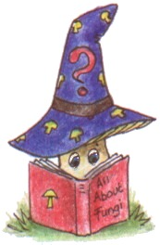

Both groups join in ‘Build a tree’

Build a tree (20 minutes)
N.B. © 1989 Cornell, Joseph. This activity was adapted from ‘Sharing Nature with Children 11’, pp 62-66 by Liz Holden with permission. For more information, see the Sharing Nature Foundation’s website at www.sharingnature.com.

Purpose of activity: to demonstrate how a tree works and where the exchanger fungus fits in.
Props: Spotty umbrella/s (optional but effective) – maybe use the balloons again. See Appendix 2 Fig. 3 for an illustration.

This can work for quite a large group but attention must be paid to how many people need to be allocated for each part of the tree and fungus. Introduce the activity by recapping how trees and fungi work together exchanging food stuffs (sugars and mineral salts) for the advantage of both, then set about building the tree:
Heartwood 1/2 people - The heartwood player/s need to stand in the middle of the activity space. The heartwood holds the trunk and branches upright so that the leaves can get their share of the sunlight. It is very strong but has been around a long time, is completely dead…but well preserved.
Taproot 1/2 people - The taproot player/s need to sit at the base of the heartwood facing outwards, drawing their knees up to their tummies. The taproots can go down as much as 10 metres and act as an anchor for the tree and also bring up water from deep in the earth (N.B. not all trees have tap roots).
Lateral roots 2+ people - The lateral root players should lie down on the ground with their feet towards the heartwood and spread out their arms and fingers. A real tree has hundreds of lateral roots that spread out through the soil. Each lateral root tip has tiny root hairs that grow into every centimetre of soil around the tree. When they sense water the cells at the tips grow towards it and draw water up for the tree to use. The tap and lateral roots should practice slurping (noisily!!) to the instruction from the leader ‘Let’s slurp’. N.B. especially if you are working with adults, check beforehand if people mind lying down on the floor. Sapwood 3+ - the sapwood players need to form a circle around the heartwood, facing inwards and holding hands - don’t tread on any of the roots! The sapwood (or xylem) draws the water up from the roots into the highest parts of the tree. On the leader’s instruction ‘Bring the water up’ the sapwood throw their arms up and shout ‘Wheeee!’
Cambium/phloem enough people to form a circle facing inwards outside the sapwood. The phloem has to distribute the food that is manufactured by the leaves to the rest of the tree. The phloem’s hands become leaves, so leader says ‘Let’s make food’, phloem holds hands up and flutters ‘leaves’; leader says ‘Bring the food down’, phloem goes ‘Whooo’- a long descending sound and drops down towards the ground.
Run through the activities - ‘Let’s slurp’; ‘Bring the water up’; ‘Let’s make food’; ‘Bring the food down’
Bark enough people to make as complete a circle as possible outside the phloem, facing outwards and working together (without moving their feet) to protect the tree from….fires, insects or maybe the dreaded ‘Wood Cauliflower’ which will infect and kill trees that are old or weak.
Fungus 1+ people, lying on the ground, stretch out their arms and use their fingers as the tubes that will grow around the trees root hairs (the fingers of the lateral roots) and enable the exchange of nutrients to take place. Long hair can be used instead of fingers for the mycelium here if you are confident the hair will not get pulled!

The tree is complete now that the mineral salts it receives from its fungal partner will enable it to grow in the poorest soils. The fungus is also now receiving sugars from the tree - I think that it might hum and/or put up an umbrella (fruitbody) so that it can produce spores.

At this point the entire tree can run through its actions - probably without instructions - the leader could remind the bark to watch out for the terrible, root gobbling, fungal spore and indeed become the spore if so inclined! The whole group should be involved at this point and when finished give itself a round of applause!

Maybe suggest they would like to take this activity back to school and develop it as a drama exercise with the tree eventually becoming old and weak so that a parasite could come in and kill it. The recycler fungi and invertebrates etc could appear and gradually remove all the parts of the tree releasing all the nutrients that were locked up in the wood and leaves so that in the clearing that has been made by the fall of the great tree there is plenty of food stuff ready to help new tree seedlings start the cycle all over again (see Teacher’s Notes).

After Build a tree the group is again split into two subgroups. Group A goes into ‘Mushroom murder mystery’ and Group B goes to the indoor activites. The groups then swap over.

Mushroom murder mystery (25 minutes)
Purpose of activity: to investigate how fungi get their food in the woodland habitat.
Props: For eighteen players including nine trees, six mycorrhizal fungi, two saprotrophic fungus and one parasitic fungus (Wood Cauliflower).
See Appendix 2 Fig. 4 for an illustration.
- nine fungus bags
- nine tree bags
- nine cocktail umbrellas
- nine small spore dispersers (film canisters with holes in the cap), each containing a little plain flour or possibly salt
- six small tubs (film canisters?), each labelled ‘mineral salts’ and containing dried chickpeas or similar
- six small tubs (film canisters?), each labelled ‘sugars’ and containing dried rice or similar
- two recycling signs on card (laminated) - See Props and Images.
- dead leaves and twigs for recycler tree hosts
- one piece of dead wood with beetle holes or galleries
- eighteen tree leaf outlines on card (laminated), nine of which should have the tree name as well. The nine named leaves for the tree bags are, 1 x larch, 1 x beech, 1 x hazel, 1 x oak, 2 x Scots pine, 3 x birch. The nine un-named leaves are attached to the string of the nine fungus bags as follows, 1 x larch, 1 x beech, 1 x hazel, 1 x oak, 2 x Scots pine, 3 x birch
- nine photographs plus names (and a little bit of text) of fungal fruitbodies, one loose in each fungus bag, as follows: THE FOOD EXCHANGERS: Fly Agarics (birch), The Blusher (birch), Woolly Milk Cap (birch), Chanterelle (beech), The Gypsy (pine), Hedgehog fungus (pine) THE RECYCLERS Coral Spot fungus (hazel twigs), Wood Woolly Foot (Oak) THE PARASITE Wood Cauliflower (larch)
- leaders bag, big enough to include the following props:
- spotty umbrellas - number optional but two seemed reasonable to carry
- larger tub of spores (plain flour)
- crib notes if you need them.

fungus bags should each contain:
    - An un-named outline tree leaf, attached to the string of the bag.
    - A pot of ‘spores’.
    - A named photo of their fungus.
    - If mycorrhizal, a pot labelled ‘mineral salts’.
    - If saprotrophic, a recycling symbol.
    - A cocktail umbrella.

tree bags should contain:
    - A named outline tree leaf
    - mycorrhizal associates need a pot labelled ‘sugars’
    - saprotrophs need some dead leaves or twigs
    - If to be parasitised then a model beetle and/or a piece of dead wood with beetle holes or galleries in it

leader’s bag should contain:
    - Spotty umbrellas
    - Tub of spores
    - Prompt cards

General comments: OK, so you have got to like props to do this one!! For a smaller group, take out the appropriate numbers of birch/Scots pine tree bags and their matching, single leaf mycorrhizal species. Always think in pairs as the game is designed to work with each tree eventually having a matched fungus. For a larger group i.e. more than you have bags for either work each bag in pairs or use some folk as ‘bystander’ trees. If you like using prompt cards – see Props and Images. This is a reinforcing activity with a lot of information that can be highlighted according to what has already been talked about during the day.

N.B. The larch will die! You (secretly) need to make sure that you know who the larch is - it is more effective if this is the last tree to identify itself. Be careful that the larch and the pine fungi have matched their leaves correctly – otherwise the pine has to die half way through rather than the larch at the end! Whilst everybody enjoys the drama of a death in the wood, don’t forget that parasitic fungi are relatively rare, play an important role and should not come out of this activity as villains.

The activity (use of crib notes recommended see props and images)
Divide the group equally into trees and toadstools (there must be the same number of each).
Arrange the trees into a semi-circle, not out of easy hearing but far enough so that the toadstools have to move around to match their leaves.
Give out the bags, explaining briefly not to look inside just yet as the bags contain clues, which will be needed later to help solve the mystery.
Remind the group that toadstools can’t get their energy from the sun – give a brief review of the three methods they use. Mention, in this review, that one tree here will die!
Instruct the trees to find their leaves and keep them out. They don’t need to say what sort of tree they are yet.
Explain that fungi often start their lives as a spore. The spore germinates and a minute tube emerges. Life is never straightforward however, and the fungus cannot guarantee that its spore will land on a suitable food source. Many fungi can only live with a particular sort of tree or plant as the trees have complex chemical defences to protect them from fungi which will not release mineral salts to them in return for their sugars. Today all the fungi will find a suitable food source but each tree can only have one fungus.
Instruct the fungi to find their leaves (inside the bag but attached to the draw string) and dust the fungi with spore powder to set them off to find a tree with a leaf that matches their own!
When all matched up, explain when toadstools occur and what they are for. If conditions are suitable, some of you might fruit (give out umbrellas) and this is when we can identify you! The fungi can look at their photos now.
Go around the ‘wood’ and ask each pair in turn to identify themselves i.e. the tree gives its name, and then the fungus reads out its name and the information given on the card. If their relationship is mycorrhizal, now is the time to exchange tubs of mineral salts and sugars. If their relationship is saprotrophic, the tree should also produce its bag of leaves, then you explain the recycling card. As each pair is revealed they can assume that the fungus has produced a fruit body and is shedding spores (shake their own tubs of spores out). Note that most of the fungi in the wood are either exchanger (mycorrhizal) or recycler fungi and that very few are parasites.
The last combination to read out their cards should be the larch tree/Wood Cauliflower (make sure that you know who they are and leave them until last). The larch can die quietly standing up or noisily on the floor depending on how much overacting you can get! It must then search its bag for the wood/quivering beetle. Ask if anybody can explain the wood with the beetle holes and thus why the death of the tree is sad for the tree but important for the health of the woodland ecosystem?

Indoor activities (25 minutes)
The activities in this section can be as many and varied as your resources, space and imagination will allow. The following are suggestions that have worked well in the past:

- Display of wild fungi (try and include different textures, smells and shapes). Magnifiers are useful.
- Badge making kit if available, crayons for colouring in the templates (see Props and Images).
- Worksheets, pencils, crayons. Simple worksheets are available in the Teacher’s Notes (Appendices 12 – 15) and in several of the references listed. Colouring an outline toadstool and naming the parts is simple and effective.
- Display of fungal items, see the A4 sheet produced by the British Mycological Society ‘Supermarket Challenge’ for lots of ideas e.g. yeast – bread/beer kit, Mycota powder for athlete’s foot, Penicillin medicine box, mushroom soup, Quorn , Soya sauce, Marmite, fizzy drinks, spalted wood, lichen etc. etc
- ‘Spot the odd one out’. Limit your examples to processed products that require fungi to enable the product (e.g. chocolate, wine, fizzy drinks, coffee, bread, cheese, soy sauce) and use yoghurt as the odd one out – it relies on bacteria to process the milk. Almost all raw materials rely on fungi somewhere e.g. fungi live in cow’s stomachs and are an essential part of the yoghurt’s main ingredient, milk!
- Food Chain cards – see Props and Images. Sorting out the food chains could lead into a discussion of how fungi are important for insects and other creatures in the forest. Two sets of cards have been made up in Props and Images (laminating will prolong their use) for groups to put in order and then explain:
  - Dead tree – wood decomposer fungus – insect larvae – small bird – bigger bird
  - Living tree – food exchanger fungus – mouse – fox
Using a big yellow sun as a back drop enables the groups to work out how each chain links back into the sun.

Toadstools and trees (10 minutes)
Purpose of activity: to reinforce many of the ideas that have been encountered during the day. A fun way for the whole group to finish the day.

Props: questions.
General comment: there was often not enough time to include this activity.
Get the group into a circle - ‘sticky elbows’ is a useful technique for groups that find ‘round’ a difficult concept! Go around the circle and give alternate names ‘toadstool’, ‘tree’ and so on around the circle. Check that everybody knows which he or she is! Explain that you will be making a series of statements that are either true or false. If the statement is true, the trees will run around the back of the circle and back to their place running to the right. If the statement is false then the toadstools will run around the back of the circle to their place running to the left. After each statement has been acted upon, take the opportunity to elaborate a bit on your statement. Carefully chosen statements can make this a good conclusion to the day’s activities.

Sample statements
These are just for starters (see also Props and Images), your own ideas will be just as good and better. Sometimes the ‘players’ can also be asked to contribute their own statements to the activity. Questions should relate to what has been discussed/seen during the day.
T = true : F = false

F Fungi are plants
F Fungi are animals
T Fungi are placed in their own kingdom
F All fungi are poisonous
F All fungi are slimy
T One small nibble of a Death Cap could kill you
F Poisonous fungi should be destroyed
F All fungi are bad news for the trees in a wood
T 90% of the higher plants live in association with a fungus
T Spores have the same function as the seeds of plants
T The flesh of some fungi turns bright blue when exposed to the air by cutting
T The spots on a Fly Agaric are left by the veil which protected the young toadstool
F Fungi that attack living trees are bad for the forest
T The ‘Ice Man’ carried a powdered fungus in his pouch to use as a fire lighter
T Toadstools are important places for insect larvae to hide in and feed from
F Fairy rings are caused by fire breathing dragons running around in circles
T Some fungi have antiseptic qualities and they can help to stop bleeding
T Highlanders used to pack their shields with the dried flesh of the Birch Polypore
F All fungi smell rotten
F The spores from puffballs can make you go blind (Folklore belief)
T Fungi are really important in the natural world
T Fungi are really important and useful to human beings

Special thanks to
Aberdeen City Council

Aberdeen Environmental Education Centre
Aberdeenshire Council Health and Safety Unit
Aberdeenshire Ranger Service

British Mycological Society
Buchan Countryside Group
Moray Council

Illustrations by Kath Hamper
Text by Liz Holden

