What’s your Favourite Fungus?
Card Game
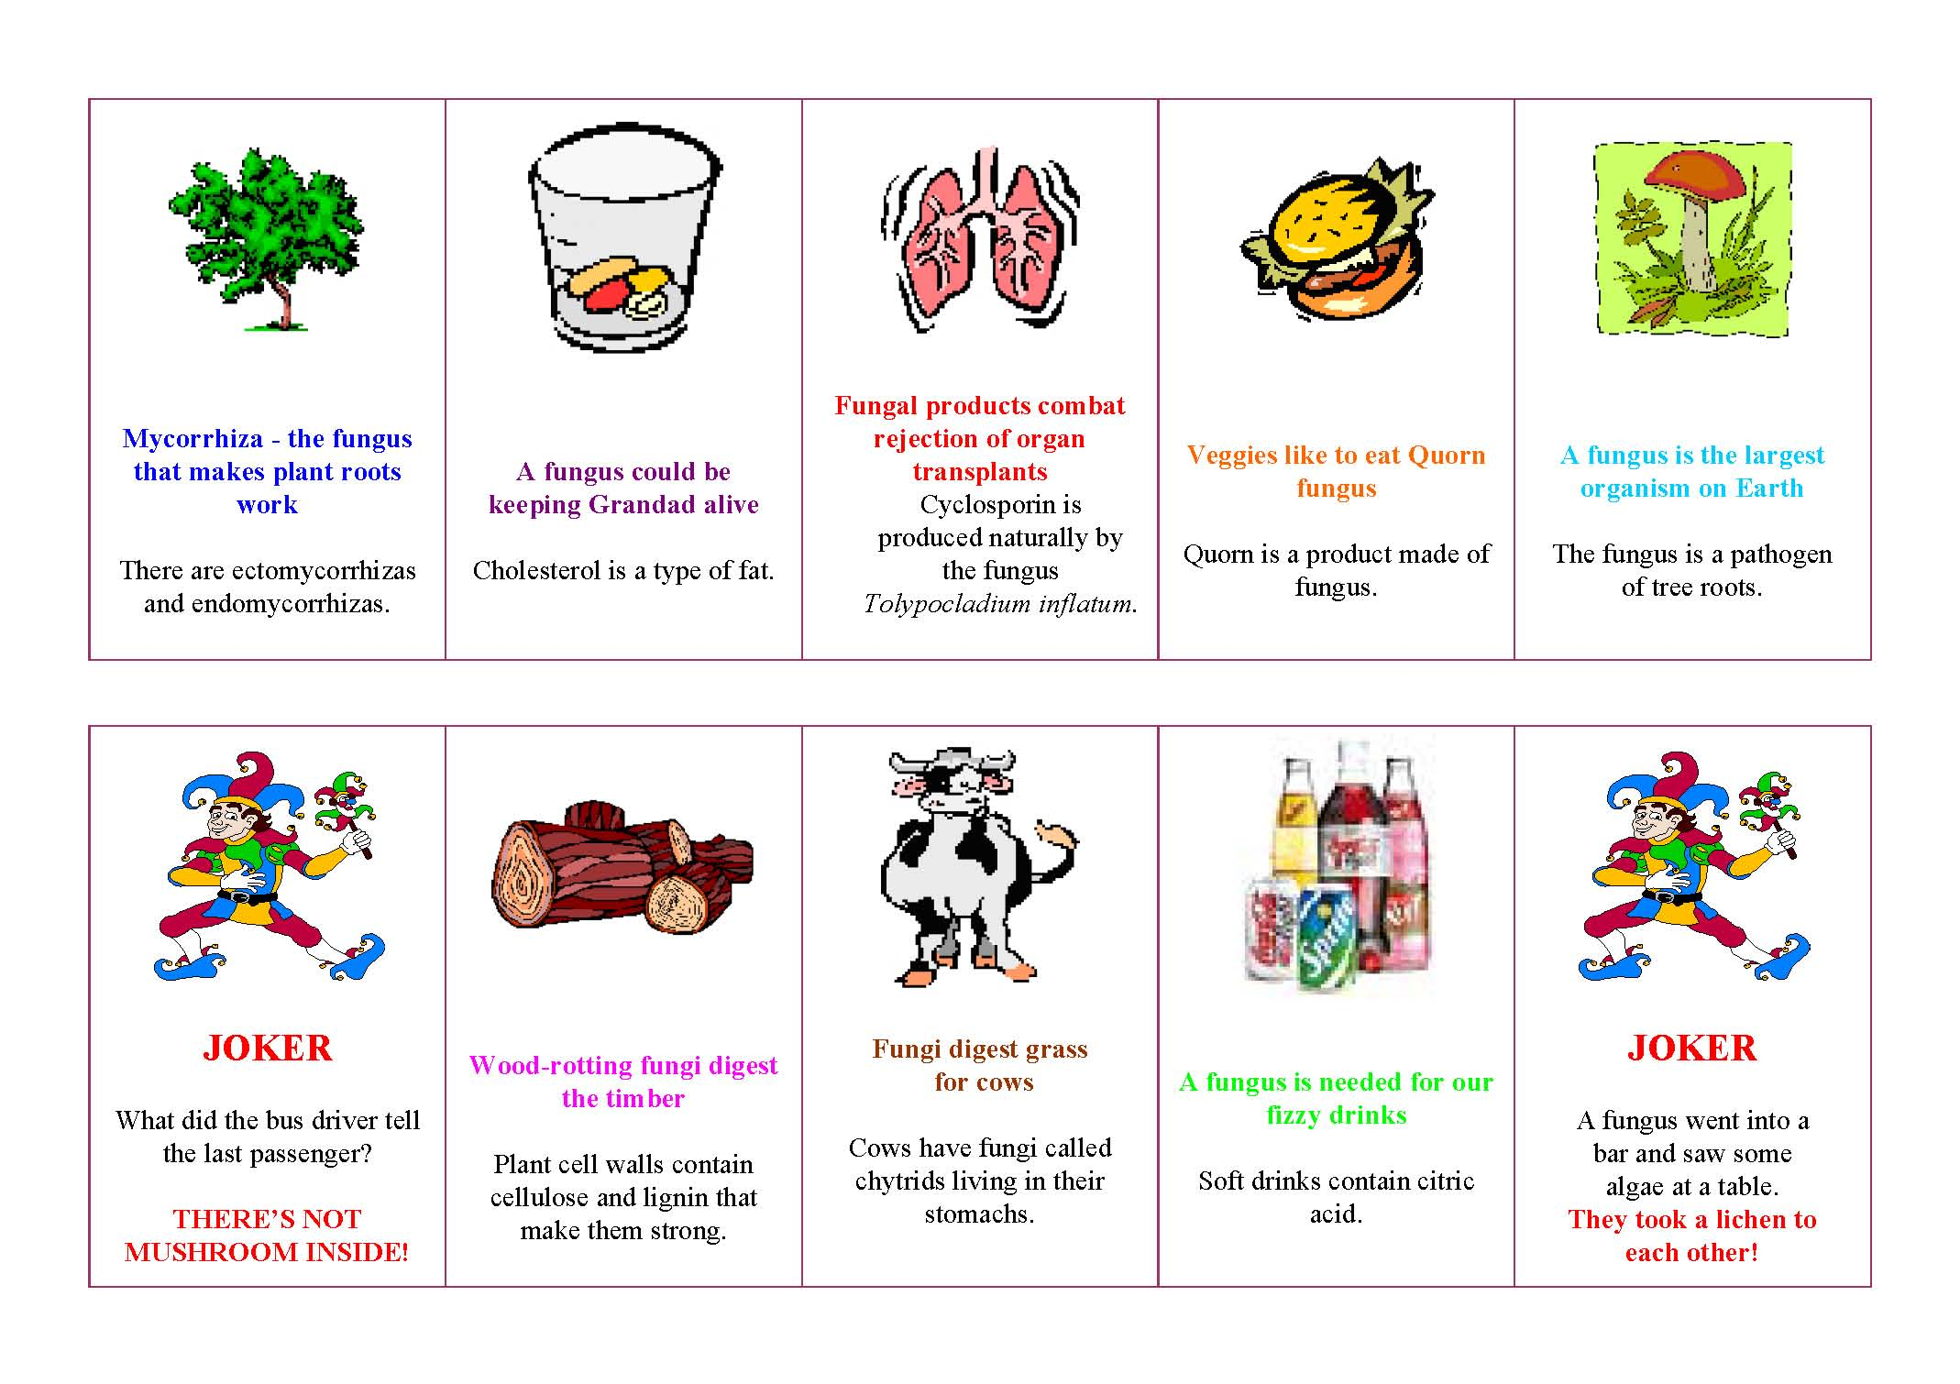
There are 8 suits of cards.
Each suit tells one fungus story
Each card gives one of 6 different facts about the fungus story concerned.
There are also a couple of jokers!
So now you know enough to play the Favourite Fungus card game.
The cards are shuffled and 5 dealt to each of 4/5 players. Surplus cards placed in the centre, face down. Object of the game is to collect five facts relating to one story (that is, one cartoon logo).
Player to left of dealer starts by taking top card from the central deck, decides whether to keep or discard, and then discards one card, FACE UP, to start a discard pile alongside the main deck.
Players after that choose in turn whether to take top card from discard pile or undisclosed card from main deck, and again maintain their own hand of cards at 5 cards by discarding the picked-up card or another card from his/her hand.
As soon as a player has collected all five cards in a story (which may include one of the jokers), he or she WINS by declaring “My Favourite Fungus! ” and putting their cards on the table for all to see.

