Reproduction and Conservation

Rewind . . . . . . . . .

During last lesson we discussed how and where fungi grow. Let’s go one step further on and focus on how fungi reproduce.

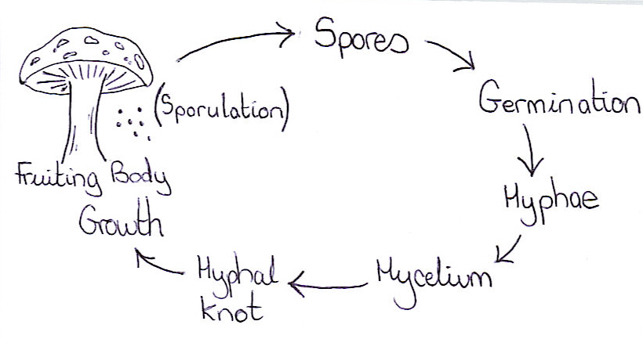

As this simplified diagram shows, the fruiting body produces spores (process called sporulation); these then germinate after they arrive in their ideal environment (which might be soil, or a leaf surface, or some rotting leaves, etc.) and begin to produce hyphae and then the mycelial network. Further growth produces the hyphal knot and eventually the fruiting body. Spores are released and the whole process starts all over again.

Do you remember that plant reproduction can be sexual or asexual? Well, it’s just the same for fungi too.

► Most fungi reproduce both sexually and asexually
► Some reproduce only sexually
► And the rest reproduce only asexually


Recap . . . . . . . . .

Sexual Reproduction: | Involves the mixing and recombination of genetic material from two parents of opposite sexes.  Produces genetically different offspring.  Process includes : cell fusion, nuclear fusion, recombination, meiosis and mitosis.

Asexual Reproduction: | Involves copies of only a single parent being made.  Produces genetically identical offspring.  Process includes : NO cell fusion, NO nuclear fusion, and ONLY mitosis.

Cell cycles in Summary:
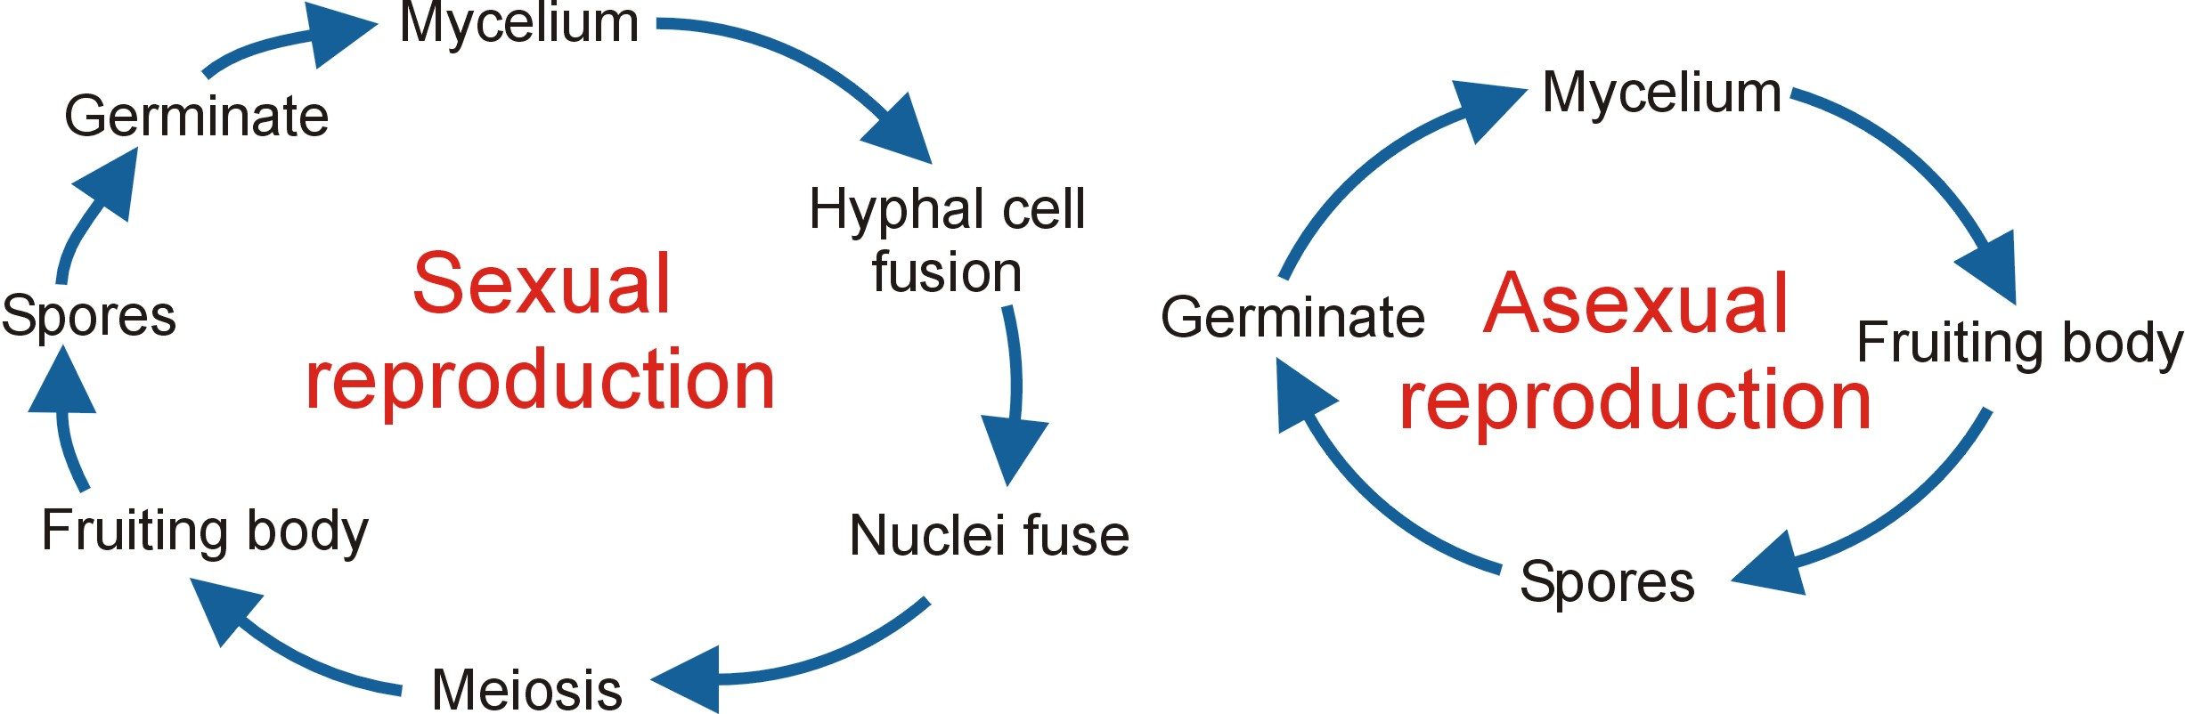

Where are Spores Produced?

Answer: from the hymenium ► | The tissue layer of the fruiting body that contains spore-making cells.

Let’s look at the mushroom as an example...........

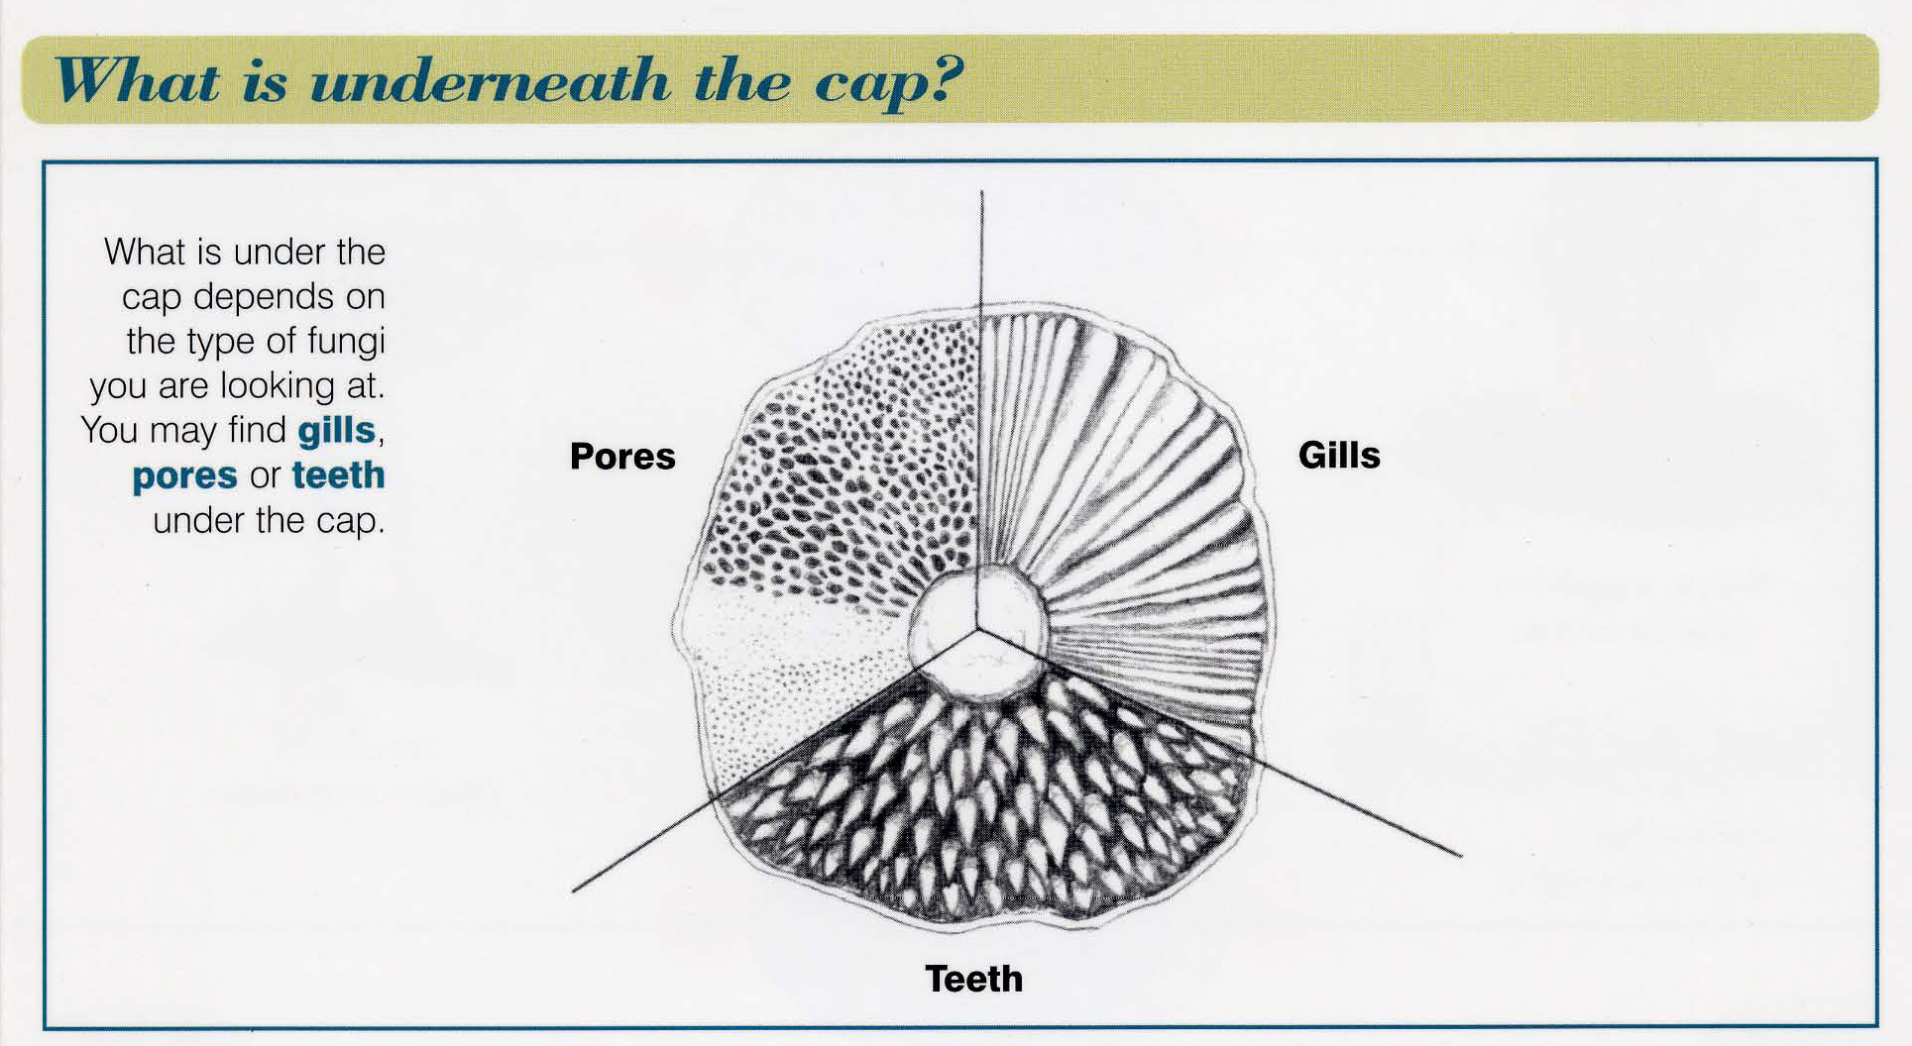
From The Fungi Name Trail by Liz Holden & Kath Hamper

These three structures (named in the picture above) are all covered with the hymenium tissue layer that contains and releases spores.

What about other fungal structures?

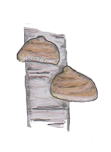 |  | 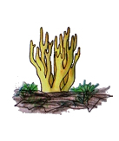
From The Fungi Name Trail |  | From The Fungi Name Trail
Birch Polypore  Piptoporus betulinus |  | Yellow Stagshorn  Calocera viscosa
This bracket fungus releases spores from pores underneath its cap |  | While this coral fungus can release spores from pores all over its body

How are Spores Dispersed?

To ensure survival of the species, a fungus must produce and release spores as quickly as possible. These spores must be dispersed over large areas to avoid competition. There are many ways in which dispersal can occur:

► Wind
► Rain
► Insects
► Mechanical Processes

Wind ► Amanita muscaria is an example of the type of mushroom that releases spores from gills (vertical plates of tissue underneath the cap). The spores fall from the gills under the cap and are then carried away by air currents. They can be spread over large distances by the wind.

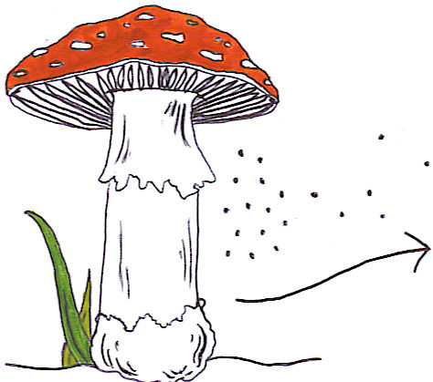
© Charlotte Quinn 2005

Rain ► The cup fungus Crucibulum vulgare or Bird’s Nest Fungus has its spores dispersed by rain fall. Raindrops fall into the fungus fruit body and the rain splash forces the spores out and away from the fruit body.
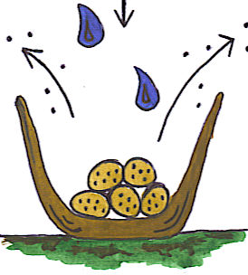
© Charlotte Quinn 2005

Insects ► The spores of the Stinkhorn fungus, Phallus impudicus, are formed in a slimy secretion on the bell-shaped tip of the fruiting body. The fungus generates a foul smell – like rotting meat. Flies are attracted to the strong smell and the spores are transferred onto their legs and body and deposited where the fly next lands.

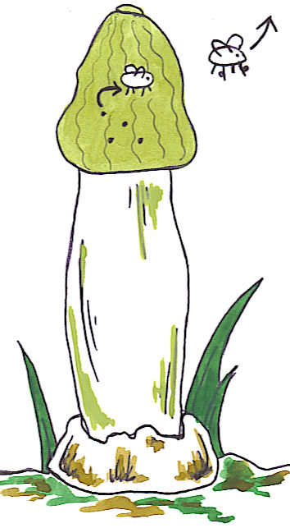
© Charlotte Quinn 2005

Mechanical Processes ► When the ball shaped fruit body of a puffball or earth star (like Geastrum) is disturbed (by an animal or by twigs, leaves or rain drops falling on it) the impact increases the air pressure inside and millions of spores are forced out on a jet of air that emerges through the pore on top.

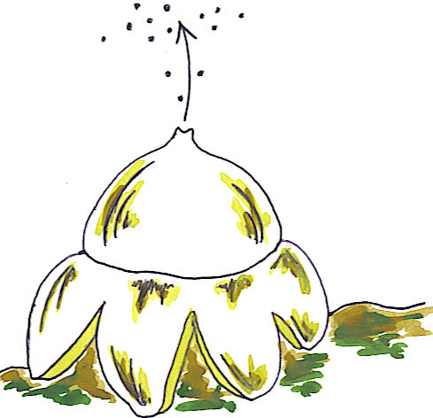
© Charlotte Quinn 2005

Conservation and Management

All fungal species are extremely important for the maintenance of our planet. We have already discussed the role of fungi as decomposers - removing dead organic matter by breaking it down using enzymes.

►Question for class discussion : What would happen if fungi didn’t exist?

You know quite a bit about what fungi do in nature, so think about it and imagine: what would happen if all fungi were killed off tomorrow?

Food webs show the many different types of plants, fungi and animals of a particular ecosystem. From them, we can understand the feeding patterns and energy flow within this system.

Use this box to draw an example of a food web (including fungi):

The Decline of Kingdom Fungi?

Reports from all over Europe suggest that in recent years there have been serious declines in the numbers of mushrooms and other fungi found in the forests. The question is: WHY?

There are several reasons; including:

► Increased large-scale picking of wild mushrooms for commercial sale
► Pollution is a major factor because of: | - Air pollution  - Acid rain  - Water contamination from fertilizer ‘run-off’  - Desertification (e.g. around the Mediterranean Sea)
► Clearing of woodland areas
► Lack of understanding of the roles of fungi in nature

Save your fungi!

The problems have been identified, so let’s focus on the solutions:

► Obey the law: | - The Theft Act (1968)  - The Wildlife and Countryside Act 1981)  both protect wildlife to some extent, and other legislation may apply to prevent picking
► Respect and caution: | Respect the natural habitat – avoid unnecessary damage and disturbance
► Conservation areas: | Some countries have vast areas protected by conservation controls
► Management: | Government guidelines for fertilizer usage in agriculture. On a larger scale, the Kyoto Agreement – carbon emission control

To save your fungi you might have to save the forest!

