CELLS

Cells are tiny building blocks that make up all living things. Cells are so small that you need a microscope to see them.

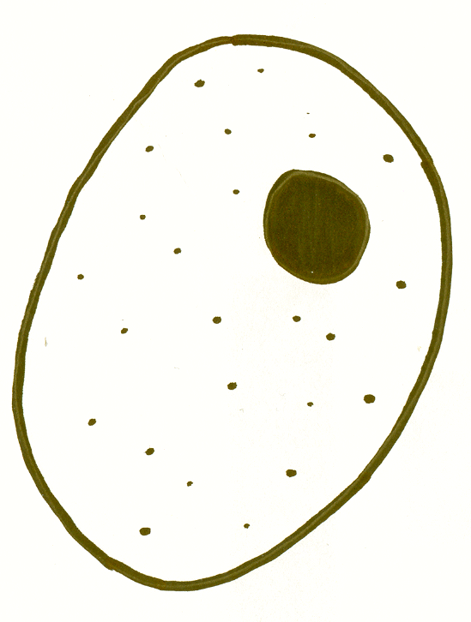  ANIMAL CELL | Nucleus  This is the control centre of the cell. It contains chromosomes with DNA instructions for all the cell’s activities, including instructions to make new cells.  Cytoplasm  This is a jelly like substance, in which many of the cell’s activities, e.g. respiration and protein synthesis occur.  Cell membrane  This is a thin skin around the cell. It is selectivelt permeable, controlling what goes in and out of the cell.
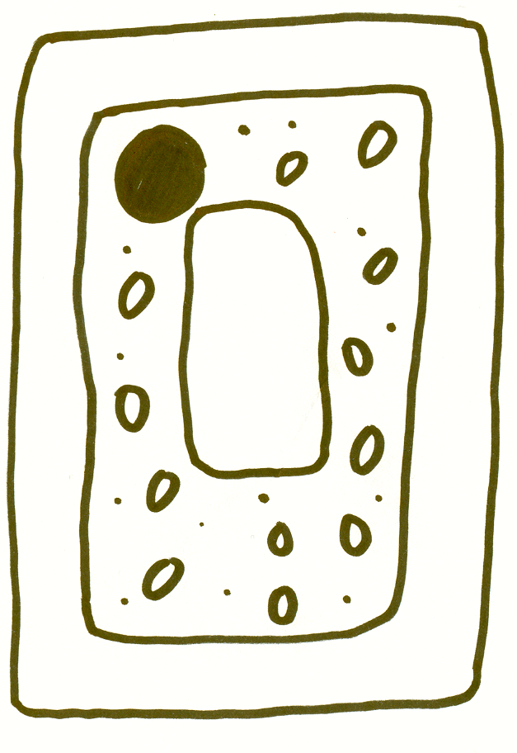  PLANT CELL  Nucleus | Chloroplasts  These are green discs, which allow the plant to make food by photosynthesis. They contain a chemical called chlorophyll.  Vacuole  This is a large storage area filled with a liquid called “cell sap”. The plant cell can store food and waste products here.  Cell wall  This covers the cell membrane. It is permeable, supports the cell and is made from a substance called cellulose.

Fungal cells
Fungal cells are the compartments along the length of the filamentous hypha, which are separated-off by the septa (cross-walls).

Hyphal Tip – this is the characteristic growing point of the fungal hypha (in the circle below). It secretes enzymes into its surroundings and then absorbs nutrients those enzymes release.
Fungi have cells, too
Living things are generally classified into five Kingdoms. Plants, animals and fungi are the three Kingdoms of ‘higher organisms’ and the other two Kingdoms are the Prokaryota (bacteria) and Protoctista (algae and protozoa). Many people confuse fungi with plants but there are several key differences between the two cell types.
How are they different from plants?
One of the main ways in which they differ is in their mode of nutrition. Plants are primary producers. They are able to make their own food in a process called photosynthesis which utilises sunlight and a chemical present in plant cells called chlorophyll to turn light energy into chemical energy.
Fungi, like animals, are heterotrophs. They cannot produce their own food as their cells do not contain chlorophyll. But, unlike animals, they do not ingest their food, instead they grow on their food source and secrete enzymes into it to digest it. They then absorb the digested food into the cell.
What are fungi?
It is estimated that there are about 1.5 million species of fungi. They exist in many different forms including; puffballs, moulds, yeasts, rusts, mildews and your everyday mushroom! Some fungi exist as single-celled organisms, like yeast, whereas most exist as multi-cellular organisms, e.g. mushrooms. Multi-cellular fungi have a body structure which allows maximum absorption of nutrients from the food source. Underneath the fruit body of the fungus exists a large network of tiny filaments called hyphae.
Fungal hyphae form a large interwoven mass called a mycelium, the structure of which maximizes the surface area to volume ratio of the fungus ensuring maximum absorption. Most energy obtained from nutrients is used to grow the hyphal tips into new substrates to absorb more food.

How do fungi affect us?
Our every day life is affected by fungi. They have a large impact on our environment as they act as decomposers (of dead tree branches and all the leaves that fall in autumn, for example), playing an essential role in both the carbon and nitrogen cycles. Some fungi live in mutual associations with other species, where both species benefit from the presence of the other. An example is that the roots of most plants contain a fungus that supplies the plant with minerals and water. Forest trees could not survive without them.
Many fungi have great medical value. They produce statins - used to lower blood cholesterol level, and antibiotics - used to treat infection. The first antibiotic discovered was penicillin and this is produced from a mould fungus (similar to the green mould that grows on rotting oranges).
Other uses of fungi are:
• producing the citric acid for fizzy drinks
• flavouring cheeses like Stilton and Danish Blue
• the yeast for brewing alcohol and making bread
• truffles dug from the ground used to flavour food
Other fungal species are parasites causing disease in both animals and plants. Diseases such as ringworm and athletes foot affect humans, and other fungi cause large damage to agricultural crops such as cereals and fruit, in fact, 10-50% of the world’s fruit harvest is lost each year to fungal attack.



