A Teacher’s Guide to

What’s Your Favourite Fungus?

The British Mycological Society’s
integrated collection of materials for the classroom

This resource package originated as an event for KS4 pupils in year 8 to year 11 during National Science Week 2005, with the content focused on fungi. It can be used in this form for Science Fairs and similar special events, and its components can be used separately in various ways for curriculum enhancement.

The core of the package is a series of class sheets telling 15 different stories about fungal biology that provide the basis for the ‘What’s your favourite fungus?’ theme of the activities. We suggest that pupils investigate the stories and extract important points from them. In addition the pack contains:
- a PowerPoint presentation giving a general overview of fungi;
- a ‘name-game’ starter exercise;
- templates for producing a pack of playing cards are also included. The playing cards mirror the class sheets and can be used to play a variety of games - and all the time the players are holding cards that each carry a different ‘fungal fact’.

‘What’s your Favourite Fungus?’ stories
This activity aims to concentrate on a wide range of fungi and their uses. The basic concept is to provide enough information for pupils to consider (including discuss and debate) which their ‘favourite’ is. The stories are short (one page) and very varied, dealing with an enormous range of fungal topics (FF01 to FF15 listed in the index table below).

They include examples where fungi are used by animals, plants and humans, their role as degraders, largest organism on earth, pharmaceuticals from fungi, their value as a food source, and in producing other foods. The theme ‘What’s your Favourite Fungus?’ aims to make pupils think about each story to see the varying importance of fungi to different people and organisms. Along the way they might see the relevance of fungi to their own daily lives.

An effective way of using the stories is to divide the class into groups of 4/5 pupils and give each group a different story and then allow 15 minutes for each group to write down six main points from their story. A spokesperson from each group can then report their group’s findings to the rest of the class.

There are enough stories in the set to allow you to extend this phase, even for a large class. Similarly, there are enough for you to choose to deal with the story topics at random, or to theme them in different sessions (e.g. health topics, environmental topics, biotechnology, etc.).

Favourite Fungus

Annotated index to story sheets
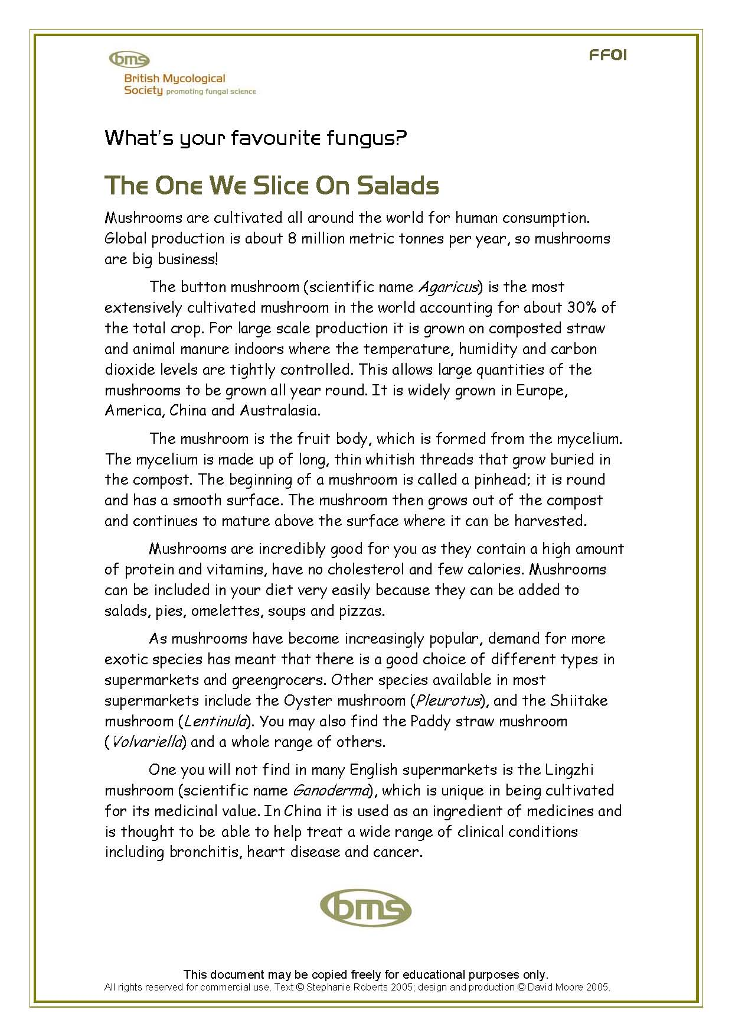 | 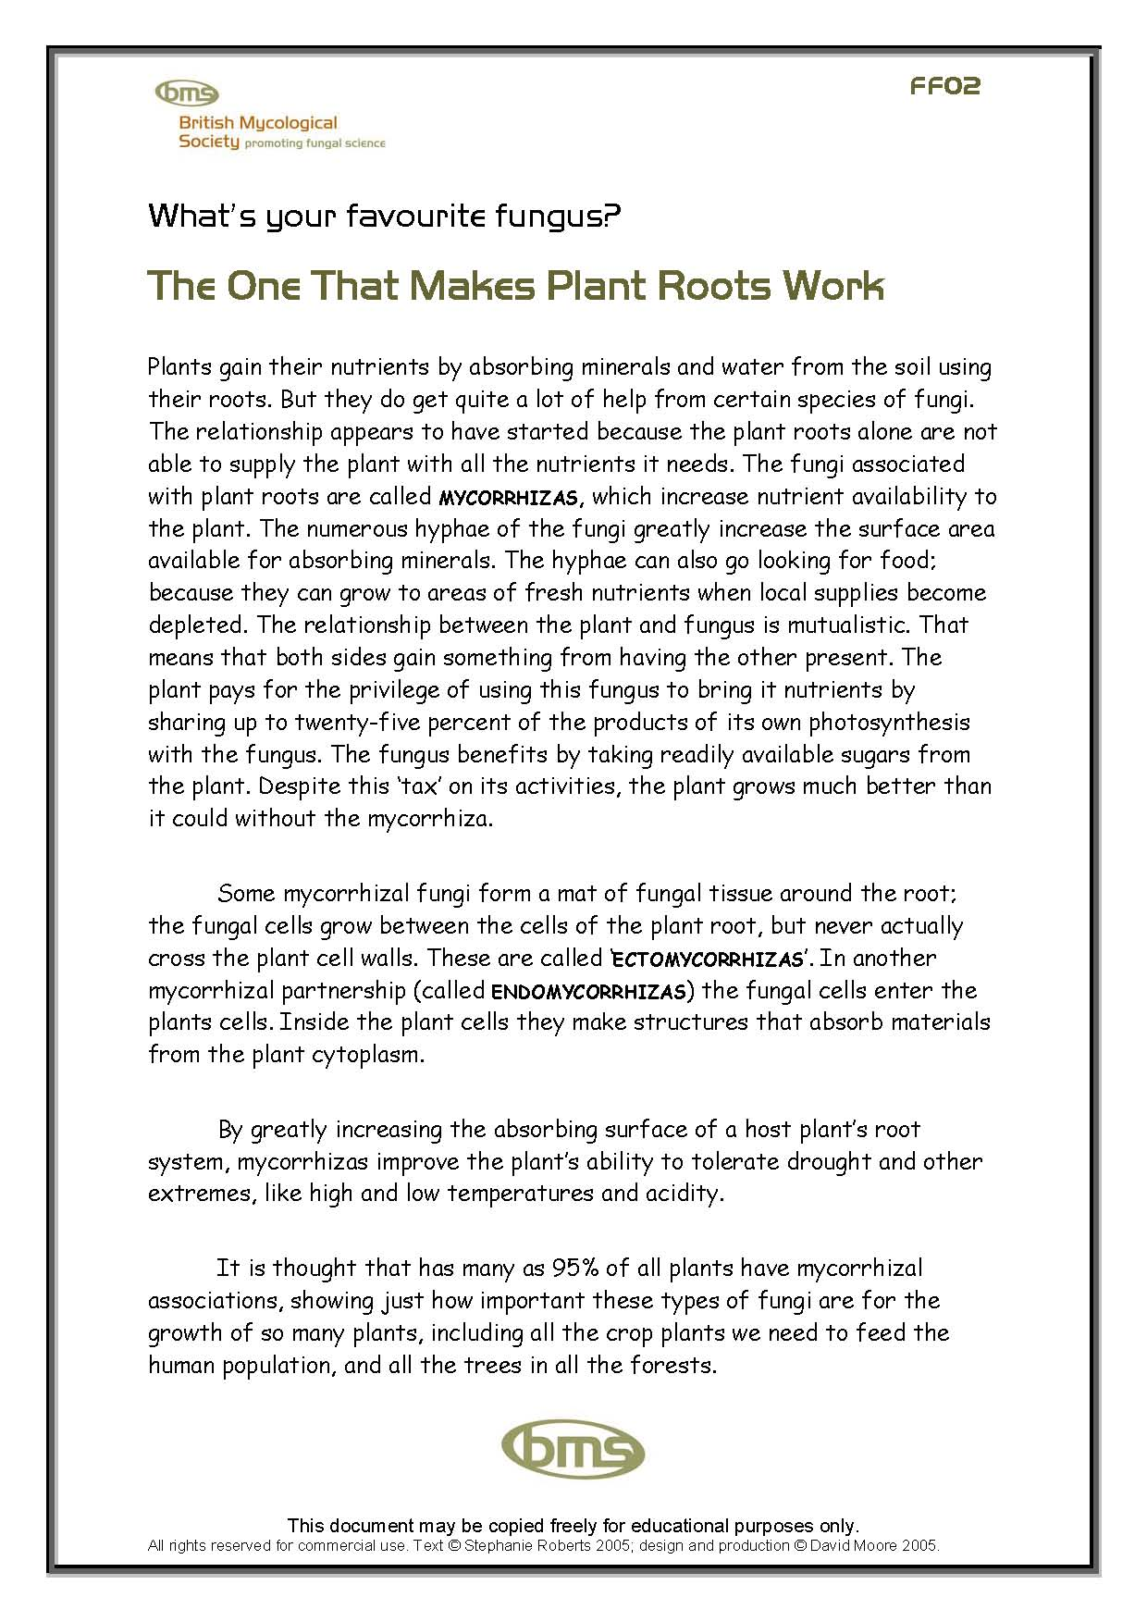 | 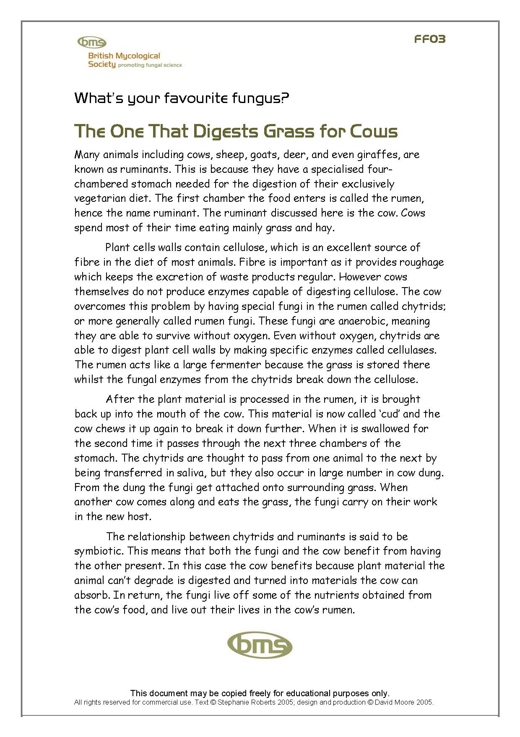
FF01: The one we slice on salads (about cultivated mushrooms) | FF02: The one that makes plant roots work (about mycorrhizas) | FF03: The one that digests grass for cows (about herbivore-chytrid symbiosis)
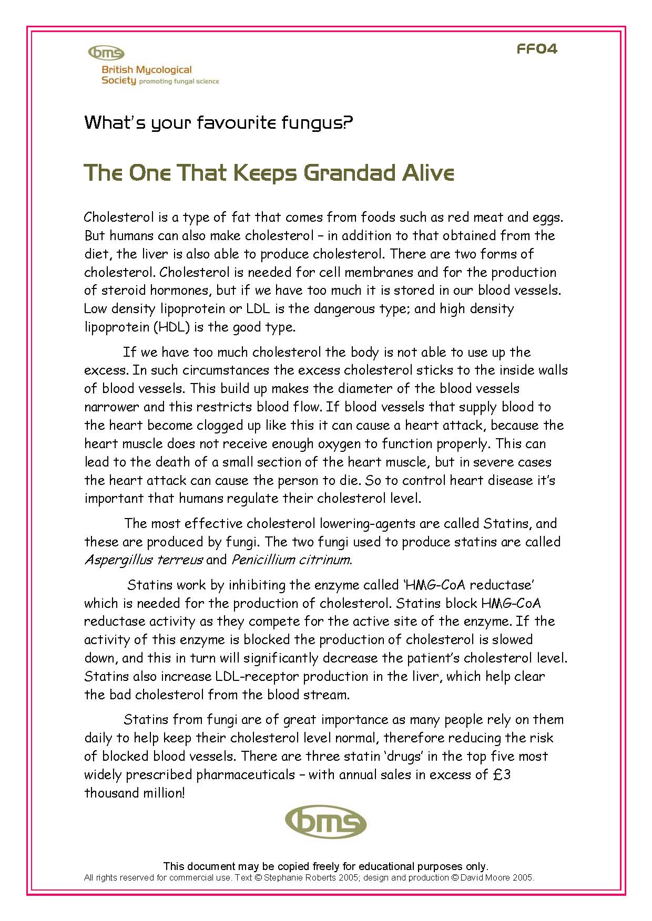 | 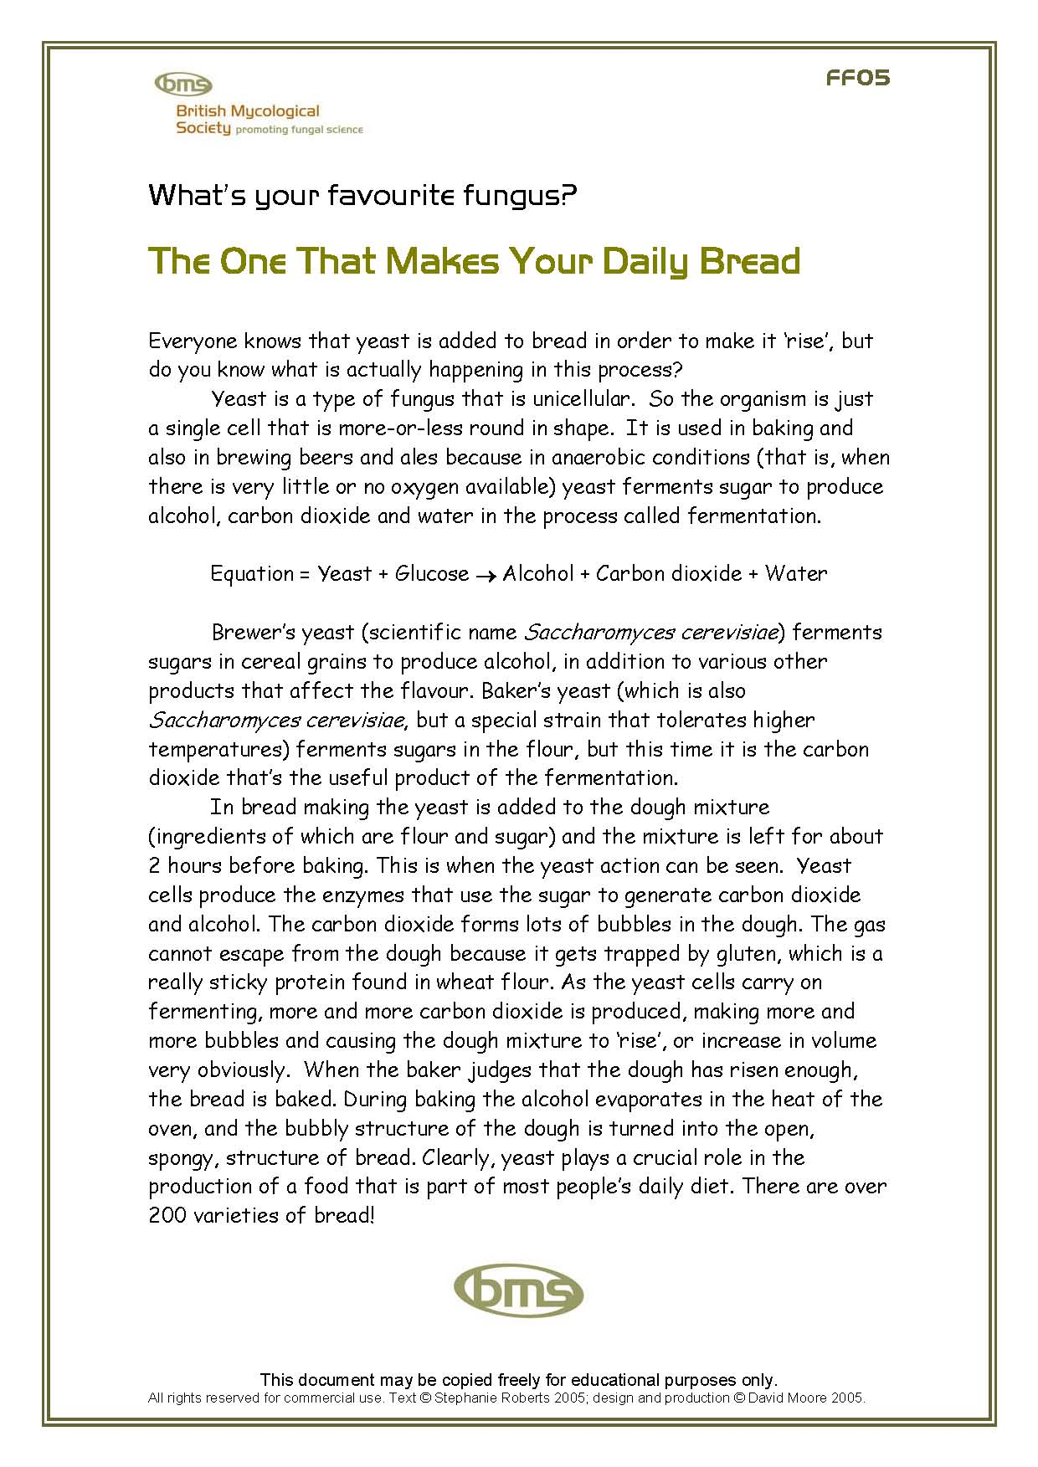 | 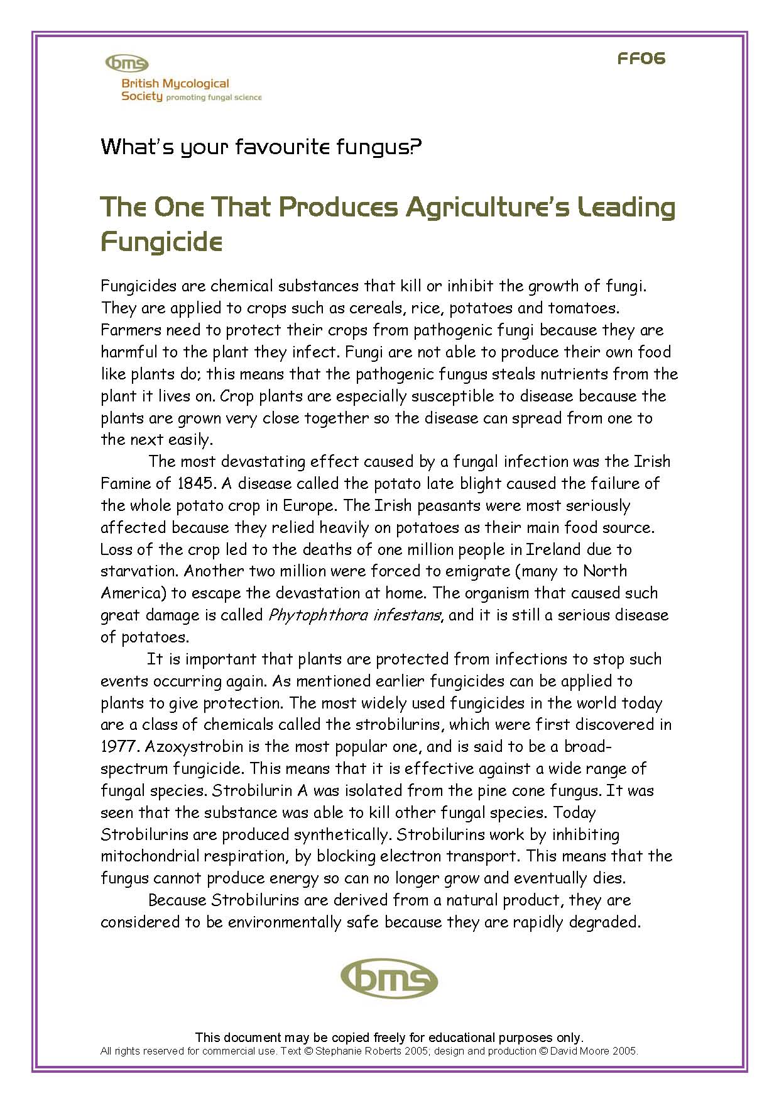
FF04: The one that keeps grandad alive (about statins) | FF05: The one that makes your daily bread (about baking industry) | FF06: The one that produces agriculture’s leading fungicide (about strobilurins)
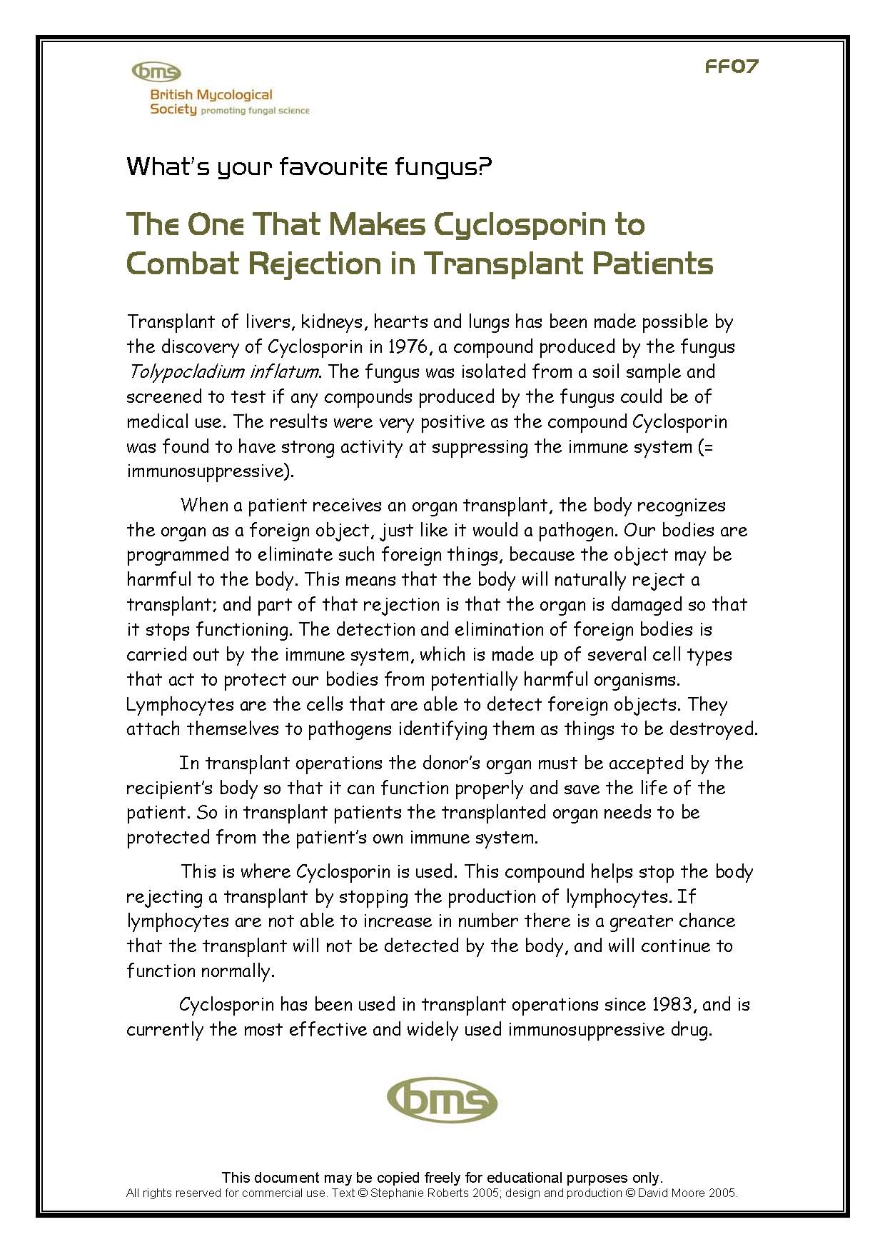 | 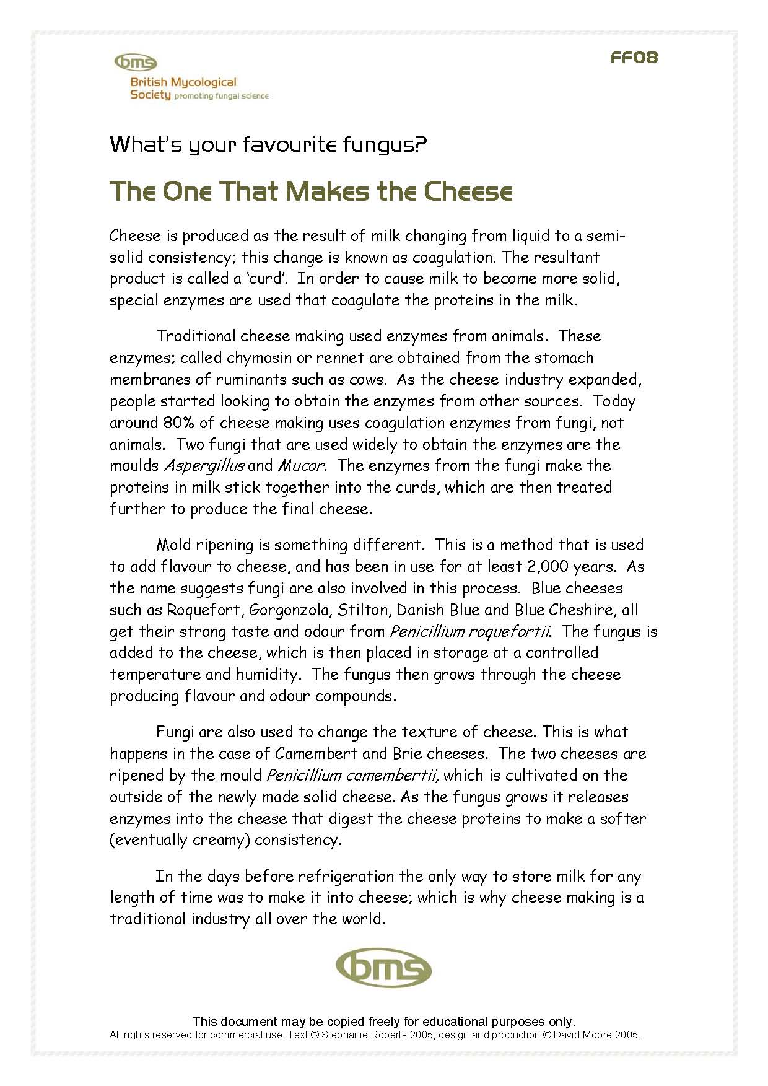 | 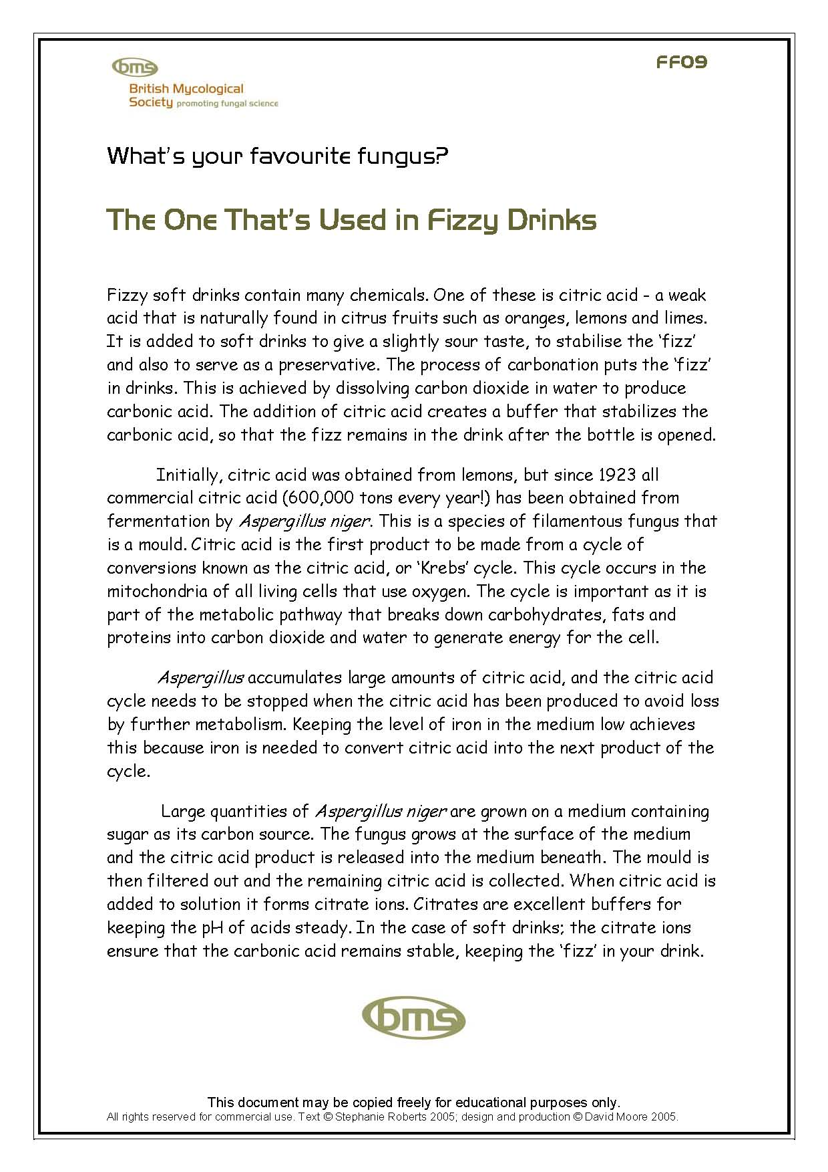
FF07: The one that makes cyclosporin to combat rejection in transplant patients | FF08: The one that makes the cheese (about cheese making & finishing) | FF09: The one that’s used in fizzy drinks (about citric acid industry)

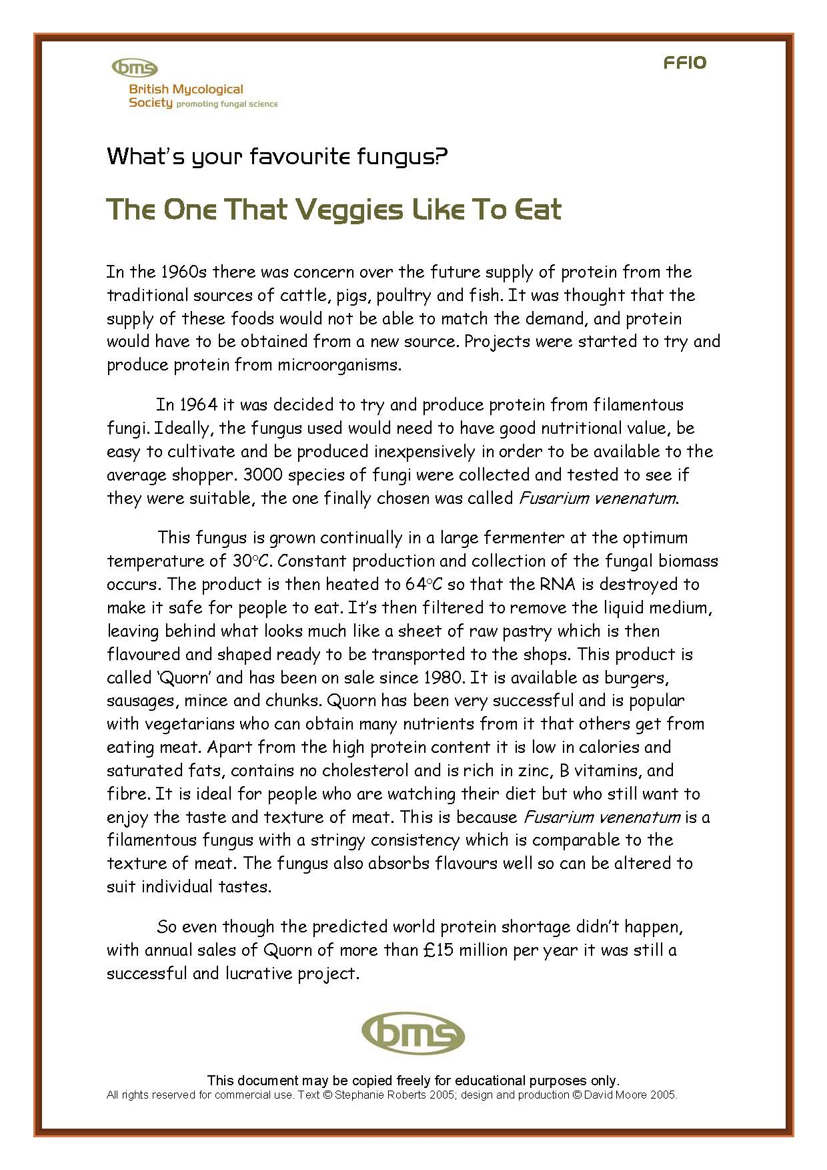 | 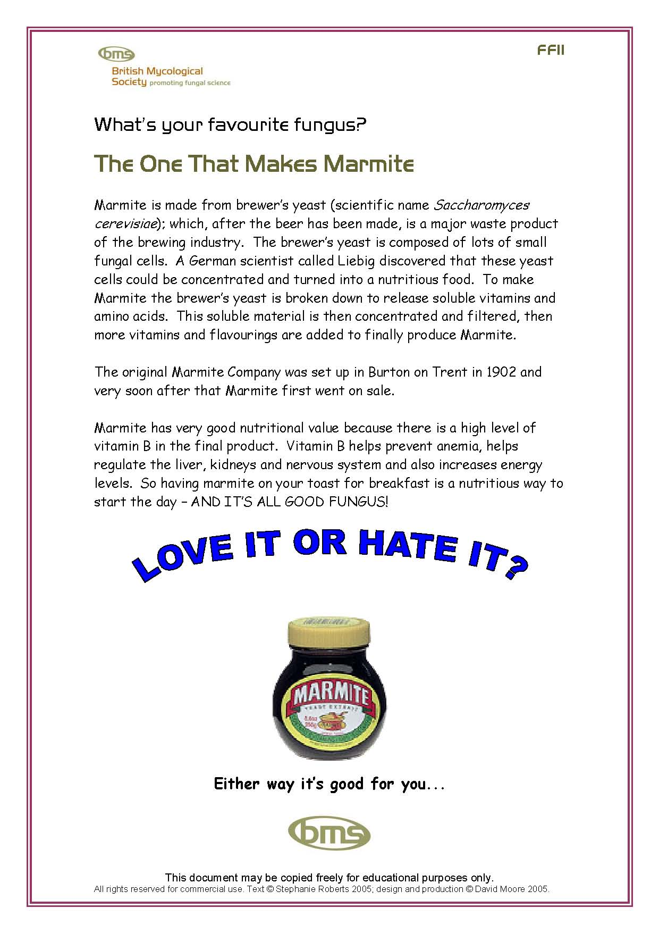 | 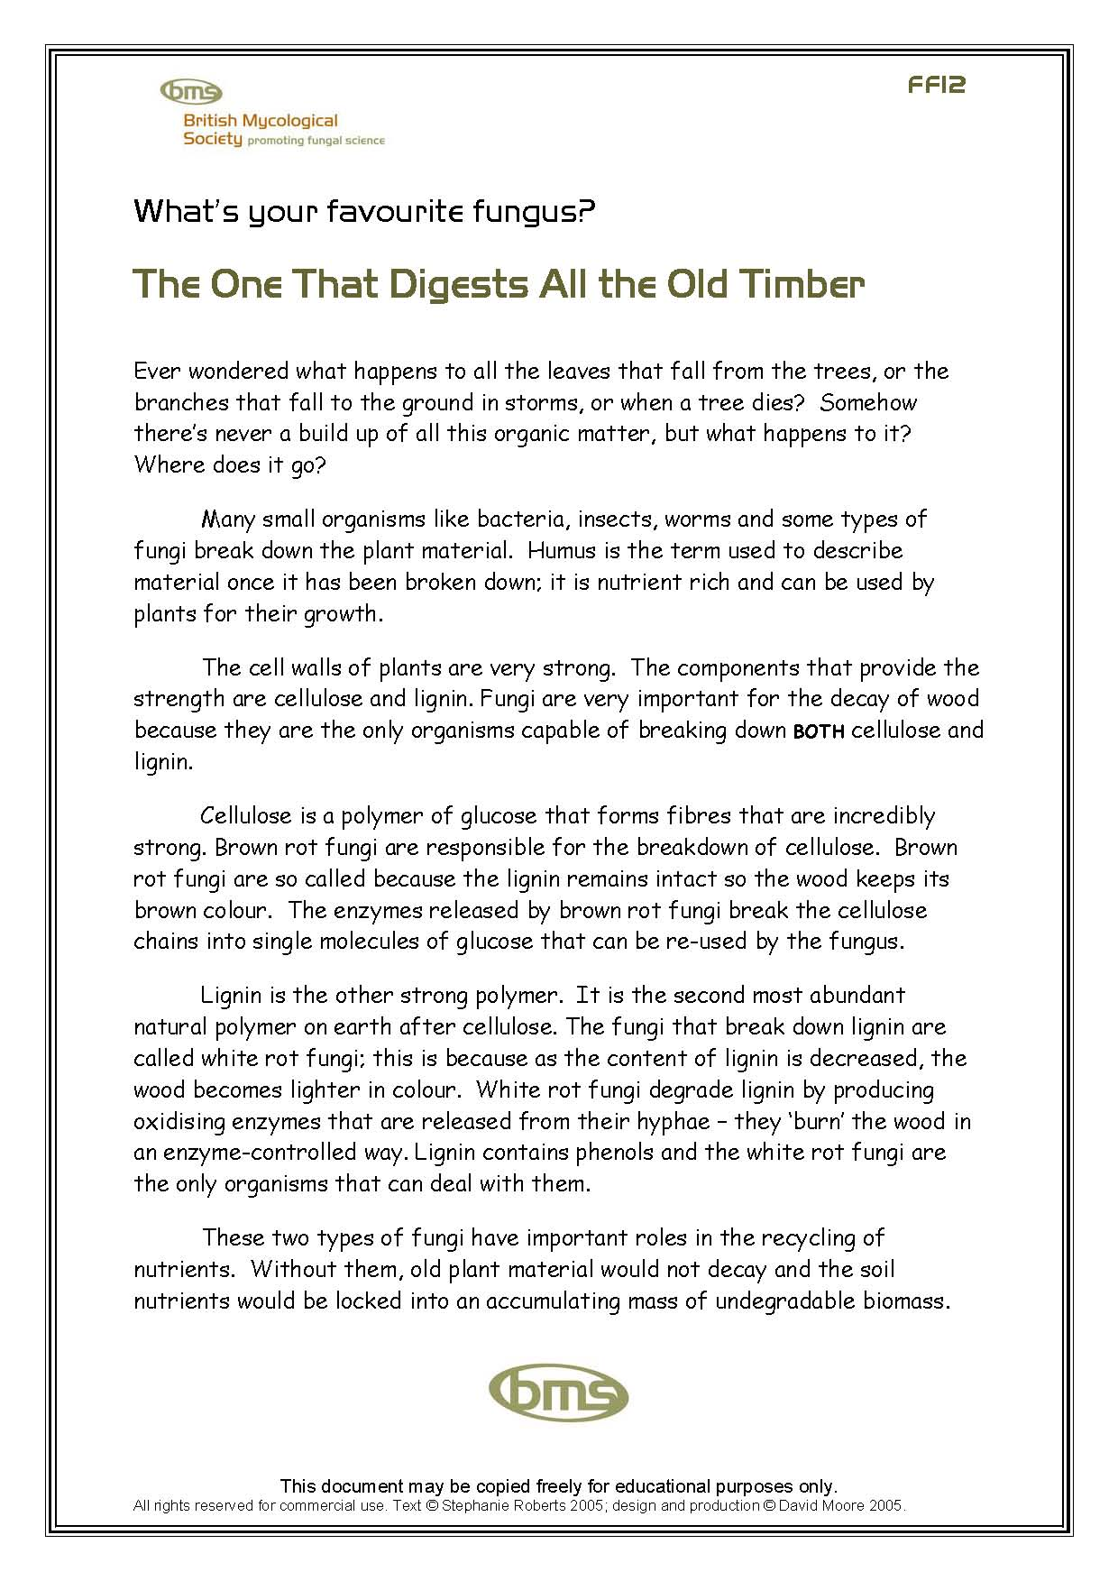
FF10: The one the veggies like to eat (about the Quorn fungus) | FF11: The one that makes Marmite (about yeast extract) | FF12: The one that digests all the old timber (about lignin & cellulose breakdown)
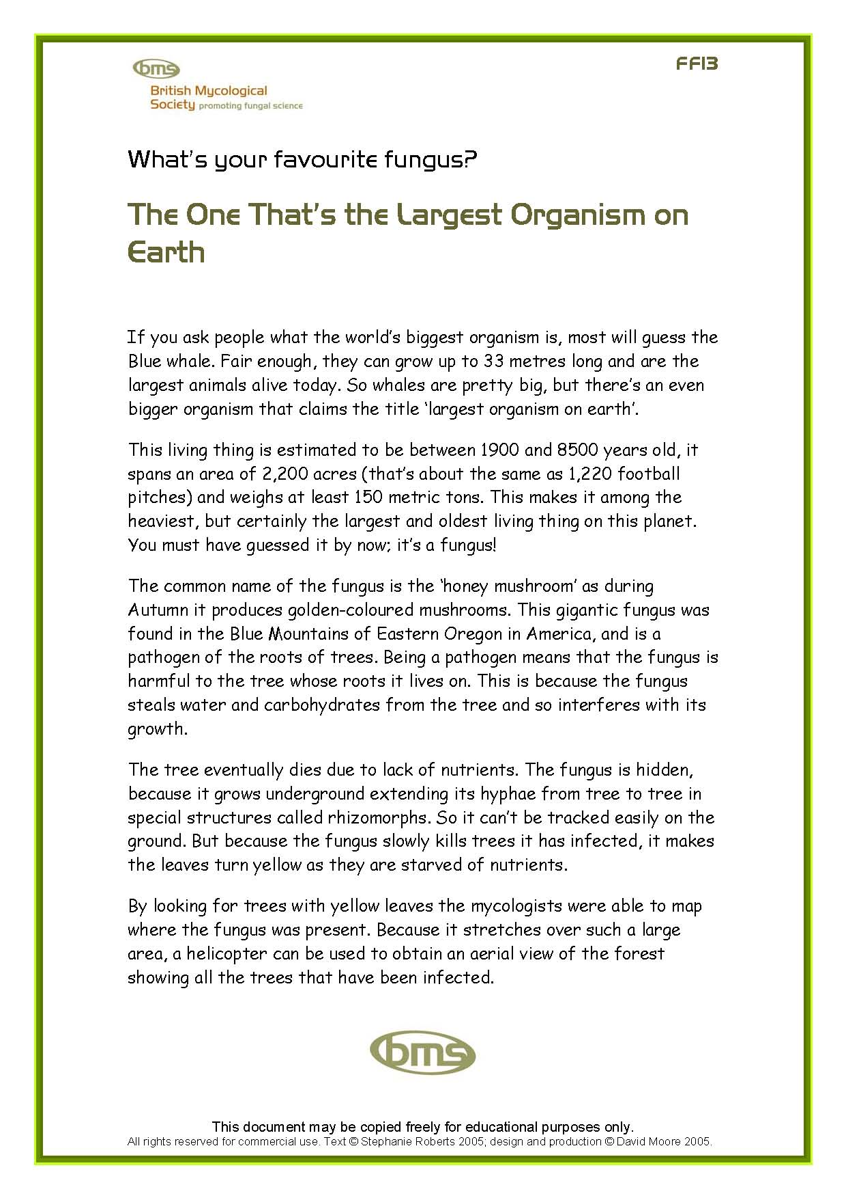 | 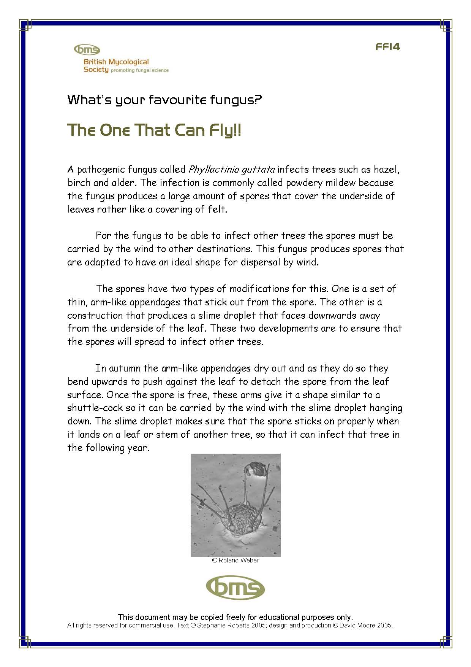 | 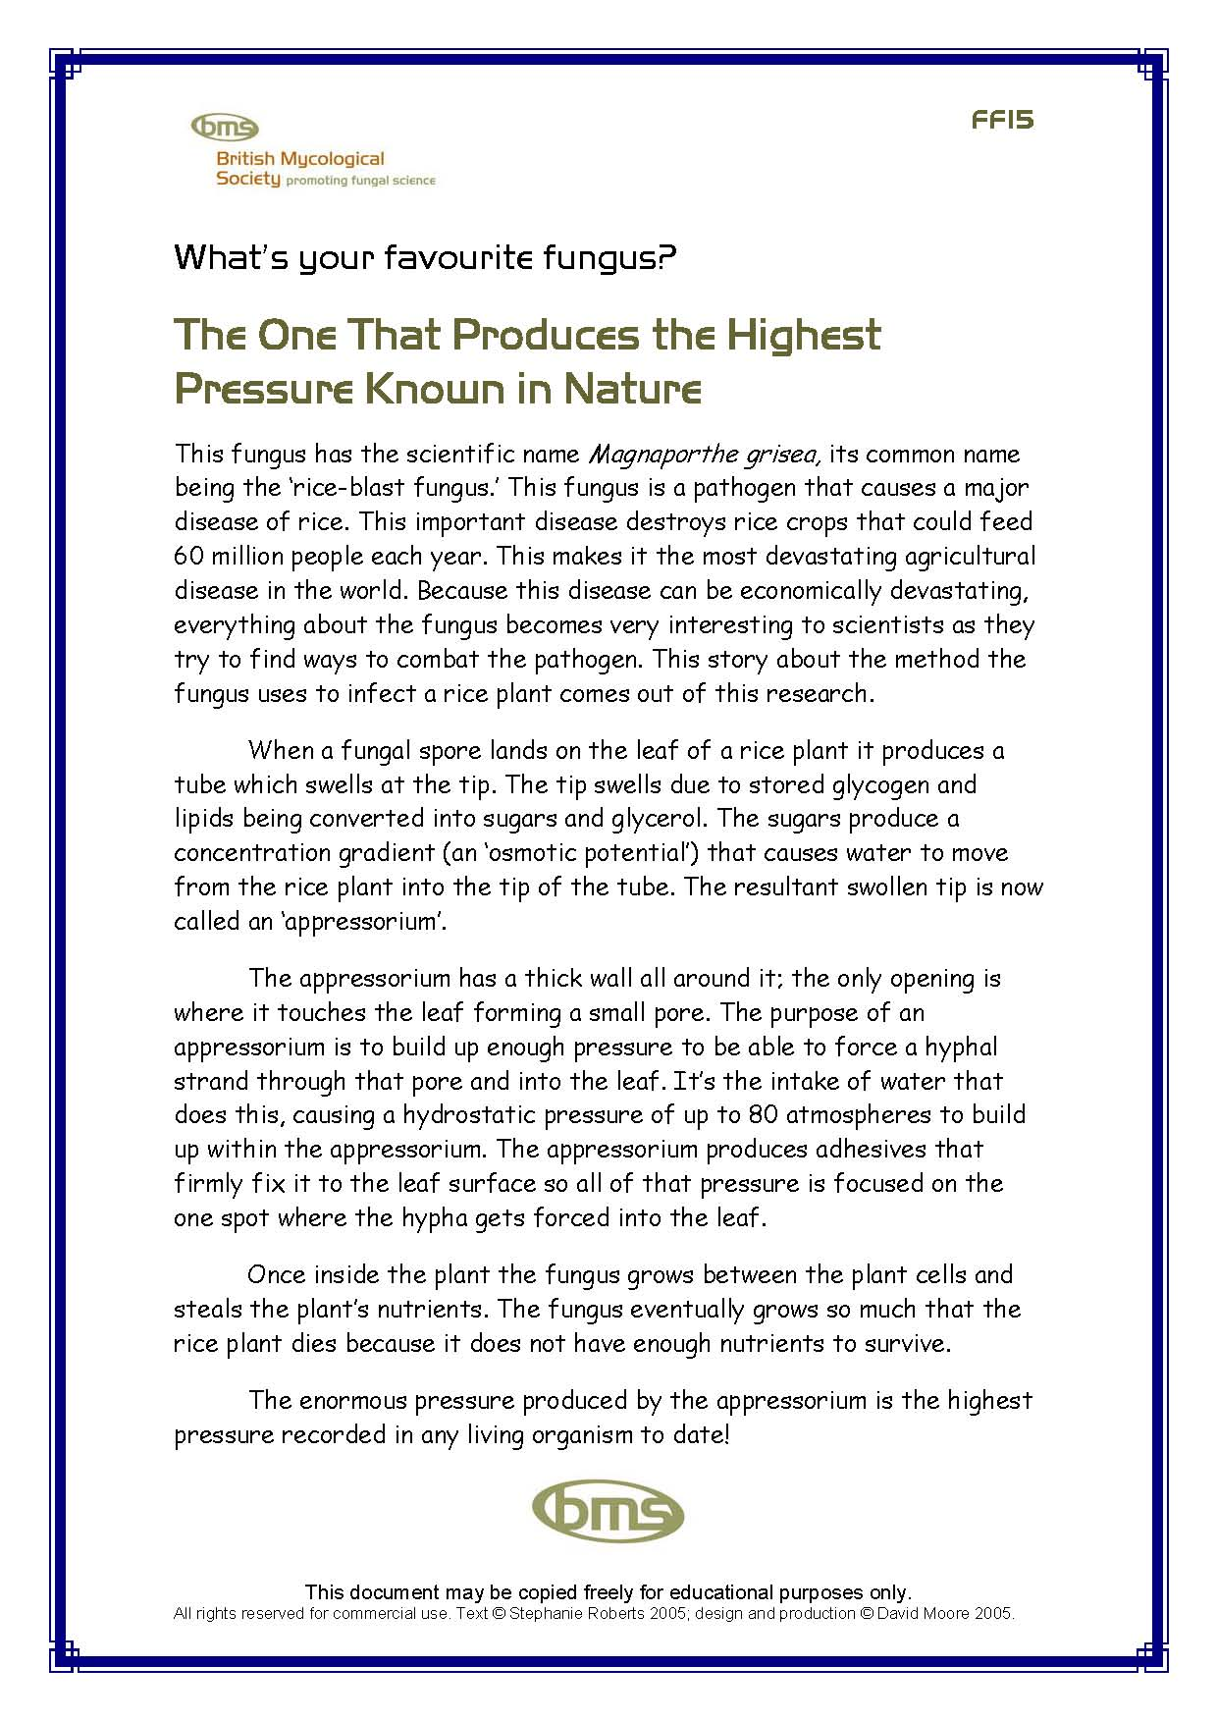
FF13: The one that’s the largest organism on Earth (about Armillaria) | FF14: The one that can fly (about spore adaptations to dispersal) | FF15: The one that produces the highest pressure known in nature (about adaptations of plant pathogens to infection)
Remember: class sheets may be copied freely for education purposes.

The stories are presented to you here in colour, but they copy well in black & white. You might also like to consider laminating the sheets.

FF16: PowerPoint Presentation
This is a set of 14 slides giving a general overview of fungi, presented as though this is a new topic to the pupils. It is offered to you as a PowerPoint PPT file which you can use as-is (note: slide transitions proceed on a mouse-click) or modify as you wish, and as a set of PDF sheets that you can copy onto overhead transparencies for OHP presentation. The slides deal with the following topics: what fungi are, how they are useful to man, examples of mutualistic relationships, fungal infections of plants and humans.

FF17: Starter Activity - The Fungi Name Game
This starter activity is used to introduce the two ways of naming fungi (common names and scientific names) in a game format. The paper versions provided here could be photocopied so that they can be handed out to the class or could be copied onto transparencies for OHP use.

Many fungi have English common names, with which pupils may be more at ease (or may think of as less exotic) than scientific names. The Fungi Name Game deals with English names – some genuine, some not. The idea is that pupils need to pick the real common names from the fake ones by shouting out guesses, with a tick or cross being placed over each name to make a path of correct choices from the top of the grid to the bottom. If you are using the OHP you could obscure the fake names as they are discovered with counter tallies, draughtsmen, or some other opaque objects to make the path more obvious. This structure is similar to several popular TV quiz games in the hope that this activity will be rapidly accepted by the pupils.

The final page introduces a variety of Latin names of fungi. The purpose is to de-mystify these names by showing that ‘scientific’ naming of organisms is not so different from any other naming process. Our experience is that pupils readily cope with Latin binomials if they are given a little help and encouragement. Anyone who follows sports is used to dealing with exotic ‘foreign names’ of sports and media stars, and there’s no reason why that easy ‘I can cope’ attitude shouldn’t be extended to biology.

FF18 – FF24: Favourite Fungus Card Game
This is a ‘Happy Families’ or ‘Rummy’ style game where the pupils need to collect 5 cards of the same topic. Eight different stories chosen from the Favourite Fungus story sheets are each represented by a symbol common to the story (Clip Art icons) and there are six cards for each fungus story, each bearing a different ‘bullet point’ fact taken from that specific story. In essence, therefore, the pack of cards consists of 8 suits, with six cards in each suit. As the suits are distinguished by their symbolic picture a variety of games based on the need to collect a hand of cards made up of a single symbol can be played. It’s proved popular with pupils of all ages and we think it’s a valid way of learning as even though pupils are playing a game, the ‘fungal facts’ on the cards repeat what has been learned in the more formal parts of the session and that repetition should improve long term retention of the information.

The cards are presented in the form of Microsoft Word (and PDF equivalent) templates for Business Cards. They are intended to be used with the A4 sheets of ‘print-them-yourself’ business cards that are commercially-available. The templates are designed for individual cards measuring 85 x 54 mm (= 10 cards per A4 sheet), and we have used cards from the ‘DECAdry PC papers’ range (see www.decadry.com). We particularly like ready-cut cards with smooth edges and rounded corners (OCC-3343 in white; OCC-3346 in parchment) as they produce a pack of cards that is easy to shuffle and deal.

The ready-cut cards can only be printed on one side (because the cards are stabilised on an A4 backing sheet), and the backing should be peeled away from the finished cards. Don’t peel the cards away from the backing – you’ll bend the cards unnecessarily. Eight suits of six cards = a pack of 48, so two jokers were added to bring the total number of cards per pack to 50 (requiring five sheets of Business Cards). NOTICE that FF23 and FF24 differ only in the jokers, so printing one OR the other will complete your pack of playing cards. FF18 is a brief instruction sheet for the card game that the players may find useful.

FF25 Supermarket challenge display poster/leaflet (with explanatory text).
FF26 Thank Fungus for That! Poster/leaflet (with explanatory text).

