THE GOOD, THE BAD
AND THE FUNGI

APPENDIX 8

GUIDELINES FOR COLLECTING WILD FUNGI

Guidelines for collecting wild fungi:

Collection is envisaged as a teacher only activity. Most habitats contain wild fungi but the fungi that are discussed below, in the section on identification, all grow in woodlands. When fungi grow with a particular species of tree this information is given in the notes. Obtaining the permission of the landowner and following the countryside and access codes are recommended. Other general guidelines are given in the ‘Scottish Wild Mushroom Code’ (Appendix 9) and in Appendix 11.

Some useful tips for collecting fungi:
- Fungi mostly fruit during the late summer and autumn
- Fungi fruit most prolifically a few days after rain
- Take care to collect the base of the fungi – sometimes the features of the base are important for identification.
- An old knife is useful to carefully extract the specimen, without damaging the substrate and mycelium.
- Once collected, store in an old margarine tub, brown paper bag or twist of greaseproof paper. Do not put into plastic bags, as this will speed the process of decomposition.
- Do not collect too far in advance (preferably the day before use) as picked mushrooms have a very limited ‘shelf life’. Once collected store in a cool place – an old fridge or cool box would be ideal. Bracket fungi tend to keep better than the soft-fleshed fungi.
- Many bracket fungi are very tough and particular care must be taken when removing them from their substrate.
- Toxins cannot be transferred through the skin.

Identification of fungi:
Seeking expert opinion or consulting a good field guide will aid in the identification of fungi. Recommended field guides include ‘Mushrooms and other fungi of Great Britain and Europe’ by Roger Phillips (ISBN 0 330 26441 9) and ‘How to identify edible mushrooms’ by Patrick Harding, Tony Lyon and Gill Tomblin (ISBN 0 00 219984 X). There are no foolproof rules to distinguish between edible and poisonous fungi.

The following is an aid to identifying a range of fungi that are mentioned in the above activities and that are reasonably easy to identify. The Dyers’ Mazegill (Phaeolus schweinitzii) is recommended for dying and the Hoof Fungus (Fomes fomentarius) and the Birch Polypore (Piptoporus betulinus) for paper making. None of the fungi illustrated are deadly and indication is given in the text where any members might cause gastric or other upset if ingested. Be aware that some people can suffer an allergic reaction to eating even shop bought fungi.
Remember that fungi can be very variable, particularly in size, and do not always look exactly like their photographs.

Boletes: these are ‘umbrella’ shaped fungi with a cap and stem that have pores underneath the cap rather than gills.
Boletes mostly produce a brown spore print and the caps come in a range of textures from viscid to suede like. Some boletes show dramatic colour changes when the flesh is cut or bruised. Sometimes bruising the pores will leave a blue finger print, but cutting the fungus in half is a good way to demonstrate a colour change. This change can be instantaneous in some species or take up to half an hour in others. Some do not change at all. The age and dryness of the fungus will affect the colour change. Different boletes grow with conifers and with broadleaves (particularly birch).

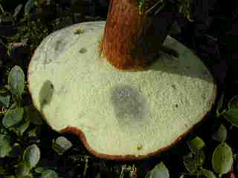
Bay Bolete (Boletus badius): bruising blue grey on small lemon coloured pores

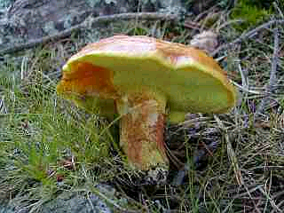
Larch Bolete (Suillus grevillei): a lovely gooey texture to the cap of this one. Very common under larch.

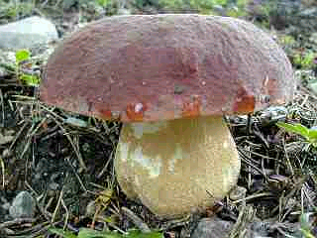
Cep or Penny Bun (Boletus edulis): a dark cap and white raised network on the stipe are good identification features.

Most boletes are edible but Scarletina Bolete (Boletus erythropus) can cause gastric upset if ingested. This fungus does demonstrate the colour change of the flesh, very dramatically when damaged, from yellow to bright blue and if the health and safety guidelines are followed then this would make an interesting demonstration fungus. This fungus is easy to recognise as its stem is covered in orange/red dots.



Russulas: this is a large group of ‘umbrella’ shaped fungi with a cap and stem and gills underneath the cap. The cap colours tend to be very bright – reds, purples, yellows and greens but the gills and stem are often a strongly contrasting white. The flesh of Russulas has a slightly different microscopic composition to other fungi and consequently they have a ‘cheesy / brittle’ texture, noticeable if you crush the gills into the cap between thumb and forefinger. These fungi do not have rings around the stem or a volva at the base of the stem (appendix 12 ‘Identifying Fungi – What To Look For’). The spore prints vary from white to orange. Some Russulas have interesting smells (e.g. Geranium Brittlegill Russula fellea – a yellowy Russula growing underneath beech trees has a smell likened to stewed apple or some species of geranium).

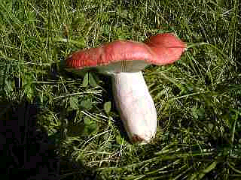

Russula paludosa: has a pale pink tinge on the stipe.

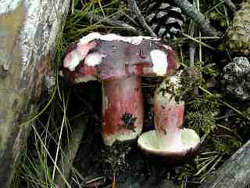
Primrose Brittlegill (Russula sardonia): has lemon yellow gills when young and a very hot taste

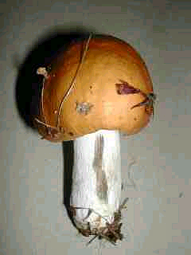
Copper Brittlegill (Russula decolorans): grows in pine woods and discolours black where damaged

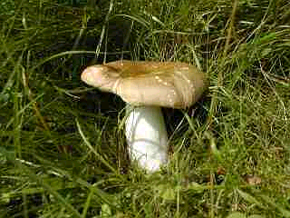

Some Russulas have ochre and green tints.

Some Russulas taste peppery hot; this in itself is not connected with toxicity but we do not recommend that you taste any fungi in the classroom situation. Many Russulas are edible but those with bright red caps and pure white stems and gills cause gastric upsets.

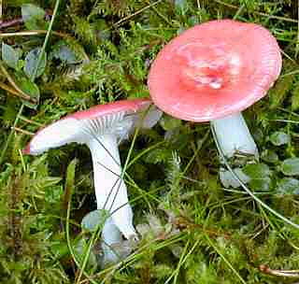

The Sickener (Russula emetica): causes stomach upsets

Lactarius: this is a group of ‘umbrella’ shaped fungi with a cap and stem and gills underneath the cap. The cap colours are often dull but when damaged the flesh will produce a milky substance. This milk can sometimes change colour once it is exposed to the air and in ‘Lactarius uvidus’ the white milk turns violet. Some species of Lactarius produce milk that tastes peppery hot; this in itself is not connected with toxicity but we do not recommend that you taste any fungi in the classroom situation. Care should be taken not to introduce the milk into the mouth or eyes. Some Lactarius have interesting smells including Coconut Milkcap (Lactarius glyciosmus) growing with birch that smells of coconut and Fenugreek Milkcap (Lactarius helvus) growing with conifers that smells of curry powder.

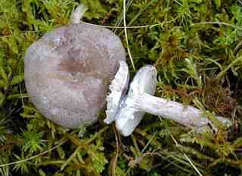

Grey Milkcap (Lactarius vietus): produces white milk. The concentric zoning is often a character of Lactarius species.

The Fly Agaric (Amanita muscaria): this is the ‘classic’ red-capped fungus with white spots, gills, a ring and a volva. It appears in many children’s fairy stories, including ‘Alice in Wonderland’ and provides one of the rare examples of a toadstool being used in our folklore. It is a beautiful fungus that also illustrates many of the characters shown in the worksheet ‘Identifying Fungi – What To Look For’ (appendix 12). These features make this an interesting fungus to use for demonstrations in class. Particular care should be taken when working with this fungus as it contains two toxins, one that causes hallucinations and the other that causes sweating and gastric upset. If the health and safety guidelines are followed then the fungus can be quite safely used.

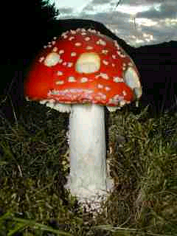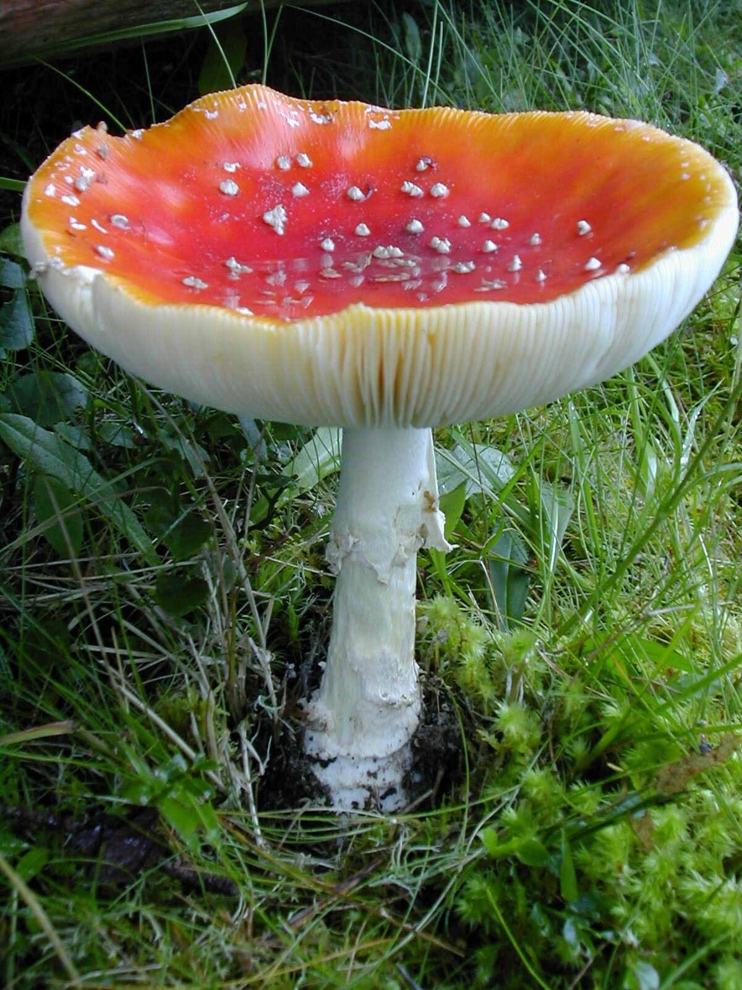

Fly Agaric (Amanita muscaria)

Dyer’s Mazegill (Phaeolus schweinitzii): this usually appears on the ground or near the base of a living conifer tree. At first it has a bright yellow velvety appearance. The yellow bruises dark violaceus black and the whole fruit body will eventually darken. It can be used for making dyes - Activity 9

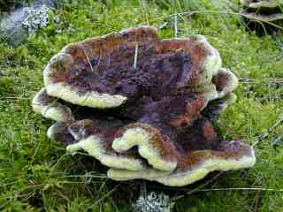

The Hoof Fungus (Fomes fomentarius): this is a perennial fungus that grows on old birch trees, often in the shape of a hoof. It is usually grey and is always hard. It can be used in Activity 8.

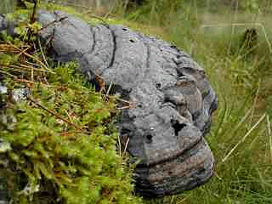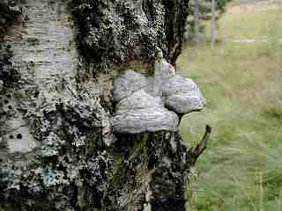

Birch Polypore (Piptoporus betulinus): this is an annual fungus that grows on old birch trees. When it is young (late summer, early autumn) it is pale and firmly rubbery. This fungus will rot during the winter. It can be used in Activity 8.

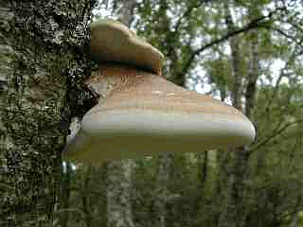

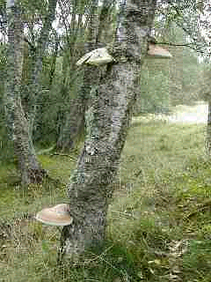Photos Liz Holden

