THE GOOD, THE BAD
AND THE FUNGI

APPENDIX 13

CLASSROOM WORKSHEET

PARTS OF A FUNGUS

Parts of a Fungus

The words below tell you about the parts of a fungus. Can you choose one of these words for each part of this fungus?

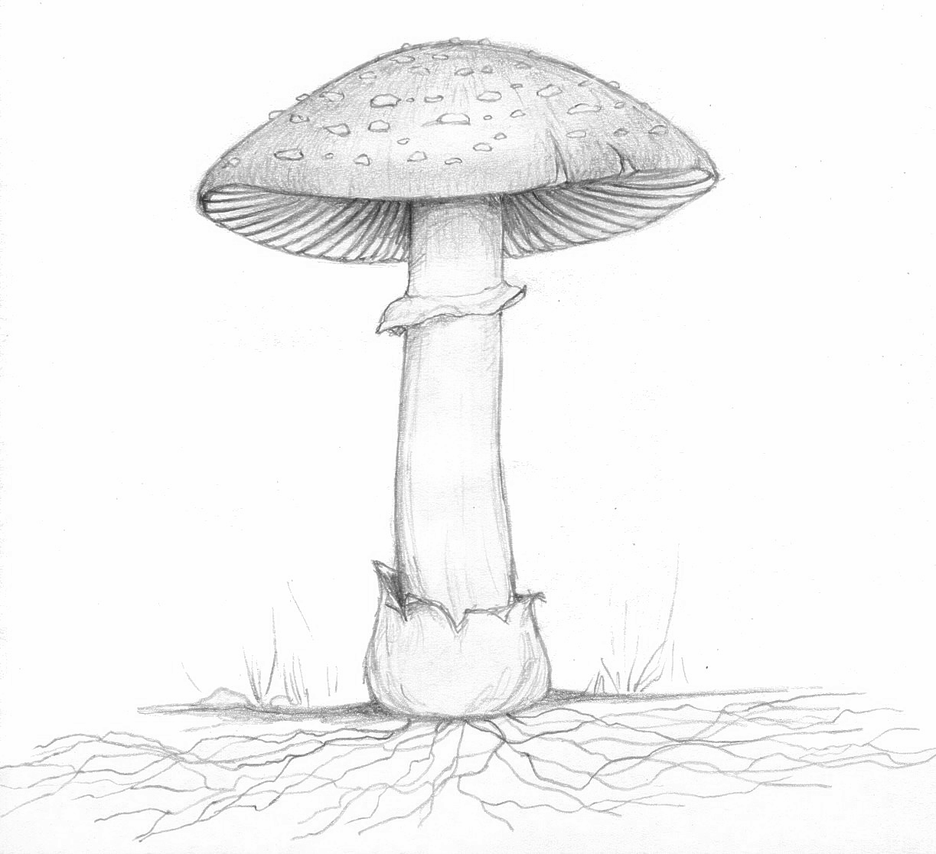

stem or stipe
volva
cap
mycelium
gills
ring

Parts of a Fungus correctly labelled

stem or stipe
volva
ring

gills
cap

mycelium

