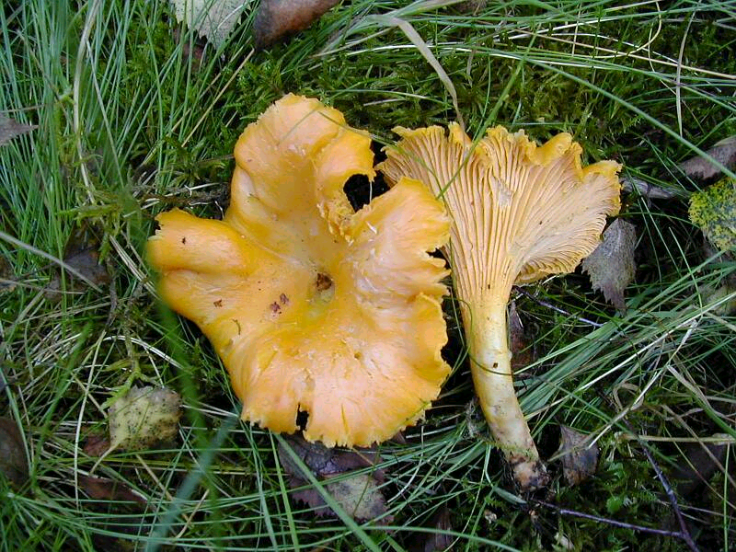

‘The Chanterelle’
I am very good to eat and
can help several different
sorts of tree to grow,
including birch
Scots pine and beech.

Mushroom Murder Mystery

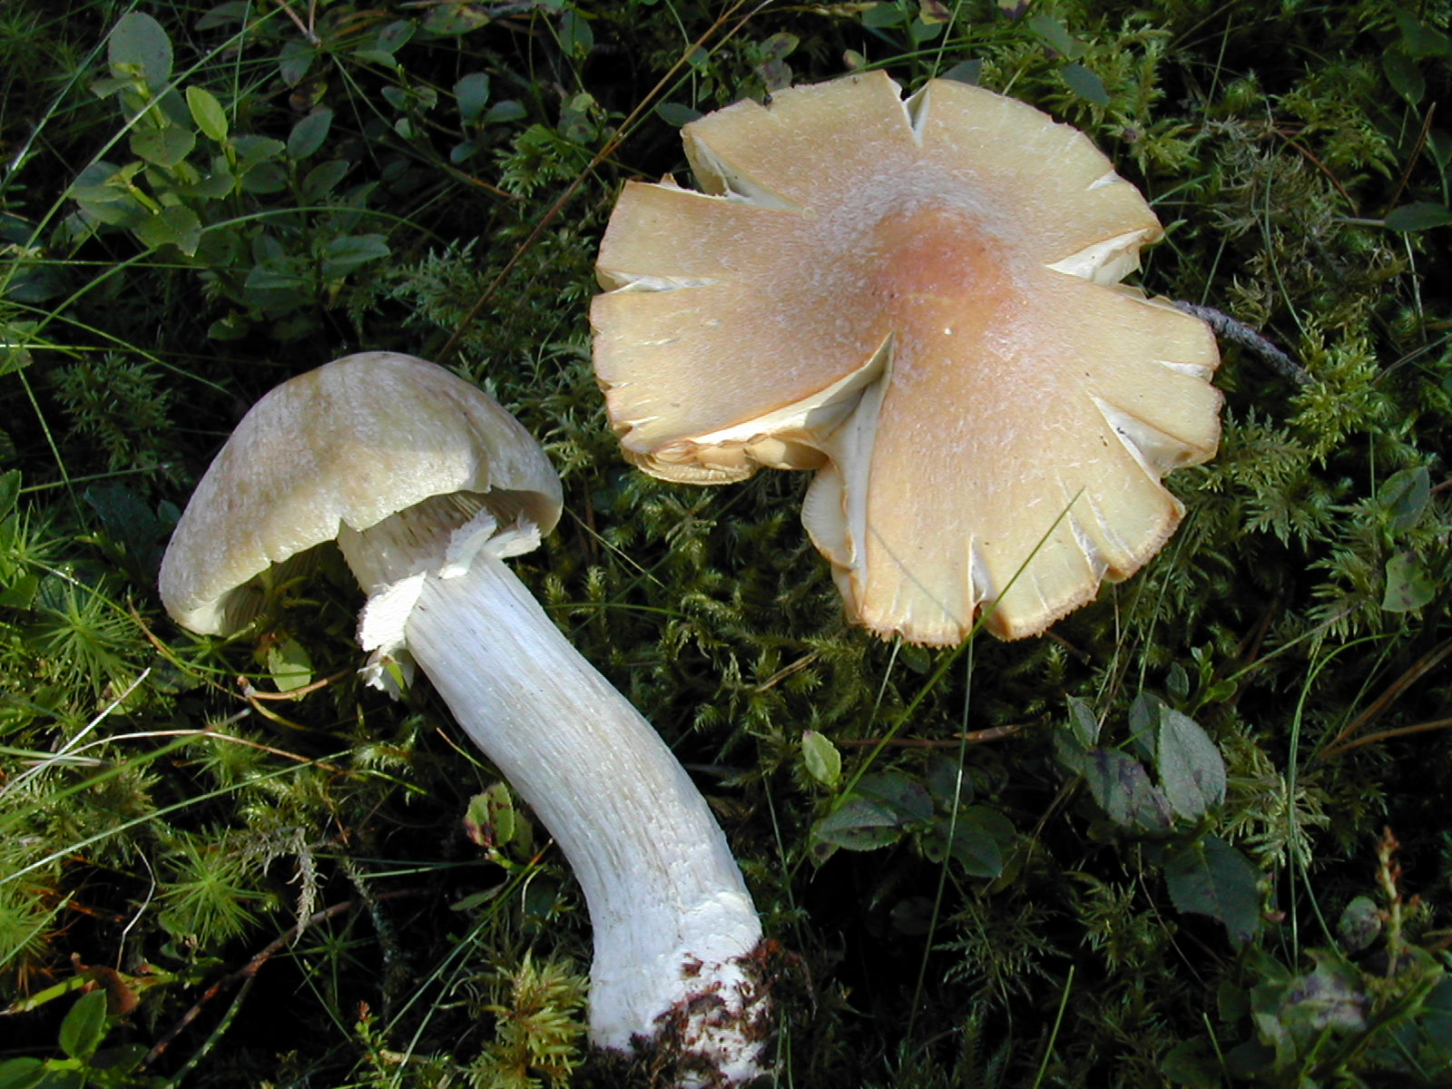

‘The Gypsy’
I help Scots pine trees to grow
and I am quite rare That is because there
is not much of the old pine forest left.

Mushroom Murder Mystery

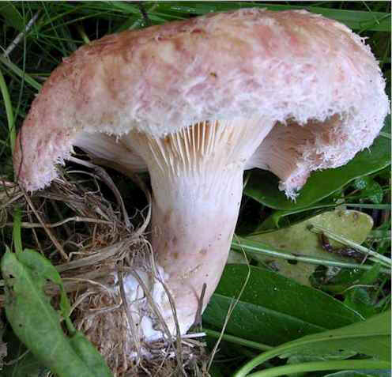

‘Woolly Milkcap’
I help birch trees to grow.
As my name suggests,
I produce a white,
milk like liquid when broken.

Mushroom Murder Mystery

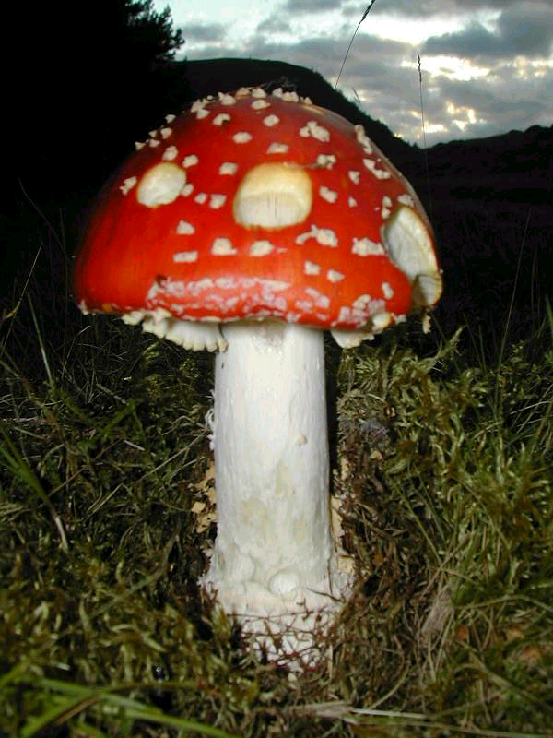
‘Fly Agaric’
I am poisonous but
very important –
I help birch trees to grow

Mushroom Murder Mystery

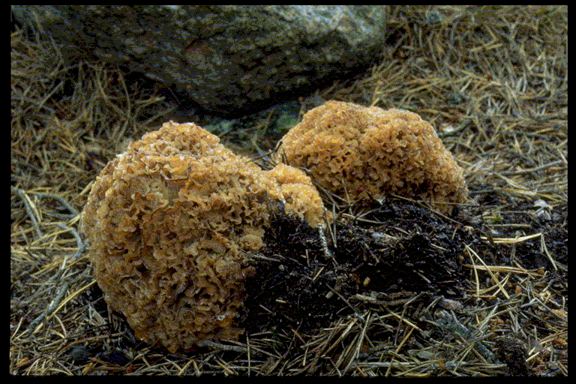

‘Wood Cauliflower’

I am a parasite – I attack
old and sick conifer trees
and can even kill them!

Mushroom Murder Mystery

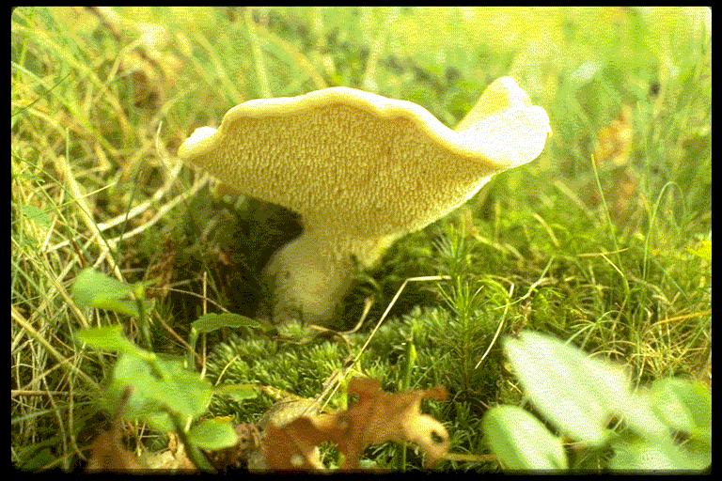

‘Wood Hedgehog’

I am called ‘hedgehog’
because I have spines.

I help birch and other trees
to grow

Mushroom Murder Mystery

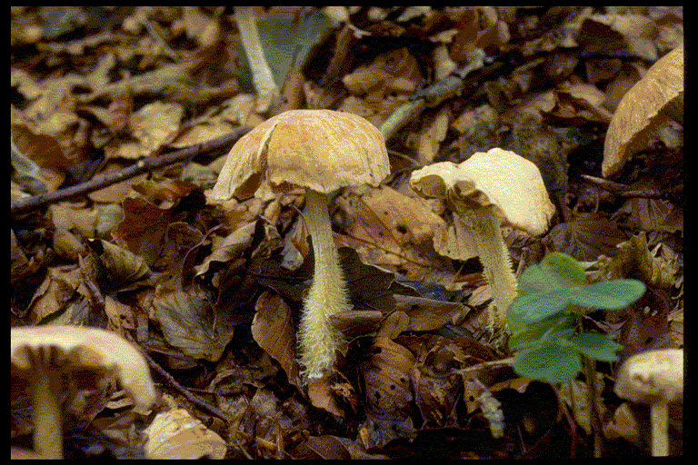

‘Wood Woolly-foot’

I am a common fungus
of woodlands. I live on
leaves and break them
down for recycling

Mushroom Murder Mystery

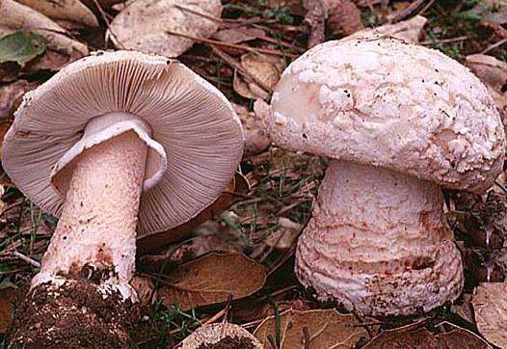
‘The Blusher’
I bruise red when I am
damaged and help birch trees
to grow

Mushroom Murder Mystery

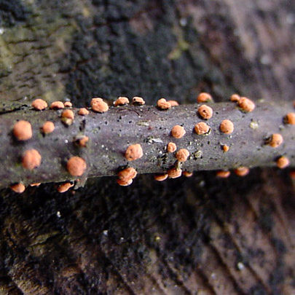
‘Coral Spot’

I am a colourful and common
recycler of dead twigs
from broadleaved trees

Mushroom Murder Mystery

