What’s your favourite fungus?

The One That Can Fly!!

A pathogenic fungus called Phyllactinia guttata infects trees such as hazel, birch and alder. The infection is commonly called powdery mildew because the fungus produces a large number of spores that cover the underside of leaves rather like a covering of felt.

For the fungus to be able to infect other trees the spores must be carried by the wind to other destinations. This fungus produces spores that are adapted to have an ideal shape for dispersal by wind.

The spores have two types of modifications for this. One is a set of thin, arm-like appendages that stick out from the spore. The other is a construction that produces a slime droplet that faces downwards away from the underside of the leaf. These two developments ensure that the spores will spread to infect other trees.

In autumn the arm-like appendages dry out and as they do so they bend upwards to push against the leaf, detaching the spore from the leaf surface. Once the spore is free, the arms give it a shape similar to a shuttle-cock so it can be carried by the wind with the slime droplet hanging down. The slime droplet makes sure that the spore sticks on properly when it lands on a leaf or stem of another tree, so that it can infect that tree in the following year.
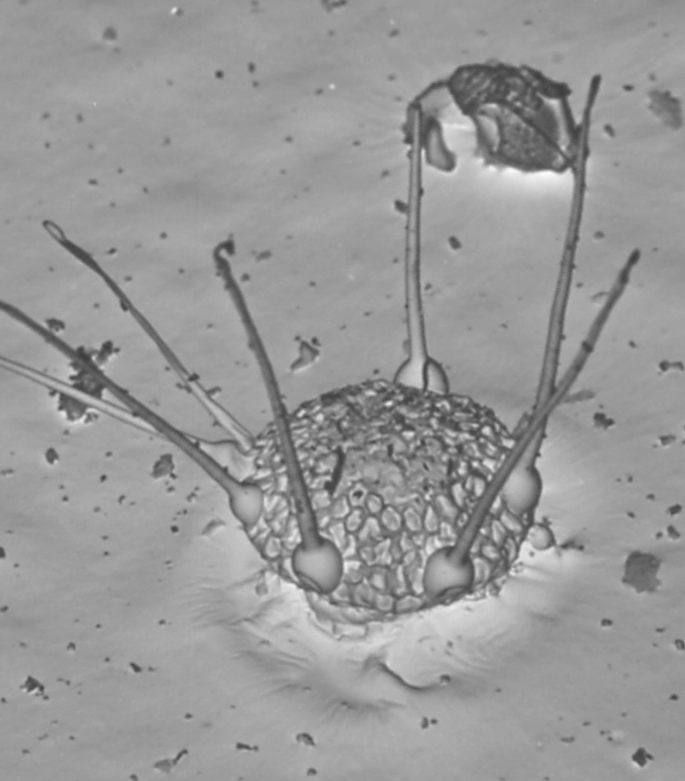
© Roland Weber



