Fungi and Disease

Recap. . . . . . .

Bacteria, fungi and viruses are all micro organisms. We learnt last lesson that some fungal species are beneficial to humans in the food industry and in medicine production.
However, some fungal species can cause disease along with bacteria and viruses. Micro organisms that cause disease are called pathogens.

Let’s Focus on Fungi

Certain fungi have the ability to cause diseases in humans, plants and animals.
When looking at plant pathogens it’s important to remember that some parts of the plant are above ground – stems and leaves and other parts are below ground – roots. So, it makes sense that airborne pathogenic fungi infect the stems and leaves and soil borne pathogenic fungi infect plant roots.
Plant diseases have some very strange names! They are given names like:
► Blights
► Rusts
► Smuts
► Mildews

Most of these names come from old descriptions of the effect on the crop and were given to the disease long before its cause was known. Mildew is a cottony covering on the leaf (on which dew forms readily). A crop that looks sick and dying might be described as being ‘blighted’; plants covered in red masses (actually fungal spores) as being ‘rusted’; or if covered in black deposits (spores again) like soot, then it’s a ‘smut’ or a ‘tarspot’.


Some Examples of Plant Diseases

This is a tarspot disease of sycamore leaves. Caused by a fungus called Rhytisma acerinum which is very common and widely distributed. You can see this on sycamore leaves throughout the year. | 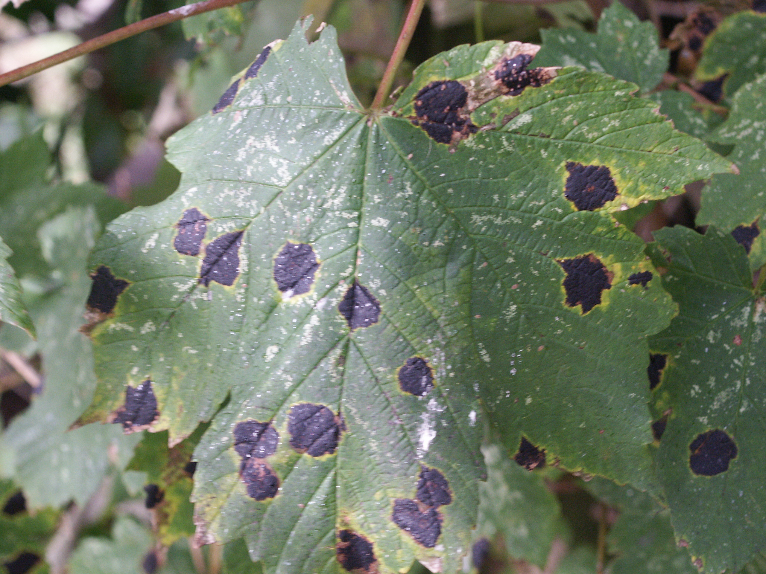  © David Moore
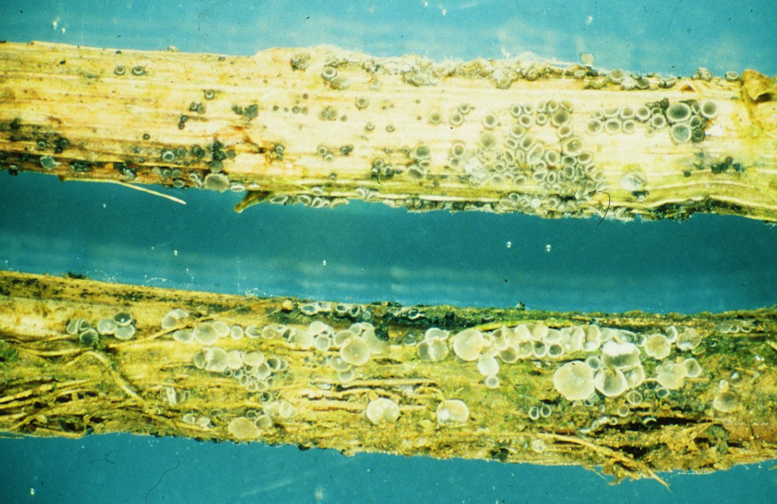  © Paul Dyer | This is ‘eyespot’ disease on wheat stems, caused by a fungus with the wonderful name of Pseudocercosporella herpotrichoides. It’s a serious disease of cereals because it survives from year to year on stubble debris, and can even survive being ploughed under and ploughed up again the following season.
This is the rust disease of wild and cultivated daisies caused by Puccinia distincta. An epidemic of this disease started in the mid-1990s and spread from Australia, through Europe, and into North America. In many places, ornamental daisies can no longer be grown unless they are protected by fungicide sprays. | 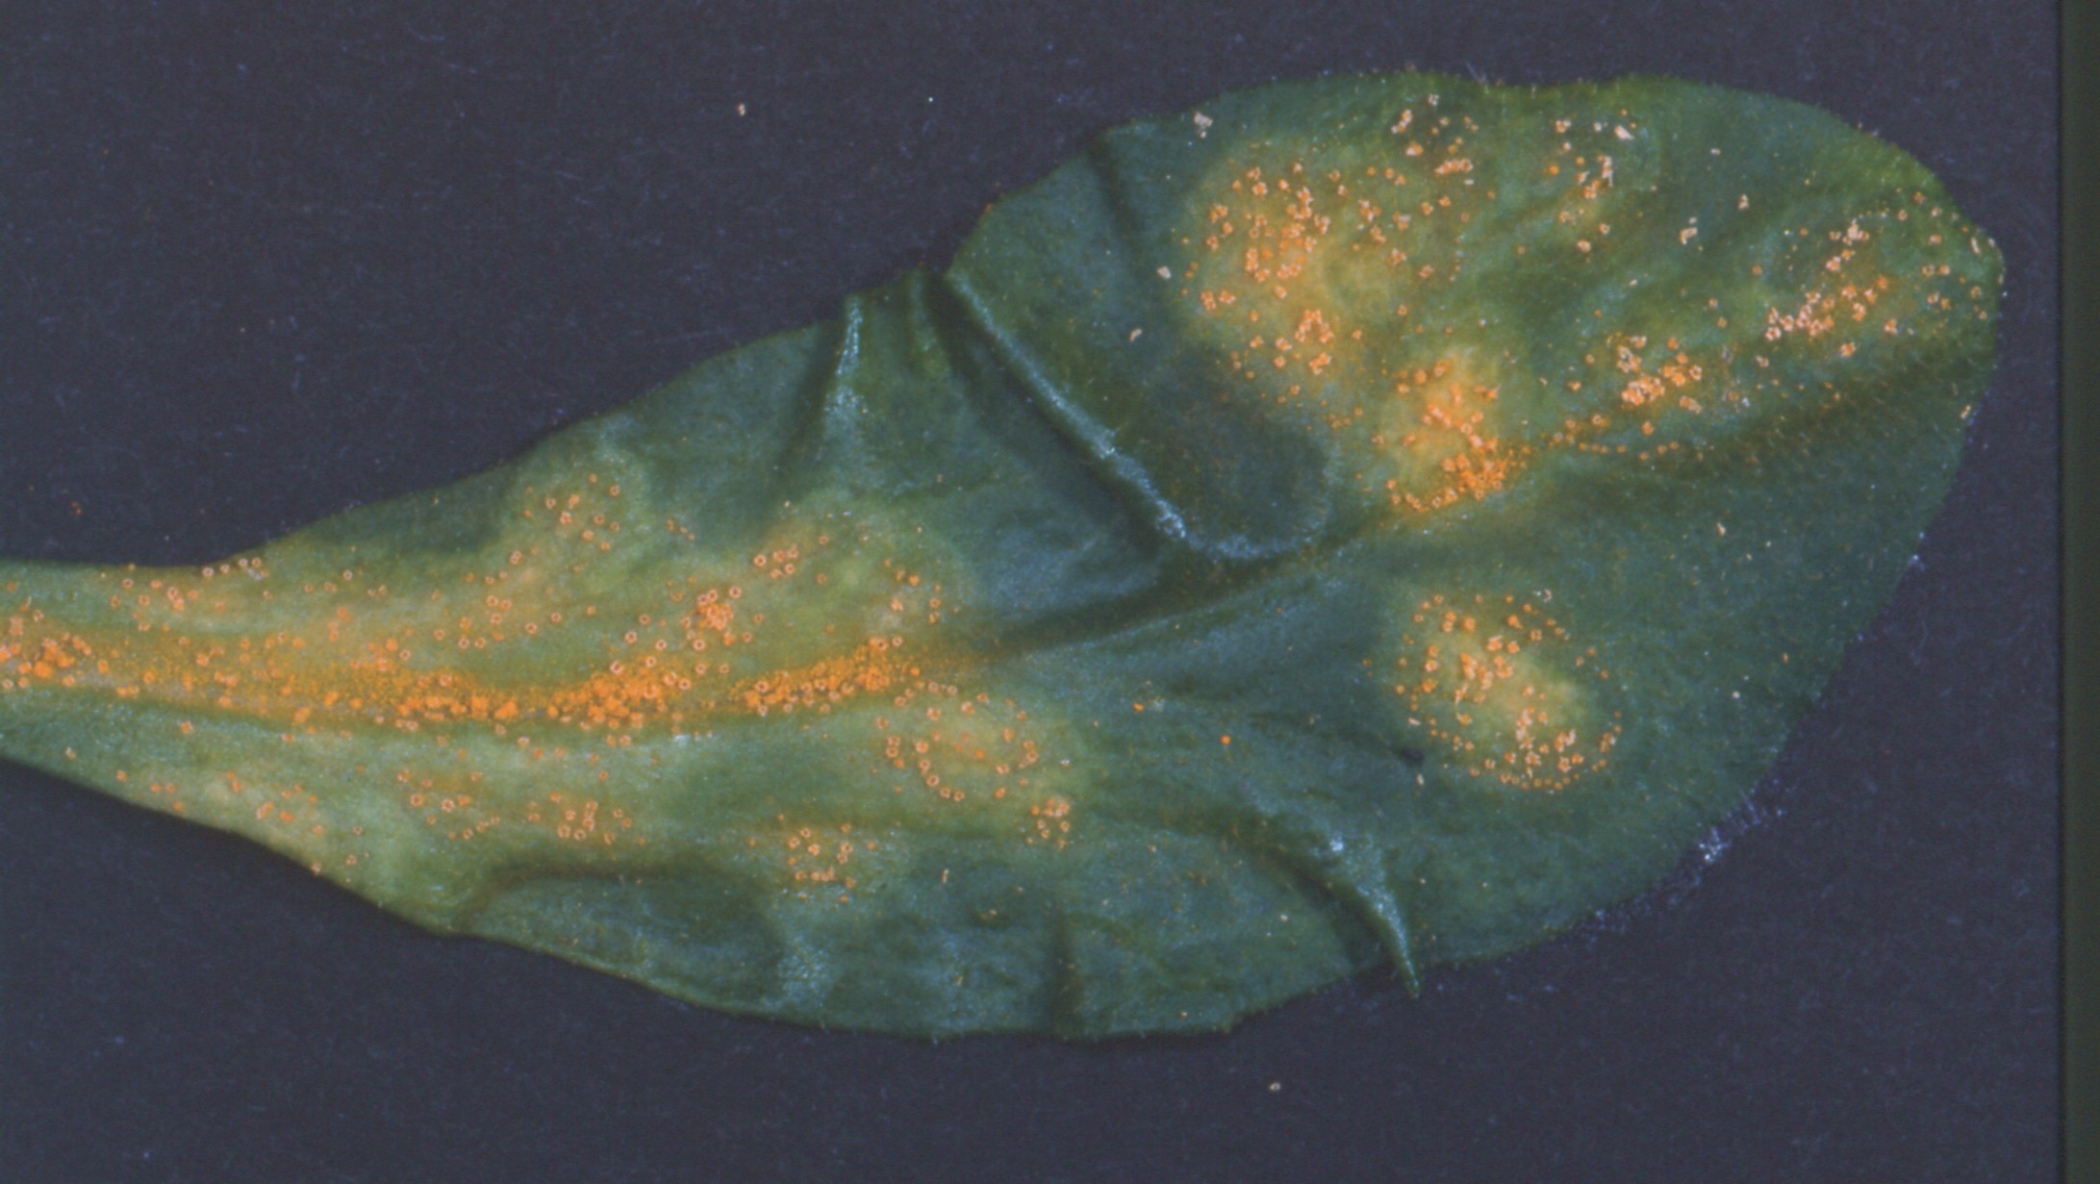  © Roland Weber

Human diseases caused by fungi are called mycoses. The diseases are divided into three groups depending on where they occur on our body. These groups are:

Superficial ► | These infect the skin, nails and hair.
Subcutaneous ► | These infect the deep layers of the skin.
Systemic ► | These are the most severe fungal diseases. An unsuspecting person may inhale the pathogenic fungal spores. Some spores stay in the lungs and grow while others enter the bloodstream, travel around the body and infect other organs.

Most fungal infections are due to opportunistic pathogens; these affect people who are already ill or have a suppressed immune system (e.g. in patients who have been given an organ transplant, or in AIDS patients). In a perfectly healthy person the fungus would not normally cause disease. True pathogens can cause disease in even the healthiest person.

Like bacteria, fungi can produce toxins. Fungal toxins are called mycotoxins and the diseases they cause are called mycotoxicoses. Several food items are particularly susceptible to fungal disease including bread, dried pasta, peanuts and stored grains and cereals. All of these are dry foods which should be stored in dry conditions. When stored in the wrong conditions of high temperature and high humidity, mycotoxins can be found as a result of fungal (‘mould’) growth in the stored material.

The most widespread and dangerous of these are the aflatoxins produced by the mould called Aspergillus flavus. These are carcinogenic, which means they can cause cancer. Aflatoxins pose a serious threat to both humans and domestic animals because the mould grows on poorly-stored grain and animal feed. When eaten, the toxin is stored in the liver where it can eventually cause hepatitis and liver cancer.

Some Examples of Human Diseases

Ringworm is not a worm, but a common fungus infection of the skin. The fungus (often one called Microsporum) does not invade living tissue but the fungus and its metabolic products cause inflammation. This 5-week old baby caught the disease from contact with the family’s pet cats. |  | 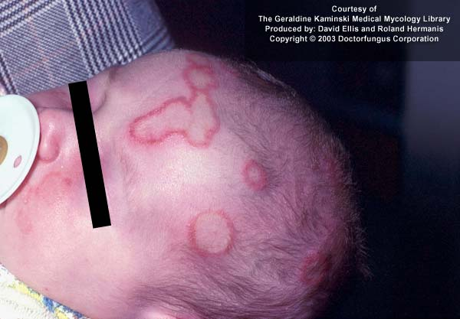  Image courtesy of www.doctorfungus.org © 2005
Image courtesy of www.doctorfungus.org © 2005 | Epidermophyton floccosum causes athlete’s foot in humans – usually in the web area between toes – and is common in shoe-wearing people because it’s favoured by warm, humid conditions. It can also affect the hand and other areas of the body, and here is attacking toe-nails.
This is a Madurella mycetoma on a patient’s limb. This disease occurs all over the world, but is most common in tropical and sub-tropical regions. It is caused by a number of fungi including Madurella, Acremonium, Curvularia, Fusarium and Aspergillus. |  |  | 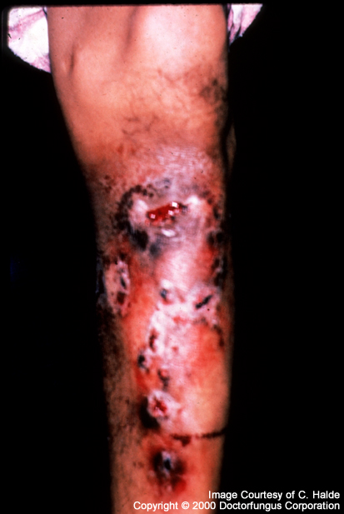  Image courtesy of  www.doctorfungus.org © 2005
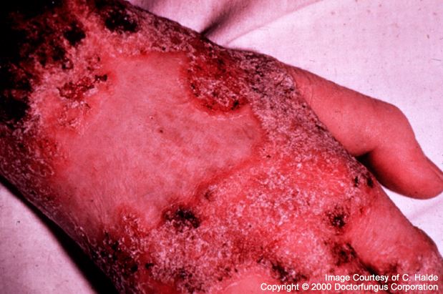  Image courtesy of www.doctorfungus.org © 2005 |  | These are skin ulcers of a patient suffering from blastomycosis (caused by Blastomyces dermatidis). The disease starts in the lungs when spores are inhaled, and then spreads to other organs.

History Lesson!

An important example that demonstrates just how devastating pathogens of our crops can be is the Irish Potato Famine of 1845 - 46.
The organism responsible was a relative of the fungi called potato blight or Phytophthora infestans – even the scientific name means ‘infesting plant destroyer’! The whole of Europe was affected with the disease (which was introduced on plants imported from the Americas) but Ireland suffered more because the poorest people lived entirely on a diet of potatoes. English labourers were less affected because they had cereal foods in their diet and cereal crops were not affected by the disease. For the majority of the Irish, though, if there were no potatoes they starved. Sadly, from 1845 to 1860 a staggering 1 million people died as a direct consequence of the famine, and over 2 million emigrated (many to the USA).

So what can we learn from this tragic incident?

► Grow more than one crop. Growing a single crop plant over vast areas (called monoculture) encourages disease to spread rapidly. Also, populations should not be entirely dependent on a single source of food.

► Use of fungicides will prevent or at least control disease. Of course, in the mid-nineteenth century the cause of ‘potato blight’ was not known because the ‘germ theory’ of disease (that is, the idea that diseases are caused by infections) had not even been suggested in 1845.

► Store in the correct conditions: this means proper control of humidity, oxygen and temperature. It doesn’t have to mean high technology – what’s required is good aeration and careful protection from rain and ground water.

► Weather conditions play in important part in the spread of crop disease.

