A Teacher’s Guide to

The World of Fungi

The British Mycological Society’s series of ready-made KS4 lessons and classroom activities about fungi

Kingdom Fungi

Although Kingdom Fungi affects many aspects of people’s lives all over the world, there is a severe lack of knowledge and appreciation of the importance of such organisms. This deficiency is apparent in the specifications provided to secondary schools, as the National Curriculum does not require pupils to have a broad knowledge of Kingdom Fungi. This package provides five learning resources which cover a complete range of fungal topics, from structure and function to fungal diseases of plants and humans. These resources aim to increase knowledge and interest in Kingdom Fungi and increase interest in biology.

The National Curriculum does not require pupils to have much knowledge of fungal biology. This fact is particularly acute in ‘double award’ specifications that the majority of pupils follow at GCSE level. Although the production of penicillin, bread and beer may be included, these are ‘historical stories’ – bread and beer represent prehistoric technology, and the industrialisation of penicillin took place in the 1940s. No attempt is made in any curriculum specification to use present day examples, despite the fact that there are many of these. Representations to the Qualifications and Curriculum Authority brought a statement from a Science Advisor for QCA to the effect that “There are opportunities to teach about fungi within this framework” and going on to explain that the probable reason for the lack of fungi in the current syllabus is most likely due to a lack of awareness by teachers and examiners!

We have identified the problems and it is the purpose of this package to deliver a set of appropriate learning resources, which could be used in schools nationwide, to increase knowledge and awareness of fungi, with the subsidiary aim of maintaining interest in science by demonstrating how much pupils depend on fungi in their everyday life.

The learning resources described here are in the form of five class sheets that together provide a complete mini-course about fungi. The material could be delivered in a series of five lessons – minimising the amount of time needed to compensate for the deficiencies of the National Curriculum – but they can also be used as the basis for wider and more extensive classroom activities. Although designed to complement the microbiology content of the AQA GCSE Applied Science (Double Award) Specification (AQA, 2006) the class sheets can be used in a wide variety of ways for other specifications as the resources provide topics for pupil investigations, class debates and discussions, and self-directed activities.

Remember, also, that you can usefully combine these class sheets with those in the other packages; some of the possibilities are noted after the brief descriptions below.

World of Fungi

Annotated index to Class sheets
WF01  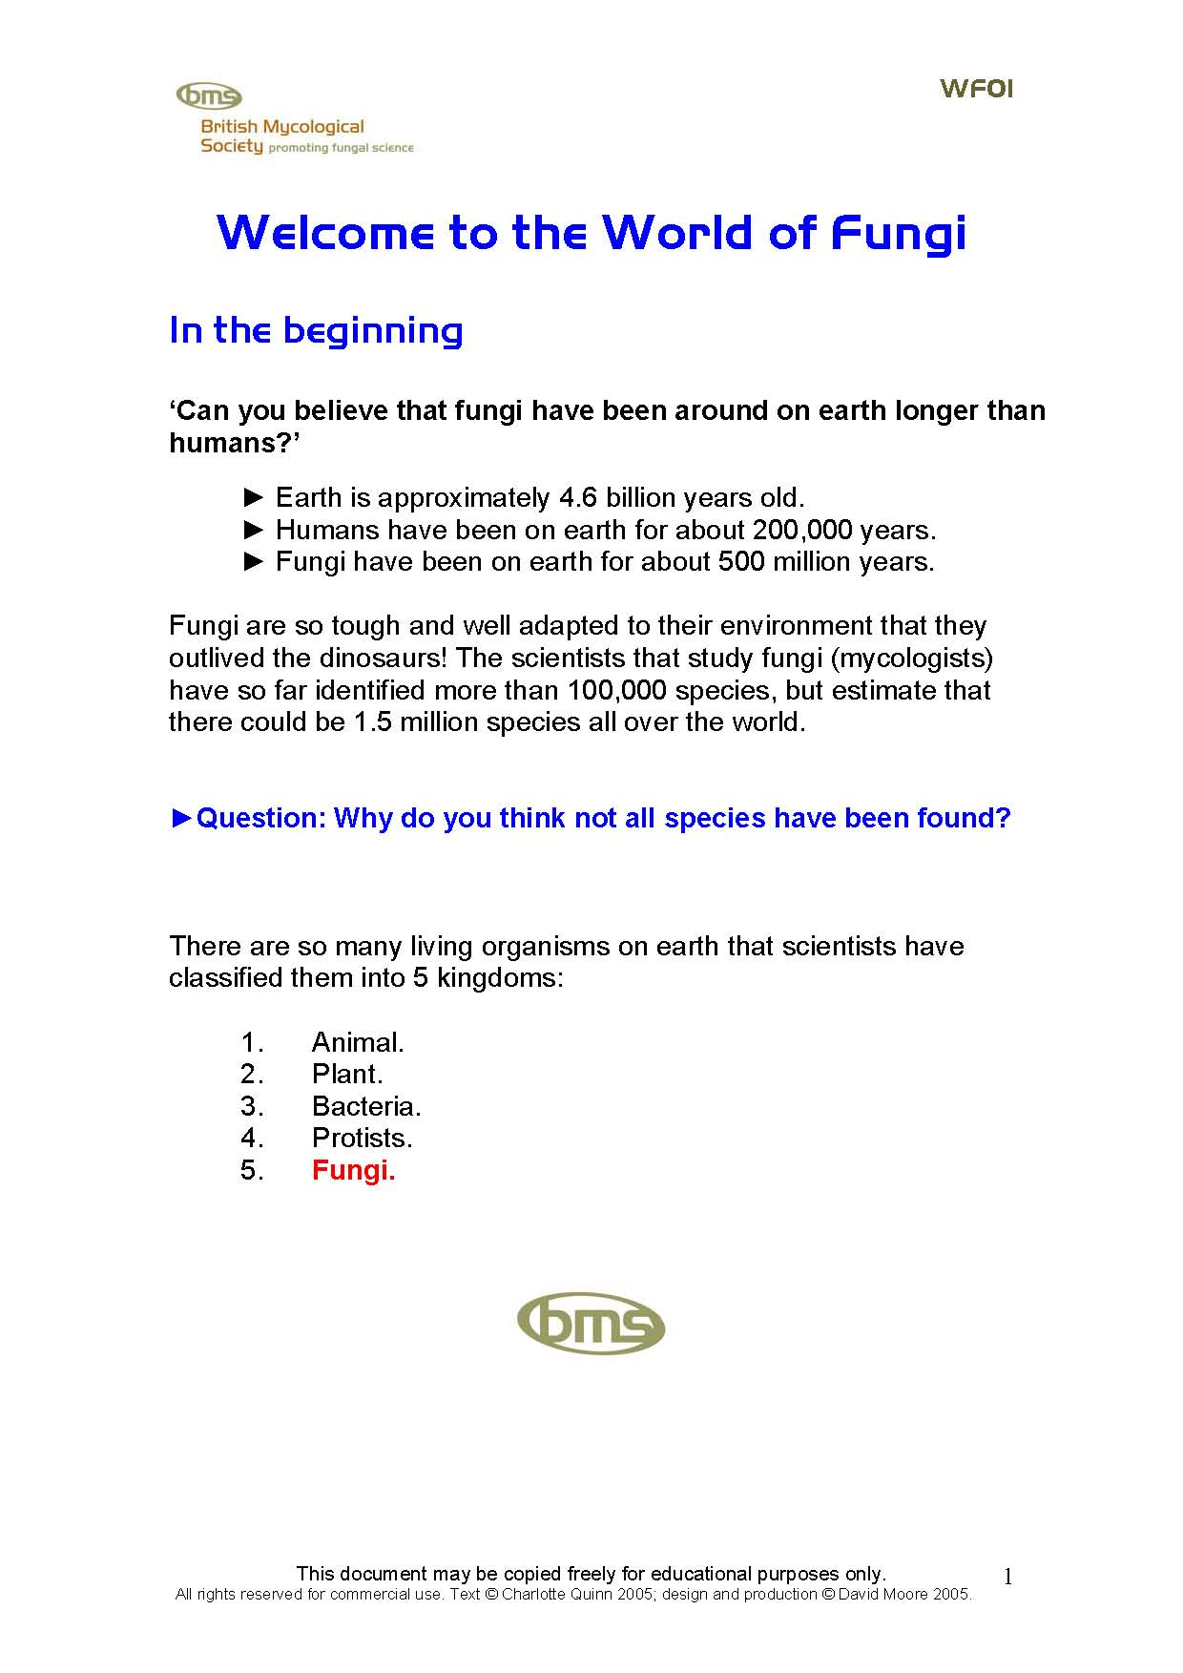 | Welcome to the World of Fungi introduces Kingdom Fungi to the pupil. A brief overview describes how long fungi have existed and how many species may exist, this indicates the sheer size and persistence in time of Kingdom Fungi. The rest of the package focuses on the structure, growth mechanism, feeding methods and introduces the numerous places fungi are found. Includes a ‘matching’ task for the pupils. Provided in two formats: PDF file (for easy printing) and as a Word.doc for you to edit and modify as you wish. NOTE also the FF16: What are Fungi? PowerPoint Presentation - 14 slides giving a general overview of fungi, and offered as a PowerPoint PPT file and as a set of PDF sheets that you can copy onto OHP transparencies.
WF02  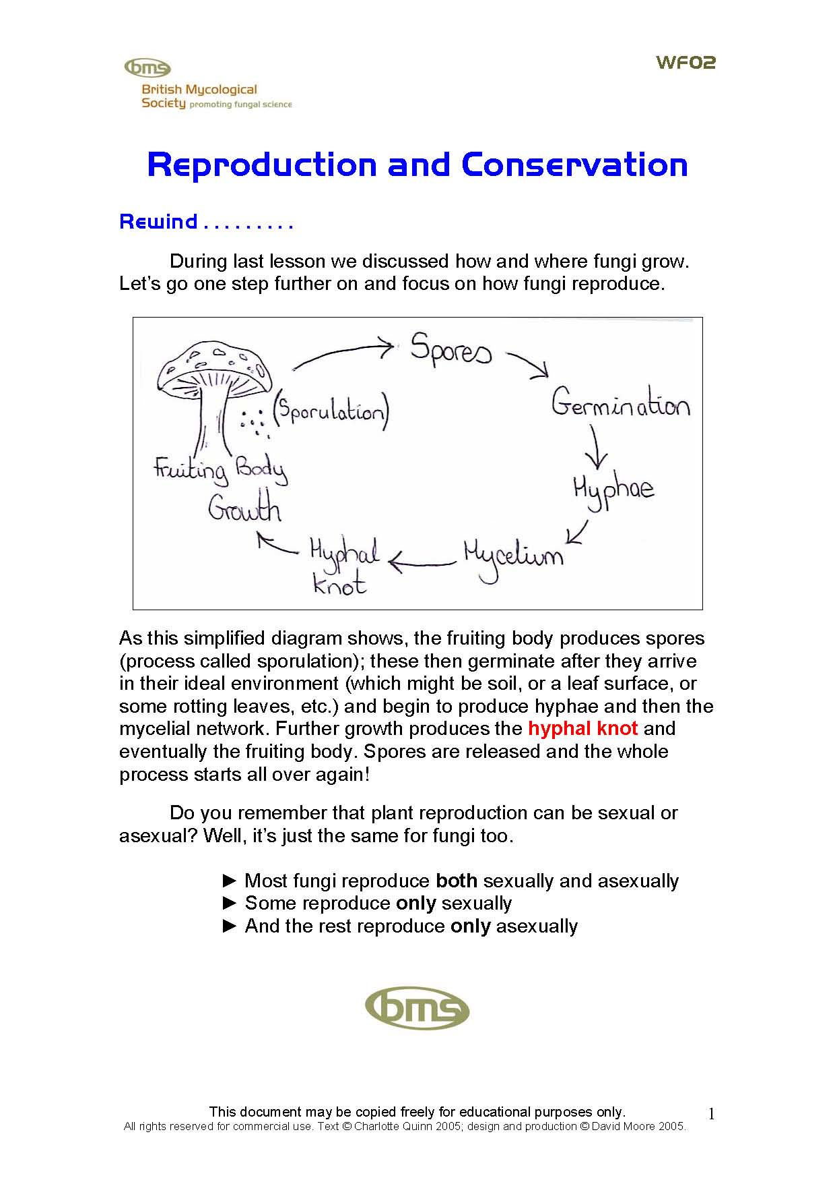 | Reproduction and Conservation briefly reviews what was covered in the previous lesson to remind the pupil. The reproductive cycle is described in detail. Both sexual and asexual reproduction are revised using short statements, and reproductive cycles are provided for pupils to exercise their visual memory. Methods of spore dispersal are described using colourful pictures of particular fungal species as examples to allow the pupil to visualise dispersal methods. Provided in two formats: PDF file and as a Word.doc you can edit.
WF03  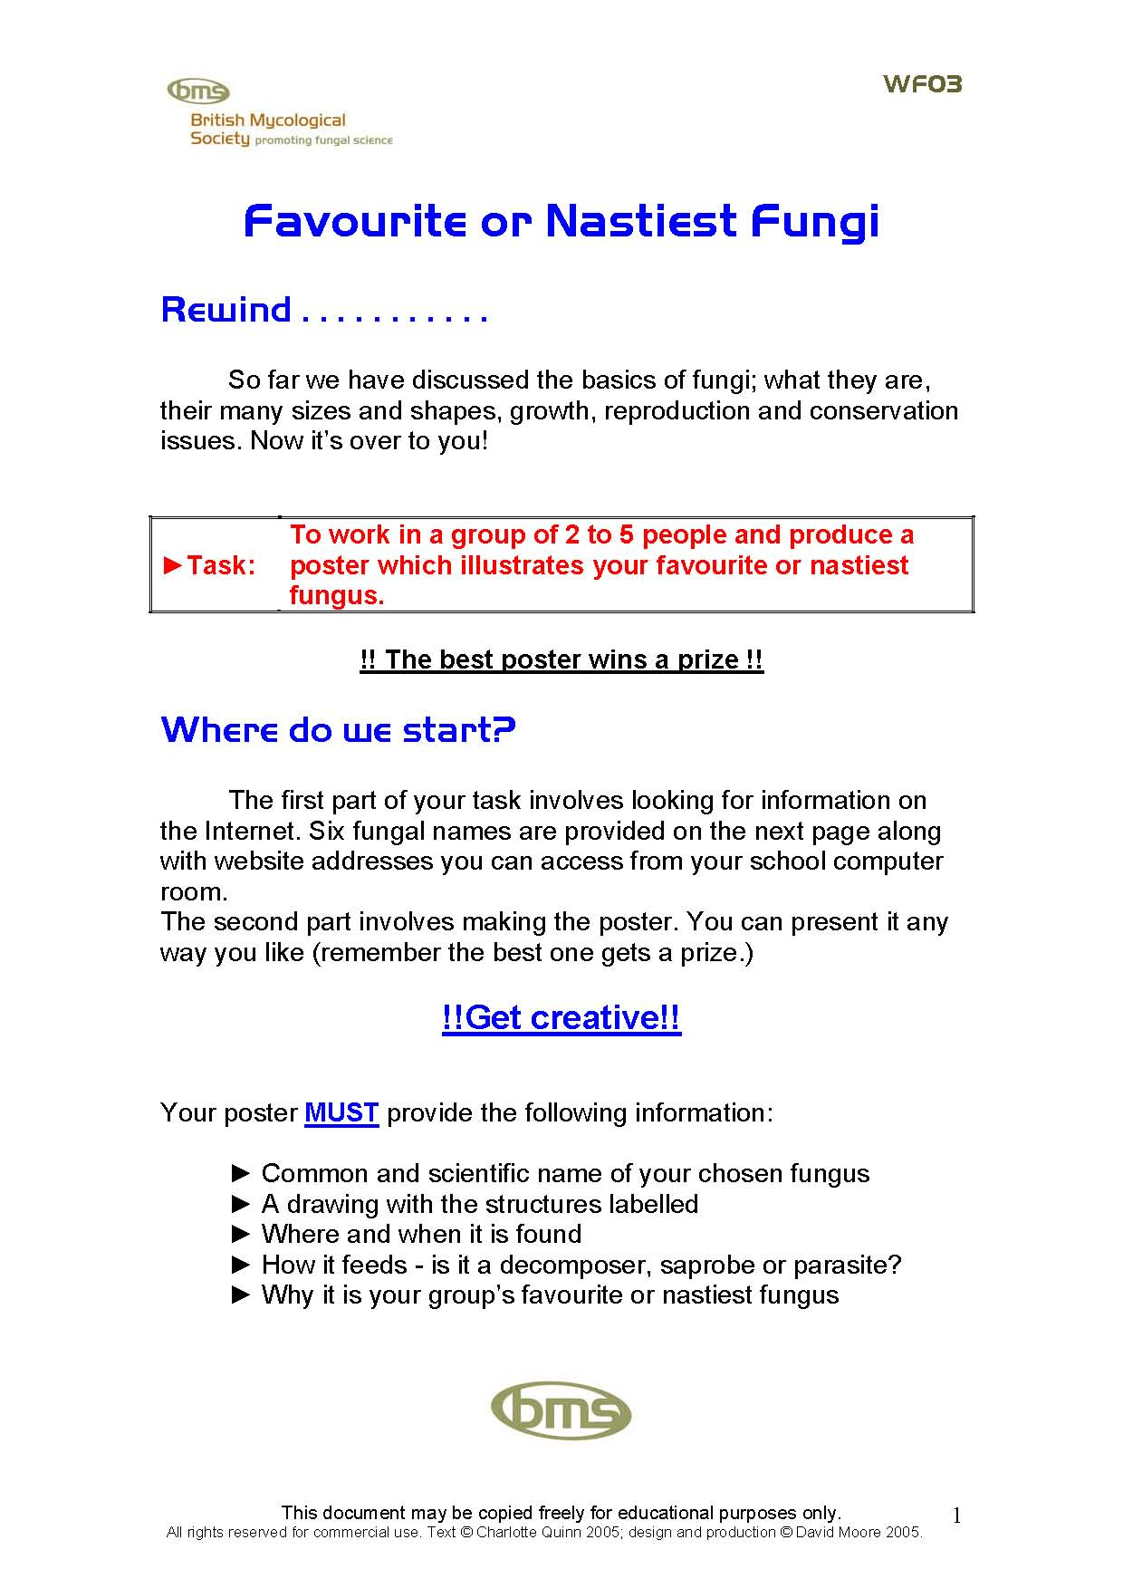 | My Favourite or Nastiest Fungus was designed for a two-hour lesson. The first session requires the pupils to work in groups of two to four and research a particular fungus in the school’s IT department on the Internet. Some website addresses are provided. Each team has to meet stated criteria to produce a poster in the second session explaining why the fungus was their ‘favourite’ or ‘nastiest’. Offering the best poster a prize and/or award certificate will give the pupils an incentive to work hard and made the research process a fun and enjoyable activity. This package incorporated teamwork, IT, enquiry, information processing and creative thinking skills. Provided in two formats: PDF file and Word.doc.
WF04  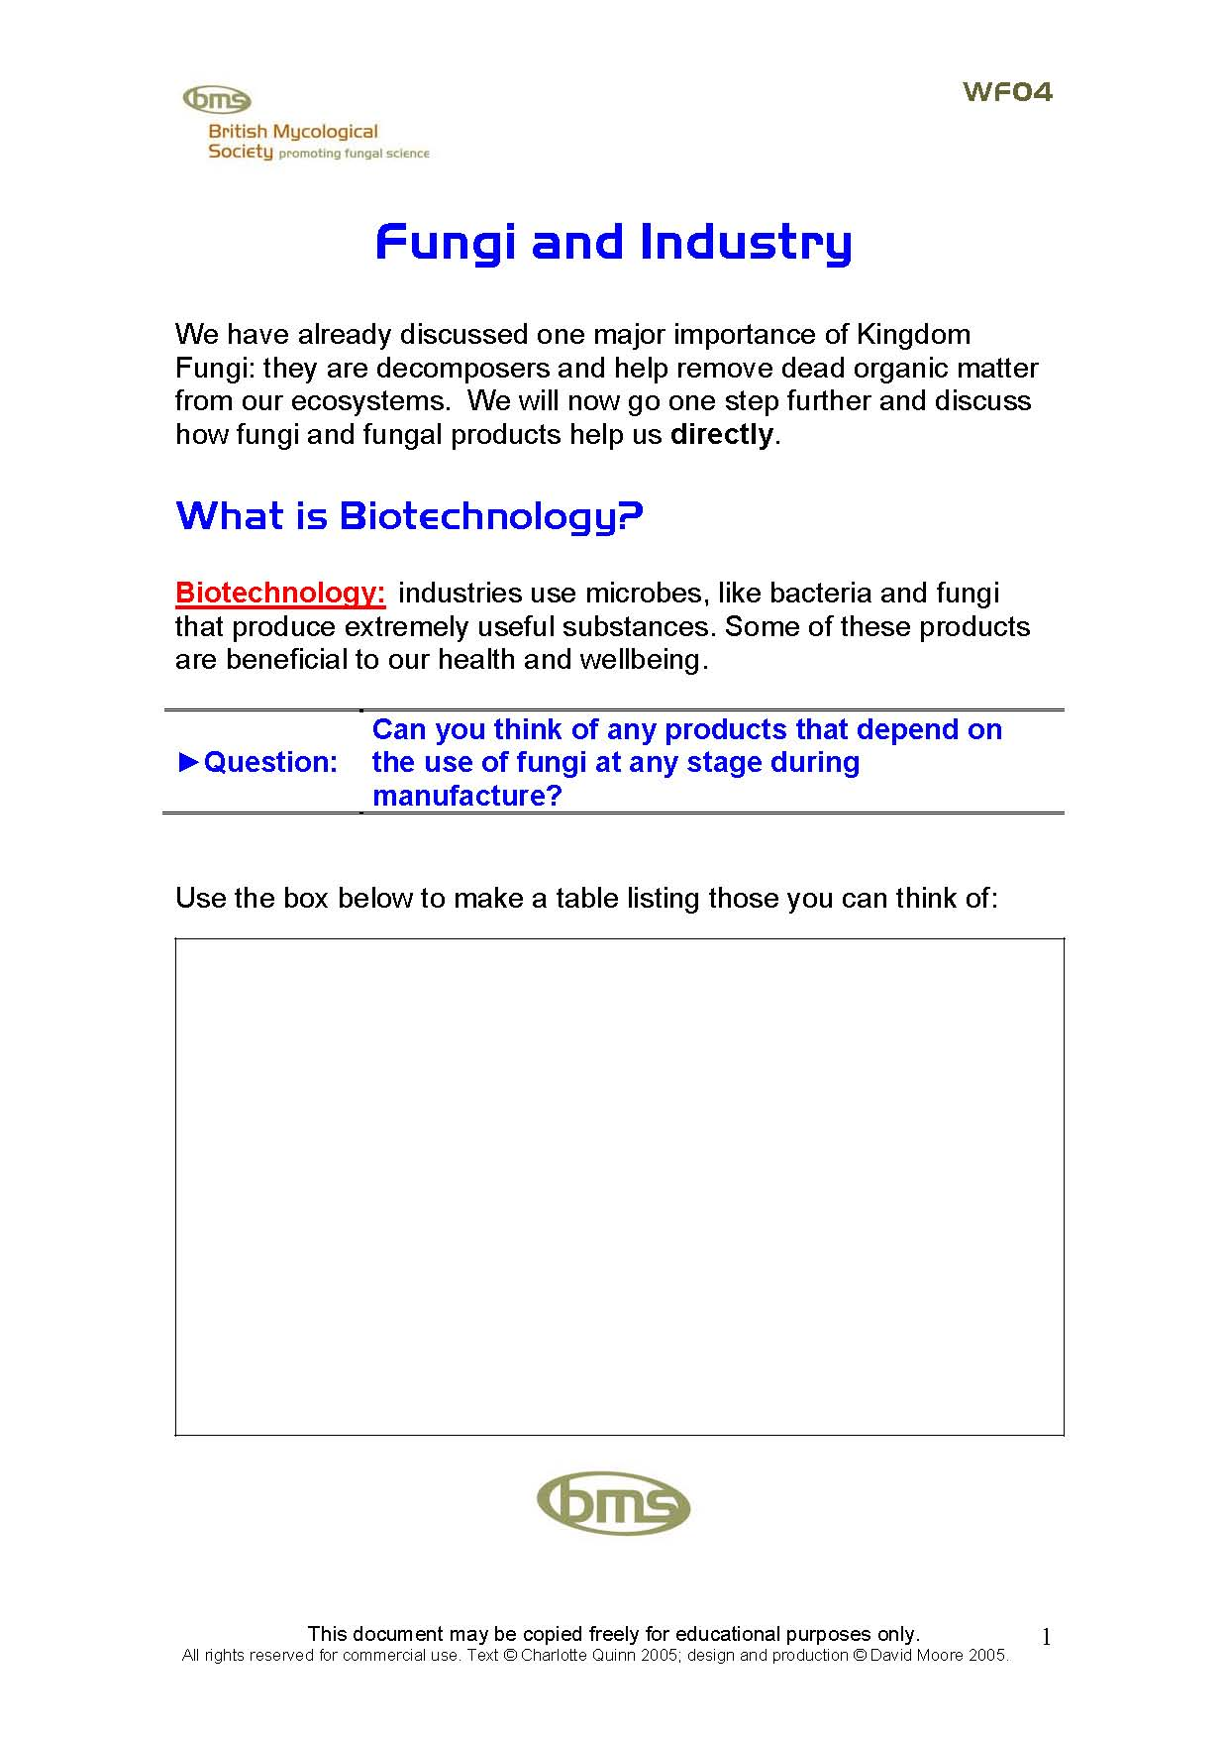 | Fungi and Industry summarises some production methods that depend on fungi, and uses the British Mycological Society’s ‘Supermarket Challenge’ to make the topic relevant to the pupils by showing the wide range of every-day products that depend on fungi. An introduction to the types of fungi that benefit human health is also given. The resource provides many opportunities for classroom debates over topics as diverse as transplant ethics, nutrition and the ‘need’ for food supplements, and the effects of long-term treatment for chronic ailments. This package incorporates communication, application of number and thinking skills. Provided in two formats: PDF file and Word.doc.
WF05  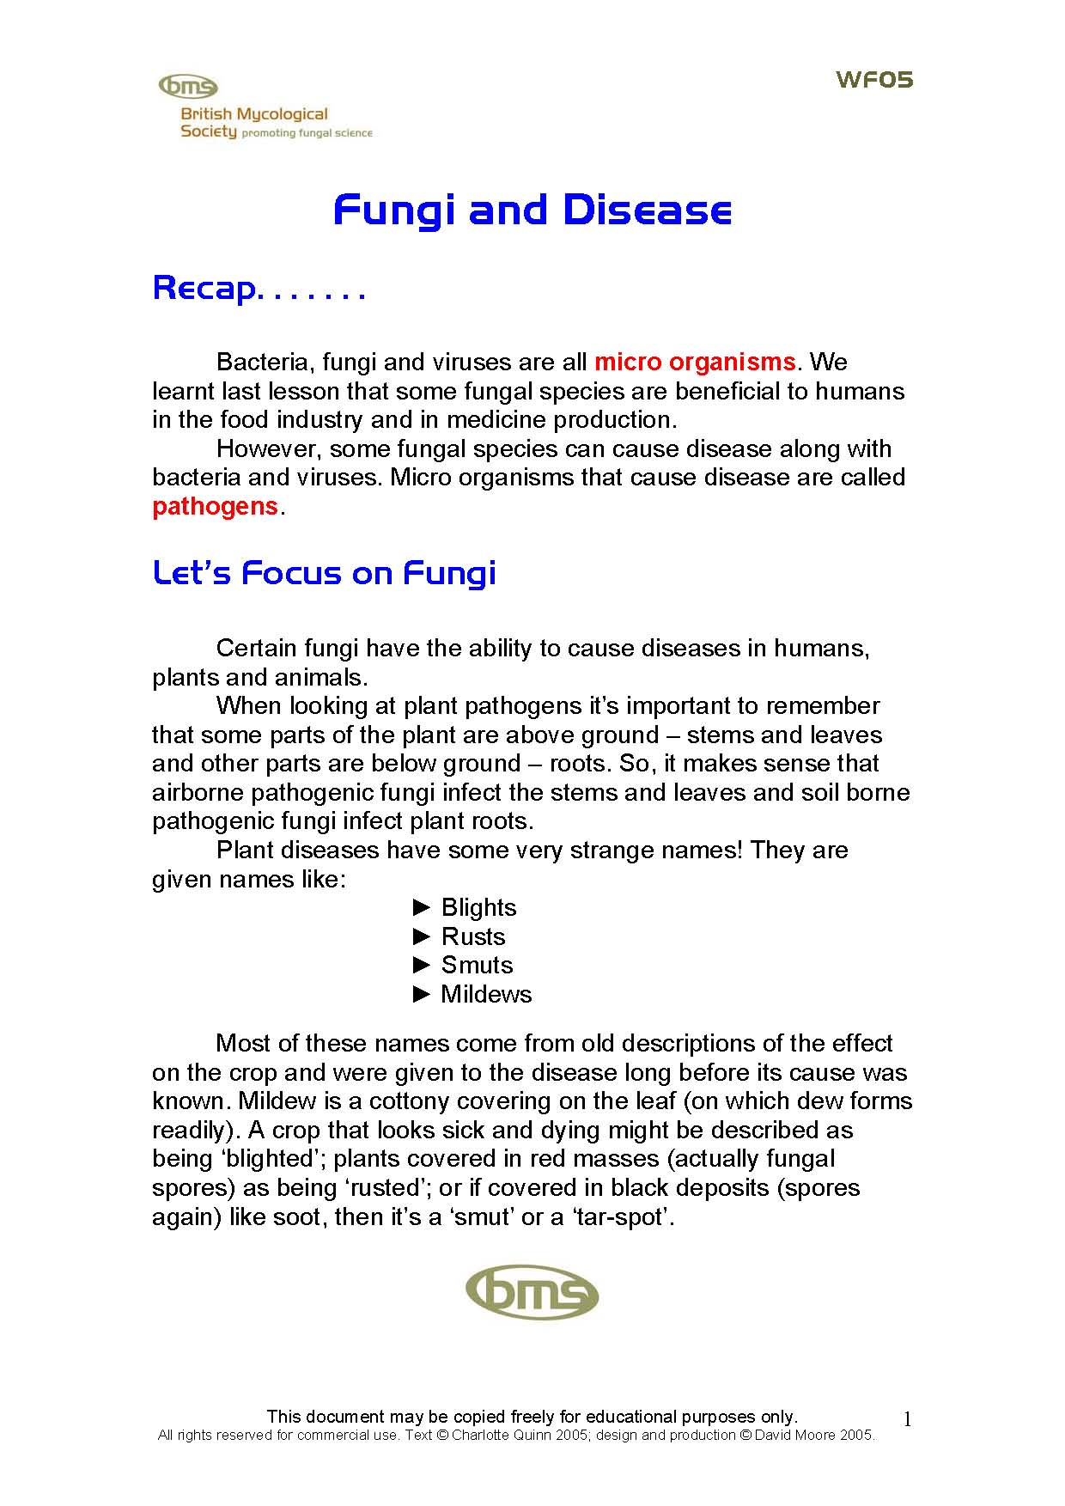 | Fungi and Disease can be usefully started with a brief verbal summary to revise the nature of microorganisms and pathogens. A description of plant and human fungal pathogens is provided in the class sheet, and the pupils are given brief descriptions next to pictures of several human and plant fungal diseases (you could remove these to leave blank space in which pupils are required to write notes). A brief case study describing the effects of the pathogen Phytophthora infestans in the Irish Potato Famine is provided that could be the basis for a class project combining biology, history, geography and community studies. Provided in two formats: PDF file and Word.doc.
Remember: class sheets may be copied freely for education purposes.

The resources included in the package entitled What’s Your Favourite Fungus? could be incorporated to enhance these lessons. The collection of fungus ‘stories’ includes a wide variety of information, which could contribute in many different ways to the above. For example, stories about chytrids, mycorrhizas, timber decay and the largest organism could contribute to WF02; those about bread, cheese, Quorn, citric acid and Marmite to WF04; and stories about statins and cyclosporin, as well as rice blast and powdery mildew to WF05. Any of the FF-stories could be the basis of alternative topics for the Internet research and poster making in WF03.

General References for Further Information:

M. J. Carlile, S. C. Watkinson, and G. W. Gooday (2001). The Fungi, 2nd ed. Academic Press; ISBN 0127384464.
Liz Holden & Kath Hamper (2003) The Fungi Name Trail, a Key to Commoner Fungi. Field Studies Council/ British Mycological Society; ISBN 1851538917 [www.field-studies-council.org].
B. Kendrick (2000). The Fifth Kingdom, 3rd ed. Focus Publishing; ISBN 1585100226.
T. Laessøe and A. Del Conte (1996). The Mushroom Book, Dorling Kindersley, ISBN 0789410737.
D. Moore (2001). Slayers, Saviours, Servants, and Sex, an Exposé of Kingdom Fungi, Springer-Verlag New York Inc.; ISBN 0387950982.
D. Pegler (1999). The Easy Edible Mushroom Guide, Aurum Press; ISBN 1854106317.
Roy Watling (2003). Fungi, Natural History Museum; ISBN 0565091824.

Additional guidance for specific Class sheets

WF01 is relevant to Unit 1 Developing Scientific Skills
Working safely in science | Students must be aware that some fungal species are poisonous. Use shop-bought mushrooms to make sure that the samples used in the classroom are edible and safe to handle.
Investigating living organisms | Students will learn about the five Kingdom classification system, the structure and composition of the mushroom, how growth occurs and the three methods fungal species use to feed.

WF01 is relevant to Unit 2 Science for the Needs of Society
Living organisms | Students will be able to describe the differences between animal cells, plant cells and the fungal hypha and should be able to name three structural components of a fungal hypha.

WF01 Class sheet page 3: Students should draw labelled diagrams as shown below:

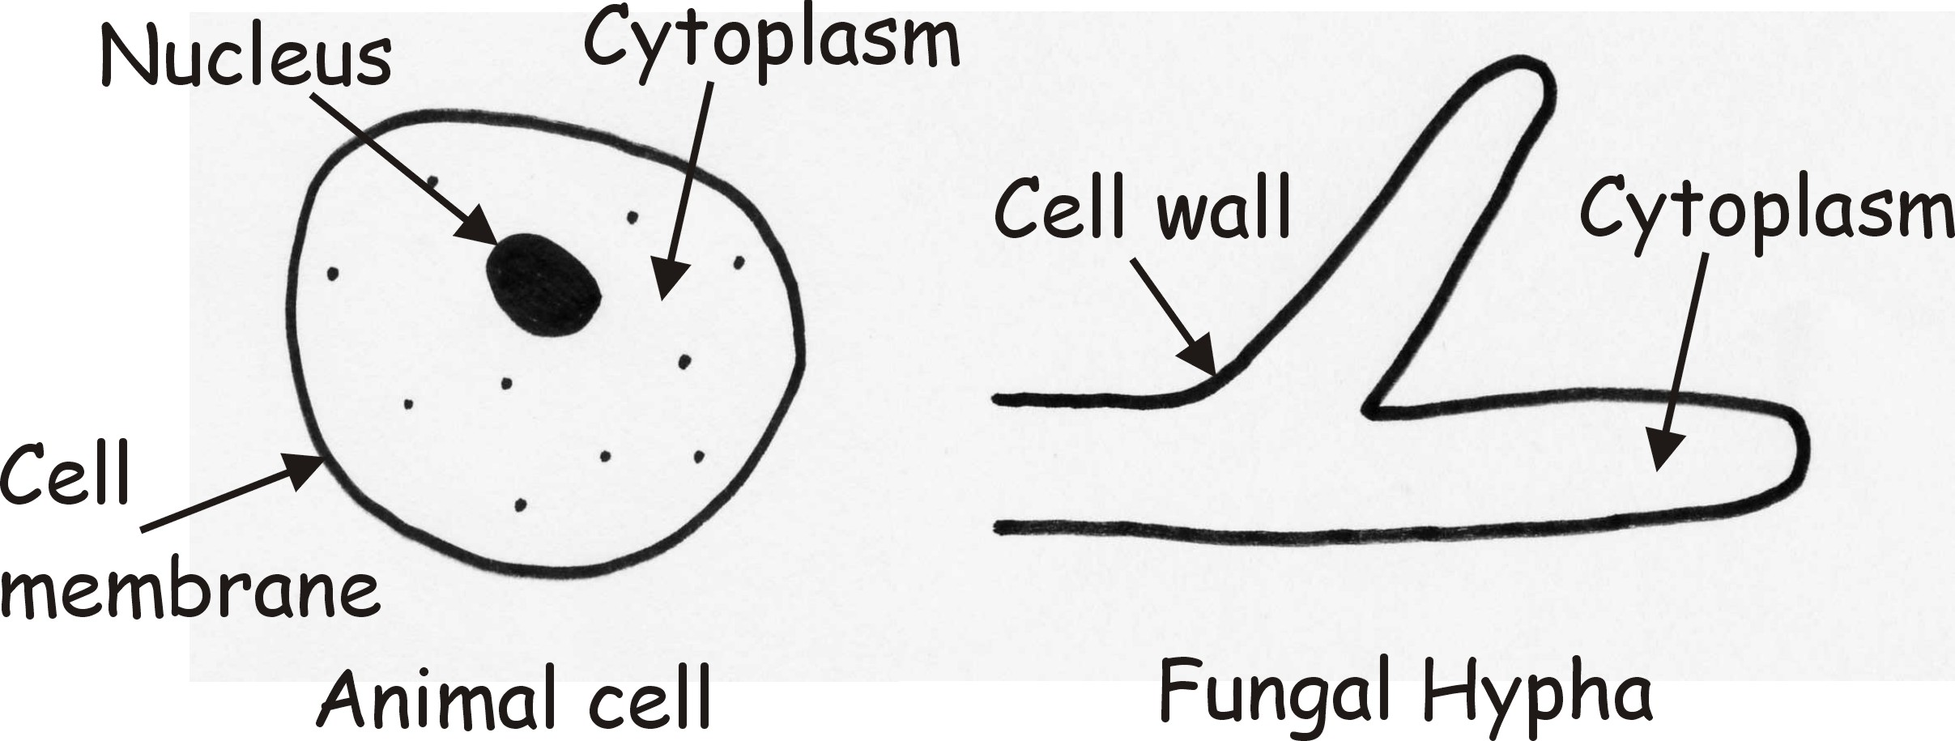

WF01 Class sheet page 4: Students should draw labelled diagrams as shown below:

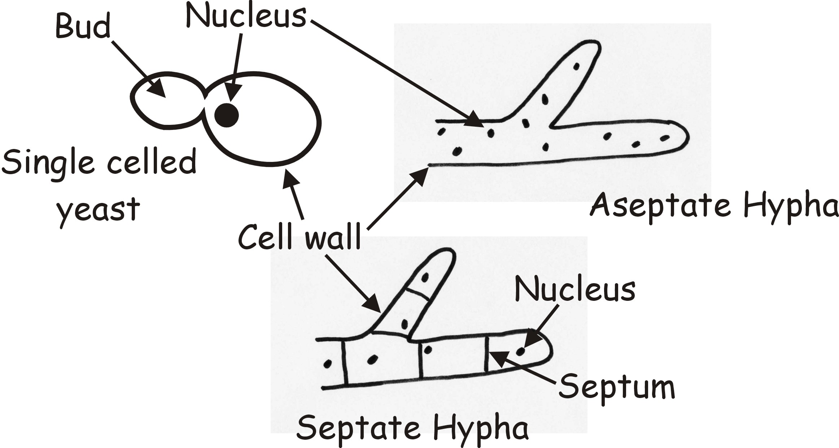

WF01 Class sheet page 5: Students should draw labelled diagrams as shown below:

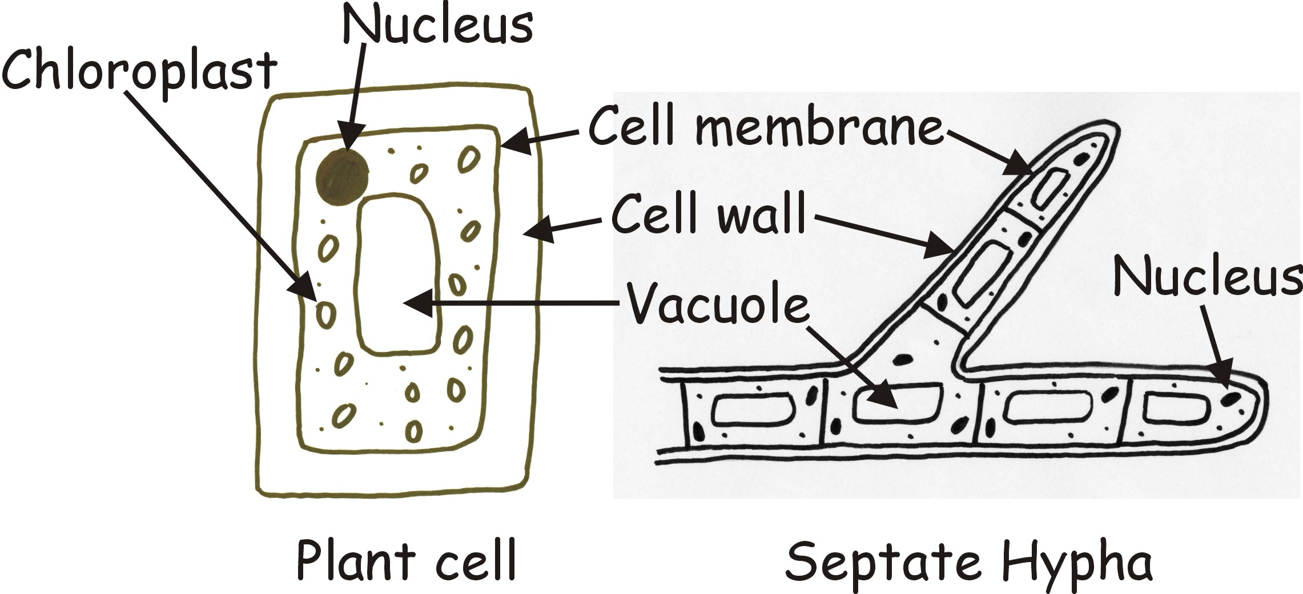

WF01 Class sheet page 7:

►Question: How many uses of fungi can you think of?

Hold a class discussion to introduce the uses of fungi. Topics include:
► Mushrooms on pizza and in salads
► Yeast in production of bread and beer
► Making other food products – cheese, Quorn, soy sauce
► Making antibiotics and other pharmaceuticals
► Making citric acid for fizzy drinks
► Enzymes for fabric conditioning & food processing
► Composting waste materials

For ideas, background and further information, check out the accompanying resource package entitled What’s Your Favourite Fungus?

WF02 Reproduction and Conservation
► Be sure to check out the information on the Fungi Name Trail.
► Make sure your pupils understand the processes (and the differences) of sexual reproduction. You might add that in many fungi incompatibility reactions can define numerous “mating types” so that there are many different sexes (rather than just two). It’s up to you to judge whether this is likely to be more confusing than enlightening!
► Don’t forget that you can compare spore production and dispersal in fungi with seed production and dispersal in plants. There are many parallels – including adaptations to wind dispersal, mechanical methods of discharge and dependence on insects (and adaptations to attract them).

WF02 Reproduction and Conservation Class sheet page 8: provides space for the pupil to construct a food web. Food chains and food webs are described in most text books. Unfortunately, fungi are never included in them – and this is despite the fact that most soils are filled with fungal mycelium which is the staple diet of many ‘microarthropods’ (= mites, springtails and small insects), and fungal fruit bodies (truffles, puffballs, mushrooms) are the main (sometimes only) source of nutrition for many small animals (mushroom fly larvae, snails and slugs, mice, voles, shrews) and important component of the diet for larger animals (squirrels and even deer). Food Chains show the transfer of food energy from one organism to the next…..so they show us who eats who! Fungi play essential roles in many food chains and not always in the role of decomposer. Two examples of food chains in which fungi are essential:
Plant/Tree roots → Mycorrhizal Truffle → Vole → Owl
Organic matter → Saprotrophic fungi → Insect → Mouse
The arrows in the food chain indicate the direction in which the food energy is transferred between organisms.
Food Webs are made up of many food chains. They give a more complete picture of how organisms interact in nature. An example of a food web containing fungi is shown in the next diagram:

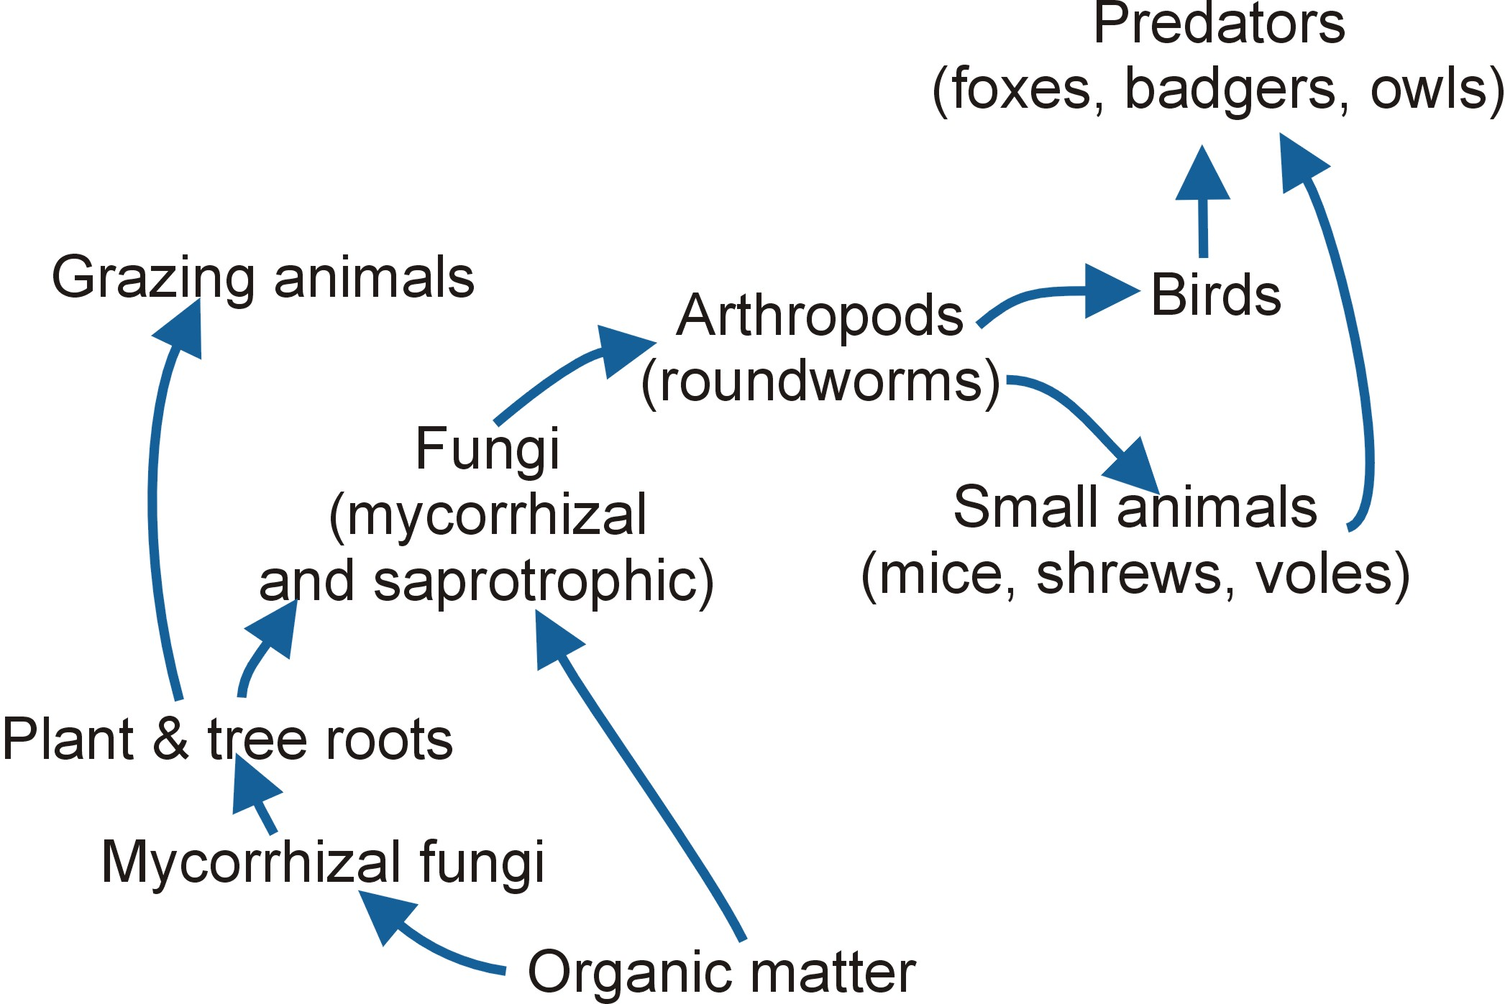

WF03 My Favourite or Nastiest Fungus
Do check out the websites yourself before you let your pupils loose on them! The basic concept here (namely: do some research on the Internet and then make a poster) is a very useful exercise and could be expanded further to stretch your pupils and to illustrate other important principles. Although our specific example aims pupils towards particular fungal species, you could aim them towards processes. For example:
► Search the websites for decomposers of leaves and dead wood and discuss their value in autumn, their contribution to nutrient recycling and nitrogen & carbon cycles.
► Research symbiotic relationships and their importance in the survival of plants (especially trees); why not discuss the proposition in the slogan ‘no fungi – no forest; no forest – no future!
► Think about fungi and industry, and fungi and disease as topics for the poster; these topics can extend into other areas of the curriculum and develop interest in many important and relevant topics.

WF04 Fungi and Industry Class sheet page 1: Products that depend on fungi include bread, beer, wine, cheese, marmite, Quorn and even coffee and fizzy drinks. Most curriculum specifications deal only with bread and beer production as biotechnological fermentations but there are other potential examples and many of these are explained in the package entitled What’s Your Favourite Fungus? (FF01 to FF15).

WF04 Fungi and Industry Class sheet page 2: The exact values for entries in the table will depend on the source of information that is used, but typical values (as %age by weight) would be as follows:

 | Protein | Dietary Fibre | Fat
Myco-protein | 44% | 18% | 13%
Beef steak | 68% | 0 (zero) | 30%

The exercise provides a departure point for discussion of food sources of protein, fibre and fats and why the body needs them:
► Protein from meat, eggs, fish needed for building and repairing cells
► Fibre from vegetables, fruit, cereals needed for proper intestinal function and regular egestion
► Fat from butter, meat, cakes needed for energy and as insulating layer (but important to control intake)
► Carbohydrate from bread, potatoes, cereals and needed as a primary energy source.

WF04 Fungi and Industry Class sheet page 3: Details about the items in the table can be found in the explanatory notes for the Supermarket Challenge poster (FF25).

WF04 Fungi and Industry Class sheet page 5: Some of these topics are explained in the package entitled What’s Your Favourite Fungus? (FF01 to FF15).

WF05 Fungi and Disease: It is useful to stress that fungi can infect plants and animals to cause disease (curriculum specifications seem to imply (wrongly) that only viruses and bacteria are infective agents). Take this a stage further to point out that different disease fungi may be specialised to infect different parts of the plant (e.g. leaf diseases or root diseases) or animal (e.g. lung infections caused by inhaling spores, skin diseases caused by contact with the infective agent).
Additional discussion topics could be the use of pesticides to control infections (fungicides, insecticides, disinfectants); their impact on the ecosystem (e.g. on food webs), which can then be developed further towards the ways that human activities affect nature.



